

Hiral

IT 496: Graduation Project Report

Product Release-1

Prepared by

Atheer alzaid, 441201404

Deema alfuaim, 441200819

Dana alsaeedi, 441201237

Nora alqaht, 441200798

Supervised by

Dr.Henda Ouertani

Term 3 -1444

Spring 2023

Table of Contents

1 Introduction 9

1.1 The Problem 9

1.2 The Solution 9

1.3 Product 10

1.3.1 Product Vision 10

1.3.2 Product Roadmap 10

1.3.3 Objectives 10

1.3.4 Scope 12

1.3.5 Hardware/Software Tools and Cost 12

1.4 Scrum Team 13

1.4.1 Skill Set Requirements 13

1.4.1.1 Learning 13

1.4.2 Roles and Responsibilities 14

2 Background 16

2.1 AI resume & job post screening tools 16

2.2 Semantic similarity 17

2.3 Semantic matching algorithms 18

2.3.1 Sentence transformers 18

2.3.2 Jaccard similarity 18

2.3.3 Euclidean distance 18

3 Literature Review 21

3.1 Competitive Product Analysis 23

4 System Requirements 28

4.1 System Users 28

4.2 Requirements Elicitation and Analysis 28

4.2.1 Survey analysis 28

4.2.2 Interview analysis 31

4.3 User Interactions 32

4.4 Product Backlog 33

5 System Design 51

5.1 Architectural Diagram 51

5.2 Class Diagram /DFD 52

5.3 Component Level Design 53

5.4 Data Design 63

5.4.1 Data Models 63

5.4.1.1 ER Diagram 63

5.4.1.2 Relational Schema 63

5.4.1.3 Data Dictionary 65

5.4.2 Data Collection and Preparation 72

5.5 Interface Design 73

6 System Implementation 83

7 System Testing 88

7.1 User Acceptance Testing 88

7.1.1 Demographics of Participants 88

7.1.2 Questionnaire/Interview Results 89

7.2 Discussion 91

8 Conclusions and Future Work 93

9 References 96

10 Appendix A: Requirement elicitation’s questionnaire 100

11 Appendix B: Requirement elicitation’s interview 113

12 Appendix C: Jira 115

13 Appendix D: Testing 118

Table of Figures

Figure 1 - 1.3.2 Hiral roadmap 10

Figure 2 - 3.1 ziprecruiter [15] 23

Figure 3 - 3.1 Indeed [16] 24

Figure 4 - 3.1 Glassdoor [17] 24

Figure 5 - 3.1 Monster [18] 25

Figure 6 - 4.3 Hiral use case 32

Figure 7 - 5.1 Hiral system architecture 51

Figure 8 - 5.2 Class Diagram 52

Figure 9 - 5.3 Register Flowchart 54

Figure 10 - 5.3 Edit account Flowchart 56

Figure 11 - 5.4.1.1 ER Diagram 61

Figure 12 - 5.5 Seeker navigation hierarchy 71

Figure 13 - 5.5 Recruiter navigation hierarchy 72

Figure 14 - 5.5 Login interface 73

Figure 15 - 5.5 Signup interface 73

Figure 16 - 5.5 Seeker Edit account interface (a) 74

Figure 17 - 5.5 Seeker Edit account interface (b) 74

Figure 18 - 5.5 Seeker profile interface 75

Figure 19 - 5.5 Recruiter Edit account interface (a) 75

Figure 20 – 5.5 Recruiter Edit account interface (b) 76

Figure 21 - Recruiter profile interface 76

Figure 22 - 5.5 Add job post interface (a) 77

Figure 23 - 5.5 Add job post interface (b) 77

Figure 24 - 5.5 Add job post interface (c) 78

Figure 25 - job posts interface 78

Figure 26 - 5.5 job post interface (a) 79

Figure 27 - 5.5 job post interface (b) 79

Figure 28 - 6 Hiral iterative development 81

Figure 29 - 6 System implementation steps 82

Figure 30 - Survey questions 98

Figure 31 - Survey questions 98

Figure 32 - Survey questions 99

Figure 33 - Survey questions 99

Figure 34 - Survey questions 100

Figure 35 - Survey questions 100

Figure 36 - Survey questions 101

Figure 37 - Survey questions 101

Figure 38 - Survey questions 102

Figure 39 - Survey questions 102

Figure 40 - Survey answers 103

Figure 41 - Survey answers 103

Figure 42 - Survey answers 103

Figure 43 - Survey answers 104

Figure 44 - Survey answers 104

Figure 45 - Survey answers 104

Figure 46 - Survey answers 105

Figure 47 - Survey answers 105

Figure 48 - Survey answers 105

Figure 49 - Survey answers 106

Figure 50 - Survey answers 106

Figure 51 - Survey answers 106

Figure 52 - Survey answers 107

Figure 53 - Survey answers 107

Figure 54 - Survey answers 108

Figure 55 - Survey answers 108

Figure 56 - Survey answers 108

Figure 57 - Survey answers 109

Figure 58 - Jira sprints 113

Figure 59 - Jira roadmap 113

Figure 60 - Jira backlog 114

Figure 61 - Testing survey 116

Figure 62 - Testing survey 116

Figure 63 - Testing survey 117

Figure 64 - Testing survey 117

Figure 65 - Testing survey 118

Figure 66 - Testing survey 118

Figure 67 - Testing survey 119

Figure 68 - Testing survey 119

Table of Tables

Table 1 – 1.3.5 Hardware/Software tools 12

Table 2 – 1.4.1 Skill set requirements 13

Table 3 – 1.4.2 Roles and responsibilities 14

Table 4 – 2.2 Example of semantic similarity detection 17

Table 5 - 3.1 competitives comparision 25

Table 6 - 4.2.1 Job seeker survey 29

Table 7 - 4.2.1 Job recruiter survey 30

Table 8 - 4.4 Product backlog 33

Table 9 - 5.4.1.3 Data dictionary 65

Table 10 - 6 Software tools 85

Table 11 - 7.1.1 Demographics of participants 88

Table 12 - 7.1.2 Questionnaire results 89



CHAPTER 1

Introduction

# Introduction

Job searching can be tedious and time-consuming. At any given time, millions of people around the world are actively looking for jobs. At the same time, millions of organizations are searching for the relevant candidates. Both sides are in need to be connected in a convenient, fast way. Our goal is to provide a platform that assists either job seekers or recruiters in making their search effortless and fast to find results in no time.

This document contains the necessary information gathered to build and explain Hiral such as, the problem which Hiral attends to solve, the solution that Hiral attempts to provide, the product vision that Hiral desires, the product roadmap and objectives, the scope of Hiral, the tools and cost to develop Hiral, and our scrum team and roles.

## The Problem

Finding the right candidates for an organization, particularly in the digital industry, can be a daunting and time-consuming task, often resulting in wasted resources. It can be challenging to sift through an overwhelming amount of resumes and cover letters to identify the ideal candidate that meets the specific needs of the company. At the same time, millions of job seekers worldwide are searching tirelessly for new opportunities that match their set of skills and experiences.

## The Solution

Our aim is to simplify the job search process by leveraging the latest advancements in AI technology, such as sentence transformers. Our innovative platform empowers recruiters to screen CVs (resumes) more efficiently by using AI screening tools, so they can quickly identify the most suitable candidates for a given position. Job seekers, on the other hand, benefit from receiving relevant job offers that match their skills and experience, thereby saving them precious time and energy. Moreover, our web application provides a personalized analytical dashboard that allows both job seekers and recruiters to tune into their specific interests and preferences, helping them to discover new opportunities that align with their career goals.

In essence, our application revolutionizes the way job searches are conducted by targeting the right candidates and job offers. By minimizing the time and effort required to find the ideal match, we help both recruiters and job seekers alike to achieve their goals efficiently and effectively.

## Product

### Product Vision

For recruiters and job seekers, who hunt for suitable candidates/look for convenient job opportunities, the Hiral is a web application, that makes the job search process simple for both recruiters and job seekers, unlike other job search platforms, our product uses AI technologies to offer the best candidates/job opportunities in no time.

### Product Roadmap

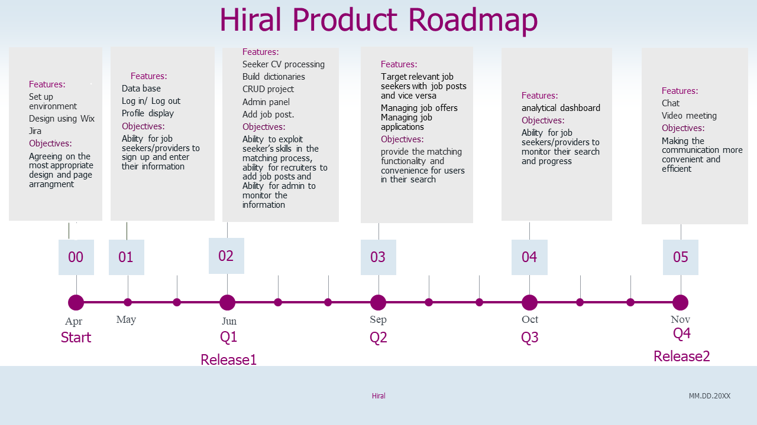

Figure - 1.3.2 Hiral roadmap

### Objectives

● Product (customer focus-value):

We are building this product because, at present, searching for good jobs and recruiting suitable candidates is tiresome, exhausting, and time-consuming. Our product will minimize the time and effort to find a qualified employee and the time and effort to find a suitable job for them by allowing the candidate to submit a detailed CV and the recruiter to submit a detailed job description.

The product will permit the following:

1. The job seeker and the recruiter to manage their profiles.
2. Screen CVs and applications to target relevant candidates and job offers by using AI technologies.
3. Notify the job seekers of relevant job offers.
4. Target relevant candidates for each job offer.
5. Send job offers and job applications.
6. Provide a personalized analytical dashboard related to the interests of the job seeker and those of the recruiter.

Anyone who is searching for a job or recruiting for candidates will benefit from this application.

● Project (solution focus-plan):

To complete this project, several steps must be taken:

1. Set environment to create the web application.
2. Understand user needs.
3. Design database.
4. Build interfaces.
5. Implement basic functions.
6. Collect data.
7. Test model.
8. Integrate model into the web application.

● Learning (student focus):

We will learn the following from completing this project:

1. Being familiar with VS CODE.
2. Design SQLite database.
3. Build interfaces using HTML, CSS and UIkits.
4. Connect to the front end with the Django app.
5. Applying sentence transformers in Python.
6. Screen CV using keyword-based AI screening tools using dictionaries.
7. Incorporate AI technologies to my website.

### Scope

Hiral is a web application that is concerned with helping either recruiters or job seekers who need to find opportunities quickly and effortlessly, Hiral will enable the user to search a large pool of either job postings or candidates that are relevant to each other. Hiral supports the English language. We will operate Hiral using the Django framework and the keyword-based scanning with sentence transformers for matching.

### Hardware/Software Tools and Cost

Table – 1.3.5 Hardware/Software tools

|  |  |
| --- | --- |
| Hardware Tools | |
| Name and Description | Cost |
| Computers and smartphone devices | Already available for the team |
| Software Tools | |
| Name and Description | Cost |
| Visual Studio IDE For creating the web application using Django | 0 |
| GitHub | 0 |
| Jira | 0 |
| Text editor | 0 |
| Diagram building software | 0 |

## Scrum Team

### Skill Set Requirements

Table – 1.4.1 Skill set requirements

|  |  |
| --- | --- |
| Technical Skill Required | What is the current level of the team (*beginner-intermediate- advanced*) for each skill? How will the gap be bridged? *(if necessary*) Learning plan |
| Django framework and Python programming language skills | beginner  -Youtube videos  -Online Django courses |
| Sentence transformers knowledge | beginner,  -Youtube videos  -Online courses |
| Keyword-based AI screening | beginner,  -Youtube videos  -Online courses |

#### Learning

We will learn to program using the Django framework and learn Python programming language more in depth and how to embed useful AI technologies. In our case they are sentence transformers and keyword-based screening tools. Also, we subscribed to some courses to learn the basics of programming with Django to create a web app.

### Roles and Responsibilities

Table – 1.4.2 Roles and responsibilities

|  |  |
| --- | --- |
| Scrum Team | |
| Product Owner:  (list name of the project supervisor) | Dr.Henda Ouertani |
| Developers: (list student names) | Deema Alfuaim  Atheer Alzaid  Dana Alsaeedi  Norah Alqaht |
| Scrum Master (SM):  (list name of designated SM for the project) | Dr.Hind Alrasheed |
| Stakeholders:  (list names of project stakeholders, include customer names if any) | Examination team |



CHAPTER 2

Background

# Background

This section aims to provide background information in Artificial Intelligence (AI) techniques that are relevant to our application. Firstly, we will explain what AI screening resumes are and overview the different AI techniques used to screen resumes. Secondly, we will briefly describe the semantic matching algorithm used to compare different text inputs.

## AI resume & job post screening tools

AI resume and job post screening tools are computer programs that use artificial intelligence to analyze and evaluate resumes from job applicants. They help recruiters and hiring managers quickly screen large volumes of resumes, find the most qualified candidates, and save time and money in the recruitment process [2].

Resume And job post screening tools typically fit into three categories [3]. Each of these tools is designed to help talent acquisition teams automate the resume screening process.

Keyword-based: When artificial intelligence categorizes candidates, it looks for specific words, phrases, and patterns in their CVs or job posts. This helps recruiters identify suitable candidates by looking for industry-specific terms that match their required skills. This method is useful for HR professionals who want to select candidates based on their skills.

Grammar-based: Machine learning algorithms analyze words and phrases on the CV or the job post to understand the meaning of each sentence using predefined grammatical rules. This method is more complex than just looking for specific words and phrases. It requires skilled language engineers to manually encode and test the parser to ensure accurate results. Although it is more time-consuming, it has a higher accuracy percentage than the keyword-based method.

Statistical-based: Statistical parsing is a way to analyze a resume or job post using numerical algorithms to understand the meaning of words and phrases. It can identify things like addresses and dates and can differentiate between the same word used in different ways similarly to grammar-based parsers.

One of the well-known statistical Natural Language Processing (NLP) tools is SkillNer which uses advanced machine learning algorithms to analyze text and extract relevant information, such as skills and certifications, from job postings and resumes. By using statistical analysis, SkillNer is able to identify patterns and relationships in the data that might be missed by simpler keyword-based approaches. This makes SkillNer a powerful and accurate tool for automating the recruitment process and improving the efficiency of hiring teams.

For example, let's say a company is looking for a software developer. They post a job description that includes the following requirements:

- Bachelor's degree in computer science or related field

- 3+ years of experience in software development

- Proficiency in Java, Python, and SQL

- Experience with Agile development methodologies

- Strong problem-solving and analytical skills

SkillNer NLP can analyze this job post and extract the most important keywords, such as "software developer", "computer science", "Java", "Python", "SQL", "problem-solving," "Agile", and "analytical skills."

## Semantic similarity

Semantic similarity is about how similar two pieces of text are in meaning or context, not just in spelling or grammar [4]. It's important in natural language processing and machine learning because it helps algorithms understand language better and make more accurate predictions [4]. An example of the semantic similarity is shown in Table 4.

Table – 2.2 Example of semantic similarity detection

|  |  |
| --- | --- |
| Sentence pair | Similar /non-similar |
| “How old are you?”  “What is your age?” | similar |
| “How old are you?”  “How are you?” | non-similar |

Sentences are semantically similar if they can be answered by the same responses. Otherwise, they are semantically different.[5].

## Semantic matching algorithms

### Sentence transformers

Sentence transformers are a type of Natural Language Processing (NLP) model that use deep learning to create a fixed-length representation (embeddings) of a sentence that captures its meaning [6]. These representations can be used to measure how semantically similar different pairs of sentences are. By computing the distance between sentences in this space, we can find the most similar sentences based on their meaning [6].

It uses the cosine similarity which is a way to measure how similar two sentences or documents are based on their meaning. It compares the words used in each sentence or document using a mathematical formula and assigns a score indicating how similar they are.

To calculate cosine similarity, each sentence or document is turned into a set of numbers representing the frequency of each word. Then, these numbers are used to calculate the dot product of the two sets. This value is divided by the product of their magnitudes to get the cosine of the angle between them, which measures how similar they are. The closer the cosine value is to 1, the more similar the sentences or documents are [7].

The direction of vectors is key to understanding their meaning. For instance, the vectors for "coffee" and "tea" might point in the same direction as the vector for "morning drinks," even though they have different strengths. This suggests that although the words are different, they have a similar meaning in the context of morning beverages [7].

### Jaccard similarity

Jaccard similarity is a way to measure how similar two sets of words are by comparing the number of words they have in common [8]. For example, if we have a resume and a job post, we can compare the words in them to see how similar they are. However, one drawback of Jaccard similarity is that it does not take into account the order of the words. Let's say we have a job post that requires "experience in software development" and a resume that lists "software development experience". Even though the words are the same, their order is different, and Jaccard similarity may not give a high score for this comparison. This can be a problem when measuring the similarity of a resume and a job post, as the order of the words in a resume may not match the order of the words in a job post. Therefore, Jaccard similarity may not be the best choice for measuring the similarity of resumes and job posts.

### Euclidean distance

Euclidean distance is a way to measure how similar two words are by comparing their numerical values. For example, if we have two words "cat" and "dog", we can represent them as numbers and calculate their Euclidean distance to see how similar they are [9].

However, Euclidean distance has some drawbacks. It can be affected by outliers, meaning one value can dominate the calculation and make the result less meaningful. It can also be affected by the scale of the numbers, meaning two words with different magnitudes but similar values may have a large Euclidean distance between them. Finally, it may not be the best as it can be computationally expensive to calculate the Euclidean distance.

In conclusion, this background section seeks to provide a comprehensive understanding of the role that AI resume scanning tools and semantic similarity in sentence transformers play in the modern job market, and to identify areas for further research and improvement in this field.



CHAPTER 3

Literature

Review

# Literature Review

This literature review aims to explore the current state of research on job hiring apps, including their benefits and limitations. The review will examine studies on the effectiveness of these apps in terms of improving the hiring process, as well as their impact on the job market as a whole and discuss possible solutions to job search issues.

Hiring methods have evolved over the years, from traditional methods such as newspaper ads and word-of-mouth referrals to more modern methods such as online job boards, social media. Traditional methods are still used in some cases, but the majority of employers now use online job boards to post job openings and recruit candidates. Social media has also become an important tool for employers to reach out to potential candidates and build relationships.

Job hiring apps have become increasingly popular in recent years, providing a platform for job seekers and job providers to connect and streamline the recruitment process. These apps offer a range of features such as resume builders, job search filters, and automated matching algorithms to help job seekers find relevant job opportunities and for job providers to identify suitable candidates.

Several studies have examined the impact of job hiring apps on the recruitment process. For example, a study by Lai and Liu (2020) found that job hiring apps can reduce the time and cost associated with recruitment by automating certain processes such as resume screening and candidate matching [10].

According to a recent report by Preptel, a job search firm, up to 75% of resumes are never seen by human recruiters due to the prevalence of AI resume screening since it became one of the main parts of automating recruiting processes [11]. This process involves evaluating candidate information such as education, skills, experience, and interests to see if the candidate is a good fit for a particular position [11]. This highlights the importance of understanding how this technology works and how to optimize your resume for AI screening.

Resume screening tools typically fit into one of three categories. Each type of these tools has its own strengths and weaknesses, and the best approach will depend on the specific needs of the organization and the job being filled. For example, key-based tools are easy to use and require minimal training, yet they can be limited unlike grammar-based and statistical-based but they are more complex. Also are designed to help talent acquisition teams automate the resume screening process.

Statistical-based screening tools, such as SkillNer NLP, are more effective for analyzing job posts. SkillNer NLP can accurately identify the necessary skills and qualifications for a job, which can simplify the recruitment process and save time for hiring managers. By using advanced algorithms to analyze job posts, SkillNer NLP can automate the screening process and make it more efficient.

However, it may not work as effectively with CVs because they often contain more complex and varied information than job posts. For example, a CV may include information about a candidate's education, work experience, skills, and achievements, which can be difficult for SkillNer NLP to accurately analyze and interpret.

Lai and Liu also found that these apps can improve the quality of hires by using data-driven algorithms to identify the most suitable candidates for a given role [10]. thus Instead of going through endless pages of prospective results, AI can help candidates find the most relevant jobs and recruiters find the best candidates for open positions resulting in a better fit for any position [12]. Job seekers can use this search feature to find work descriptions that are optimized for their abilities, location, or other needs. Advanced machine learning and NLP-based models power the search features to assist job seekers in finding the most accurate information in their search. employers are increasingly using data-driven methods such as applicant tracking systems and predictive analytics to identify and select the best candidates [12].

The best natural language processing models that use semantic similarity search are sentence transformers. Thus they can be used for job matching. It works by analyzing and understanding the language used in job postings and resumes, sentence transformers can help match job seekers with suitable job opportunities. They can also be used to identify the most relevant job postings for a particular candidate by deriving semantically meaningful sentence embeddings that can be compared using cosine-similarity which has been shown to be a more effective approach compared to Jaccard and Euclidean similarity. [13].

Also analytical dashboards in job hiring apps are becoming increasingly popular as a way to help recruiters and hiring managers make data-driven decisions. These dashboards provide a visual representation of key recruitment metrics, such as the number of applicants, the, and the quality of candidates [14].

One of the main benefits of analytical dashboards is that they allow recruiters to quickly identify trends and patterns in their recruitment data [14]. For example, they can see which job postings are attracting the most applicants, which sources are generating the most qualified candidates and number of views, as for the seeker it shows how similar their resume is to the job postings in their field and number of profile views.

After examining relevant literature, we discovered that the use of semantic similarity in sentence transformers and keyword AI resume scanners can help to identify the most relevant candidates for a job since they are simple and costless yet effective which highlights the importance of using advanced technologies to improve the recruitment process. Also it shows that analytical dashboards are a valuable tool for both recruiters and seekers to check the quality of the candidates and how relevant their resumes are to jobs. This can save time and resources for Candidates and employers, and improve the overall quality of the hiring process. As such, job matching algorithms are becoming increasingly popular in the job hiring process, and job hiring apps are increasingly using these algorithms to match job seekers with employers.

## Competitive Product Analysis

This competitive analysis is focused on web applications with similar features to the Hiral application. The goal is to investigate and learn from our competitors to avoid mistakes.

|  |  |
| --- | --- |
| Ziprecruiter    Figure - 3.1 ziprecruiter [15] | Ziprecruiter, is an online employment marketplace that connects millions of job seekers with companies of all sizes. They use AI-matching technology for analyzing billions of user interactions to improve the job search experience for users every month and help businesses of all sizes find and hire the right candidates quickly. Furthermore, they help job seekers with the tools they need to stand out and get hired. Like a personal recruiter. For recruiters, they target the most qualified candidates to apply when a job goes live in their marketplace. to help them get more quality candidates and reduce hiring times. |

|  |  |
| --- | --- |
| Indeed    Figure - 3.1 Indeed [16] | Indeed, is a job search platform. It strives to put job seekers first, giving them free access to search for jobs and research companies. they connect millions of users to new opportunities. A job seeker can post their resume, get career advice, read company reviews, find certifications, browse jobs and get resume help. On the other hand, recruiters can post a job with the job description., find candidates, search resumes, schedule interviews and Monitor and analyze performance. |

|  |  |
| --- | --- |
| Glassdoor    Figure - 3.1 Glassdoor [17] | Glassdoor is a job search platform that aims to elicit for workers and companies to find the perfect match. For job seekers, they simplify their search by filtering millions of jobs and ratings, allowing them to talk to professionals, and then apply. For employees, they amplify their voices so they can enhance their work experience, leave reviews, search and post salaries, and join candid conversations about life at work. For recruiters, they can find job candidates, post jobs, respond to reviews and gain insights to shape their messaging. |

|  |  |
| --- | --- |
| Monster    Figure - 3.1 Monster [18] | Monster is a job search platform, striving to innovate by bringing recruiters and candidates together. For 25 years, Monster has worked to transform the recruiting industry. Today, the company leverages advanced technology using intelligent digital, social and mobile solutions. Job seekers can browse jobs, upload resumes, use salary tools to calculate their salary, get resume help and career advice. Recruiters on the other hand can post jobs and search for resumes. |

Table - 3.1 competitives comparision

|  |  |  |  |  |  |
| --- | --- | --- | --- | --- | --- |
| features | Ziprecruiter | Indeed | Glassdoor | Monster | Hiral |
| Ability to apply for a job | ✔ | ✔ | ✔ | ✔ | ✔ |
| Ability to post a job | ✔ | ✔ | ✔ | ✔ | ✔ |
| Scan the job seeker’s CV |  |  |  |  | ✔ |
| Use AI technologies to enhance the search | ✔ |  |  | ✔ | ✔ |
| Provide analytical dashboard |  |  |  |  | ✔ |

Discussion

Job search platforms are one of the most important applications in today’s world. considering the economic growth in most of the countries, which generate more job opportunities and hence stronger demand for the labor force.

With that being said, we studied similar applications to our application (Hiral). We found that all of these applications provide the ability for job seekers to apply for a new job. And the ability for recruiters to post a new job.

However, we found that we were the only platform that provides the feature of scanning the job seeker’s CV out of all our competitors in order to find the job opportunities that suit them the best. Which we see as an important feature that will enhance the job search for both job seekers and recruiters.

Furthermore, 2 of the 4 competitors we searched (Indeed and Glassdoor) do not use advanced AI technology to enhance the search process. which makes us conclude that our application would be more preferable for users considering AI would help their search in terms of speed and efficiency. Finally, we did not find any competitor that uses an Analytical dashboard that is related to the interest of the job seeker and recruiter. which makes our application stand out from all other 4 applications and help us attract more users.



CHAPTER 4

System

Requirements

# System Requirements

In this section we present our use case diagram and requirement elicitation. For requirements elicitation we collected user needs by using requirements discovery methods which are interviews and questionnaires to elicit the requirements for our application, we conducted an interview to gather information and observe.

## System Users

The users of our application are people who look for convenient job opportunities and recruiters who want to find the best candidates for a job. Their characteristics are as follows, age is 18 and above, educational level is high school and above, familiar with browsing web applications, and know basic English. have a device with a browser to browse our website.

## Requirements Elicitation and Analysis

Understanding our users' needs and behaviors whether they are job seekers or recruiters is a crucial requirement in order for us to develop a platform that meets their needs and guarantees their full satisfaction. In order for us to accomplish that we adopted two methods. First, we created a survey with google forms to survey both job seekers and recruiters. Second, we did 3 interviews. in which two of them were with job recruiters and one with a job seeker.

### Survey analysis

We created a survey using Google Forms to survey our target users (job seekers and recruiters), the survey has two main sections: job seeker and job recruiter. In which the job seeker section consists of 9 questions and the recruiter section consists of 8 questions, the survey was distributed via social media channels; 37 (27 job seekers and 10 job recruiters) responses were received to help us understand our users’ behavior and how our platform is going to affect their search process. All the questions and their answers are included in Appendix A.

Table - 4.2.1 Job seeker survey

|  |  |  |  |  |
| --- | --- | --- | --- | --- |
| Question 1 | Question 2 | Question 3 | Question 4 | Question 5 |
| Yes: 66.7%  No:33.3% | Awful  Fine  Good  Hard  Not good  Stressful | 1: 0%  2: 3.7%  3: 33.3%  4: 33.3%  5: 29.6% | Yes: 66.7%  No: 0%  Sometimes: 33.3% | Yes: 88.9%  No: 11.1% |

|  |  |  |  |
| --- | --- | --- | --- |
| Question 6 | Question 7 | Question 8 | Question 9 |
| Yes: 44.4%  No:7.4%  Sometimes: 48.1% | Yes: 37%  No: 29.6%  Maybe: 33.3% | 1: 14.8%  2: 40.7%  3: 29.6%  4: 7.4% | Agree: 92.6%  Disagree: 7.4% |

We conclude that most job seekers haven’t tried a job search platform before, or that they didn’t have a pleasant experience, and that most of them are having difficulties finding the right jobs for their skills and capabilities. Also, most of them are keen to write all of the information recruiters need to know what job they’re fit for. Furthermore, the majority of them are having difficulties in understanding the requirements recruiters write and are open to expanding their search to other industries and locations.

Table - 4.2.1 Job recruiter survey

|  |  |  |  |  |
| --- | --- | --- | --- | --- |
| Question 1 | Question 2 | Question 3 | Question 4 | Question 5 |
| Yes: 72.7%  No: 27.3% | Good  Great  Not bad and not good  Bad experience  excellent | 1: 0%  2: 0%  3: 50%  4: 40%  5: 10% | Yes: 80%  No: 0%  Sometimes: 20% | Yes: 30%  No: 20%  Maybe: 50% |

|  |  |  |
| --- | --- | --- |
| Question 6 | Question 7 | Question 8 |
| 1: 0%  2: 0%  3: 50%  4: 40%  5: 10% | Yes: 40%  No: 20%  Sometimes: 40% | Agree: 100%  Disagree: 0%  Neutral: 0% |

We conclude that most of the recruiters have had experiences with job search platforms, and that their experiences were mostly positive, although some of them have faced fraud with some information. We can also say that the majority of them are having difficulties in finding suitable candidates for a specific job. Furthermore, we found that the majority of them are aware of the importance of providing clear job descriptions. We also found that they are having difficulties in targeting the right candidates.

### Interview analysis

We conducted three interviews, which comprised 4 questions (appended as Appendix B) on April 6th, 7th, and 9th, 2023 with HR professionals and a product owner. In the first interview, Mr.Hamad Aldhaeefi explained the five stages of selection that he follows to determine if a candidate is suitable for a particular job. He also discusses the benefits of using an online job search platform and common mistakes associated with it. In the second interview, Mrs.Shahad Alqahtani emphasized the importance of evaluating candidates based on job conditions and mentioned the advantages of using an online job search platform. In the third interview, Mr.Nawaf Alsaeedi talked about the challenges he faced while job searching during the COVID-19 pandemic and how he used technology to enhance his job search. He also mentioned that social media helped him find a suitable job and that he is currently not open to the possibility of moving to a new city.

At the end of this chapter, we analyzed and compared systems in the market that are similar to the proposed system to give a vision of possible features that could be added. We will propose a web-based platform that will help job seekers getting better job opportunities based on the skills and capabilities written in their CV, simultaneously helping job recruiters get better candidates to the job they're offering based on their job description. With the help of AI technology. We analyzed the interview with Mr.Hamad Aldhaeefi, Mrs.Shadad Alqahtani and Mr.Nawaf Alsaeedi, and the survey that was distributed through social media channels.

## User Interactions

Higher quality link: [Hiral use case.pdf](https://drive.google.com/file/d/1VZvGTD6yPWKTG_CgrZA5Ckx2w_Nk2C90/view?usp=sharing.)

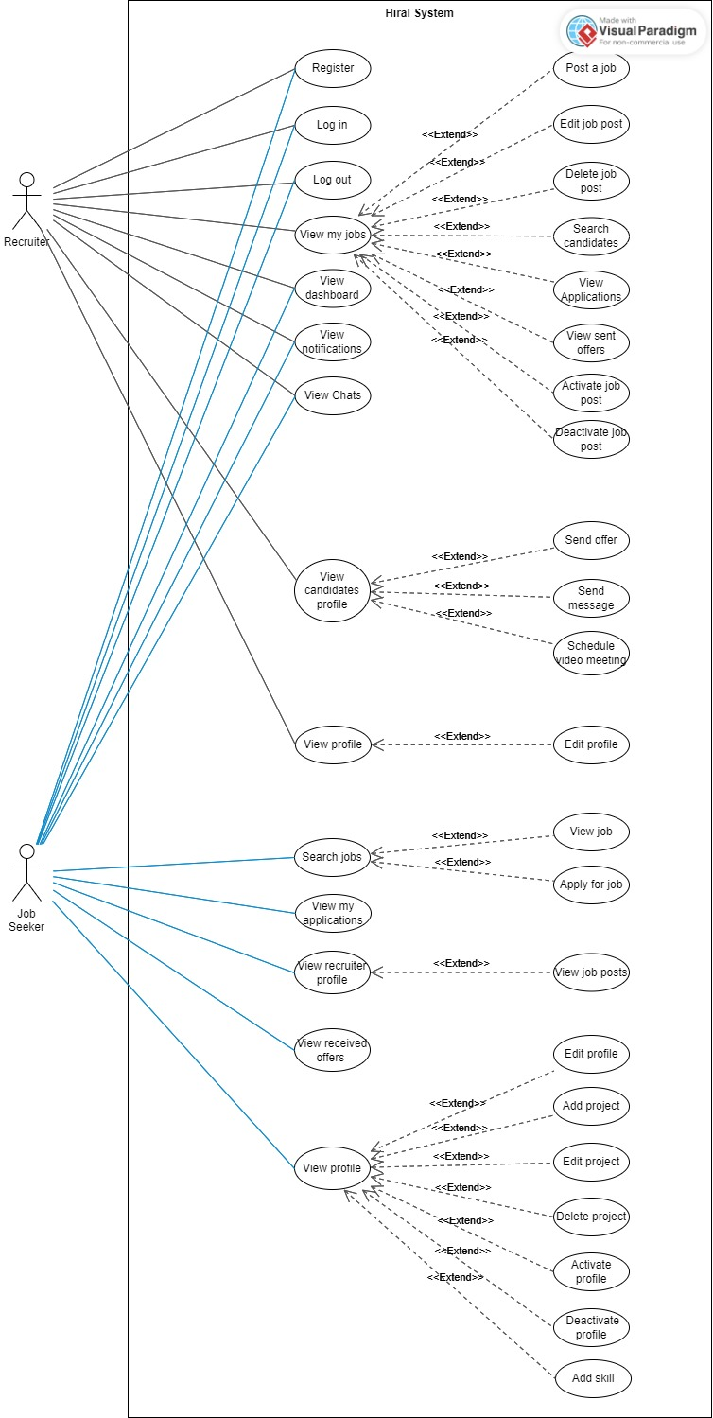

Figure - 4.3 Hiral use case

## Product Backlog

Table - 4.4 Product backlog

|  |  |  |  |  |  |
| --- | --- | --- | --- | --- | --- |
| ID | **PBIs** (User Stories) | Size | Type  (Feature, defect, technical work, knowledge acquisition) | Status  (To do, in progress, or Done) | Acceptance Criteria  (The conditions of satisfaction that must be met for that item to be accepted.) |
| 1 | As a job provider, I want to add a Job Post so that other users can know about available jobs. | 4 | Feature | Done | - As a job provider, if I go to the My Job page and click on Add Job Post, I will be redirected to a form page.  - As a job provider, if I don’t fill in a mandatory field, then I will receive an error message.  - As a job provider, if I complete the form correctly, I will be redirected to the My Job page, and my post will be saved to the.  - As a job provider, if I complete the form correctly, I will be redirected to the My Job page and my post will be saved to the database. |
| 2 | As a job provider, I want to activate my job posts so that other users can know about available jobs. | 3 | Feature | Done | - As a job provider, if I click on the Active button, my post will appear for users, and then the user will know if I have an available job. |
| 3 | As a job provider, I want to deactivate my job posts so that they don’t appear for users. | 3 | Feature | Done | - As a job provider, if I click on the Deactivate button, my post will not appear for employment. |
| 4 | As a job seeker, I want to be able to update my availability for job postings so that I receive offers only when I am available. | 4 | Feature | Done | - As a job seeker, if I register, then my status will be available.  - As a job seeker, if I open my profile and click available, then my status in the database will change to unavailable.  - As a job seeker, if I click the available button a second time, then my status will change to available in the database. |
| 5 | As a job seeker, I want to add my project so that I can display my work. | 4 | Feature | Done | - As a job seeker, if I open my profile and click on the add project button, I will be redirected to the add project form.  - As a job seeker, if I don’t fill a mandatory field, then I will receive an error message.  - As a job seeker, if I fill a field in the wrong format, I will receive an error message.  - As a job seeker, if I complete the form correctly, I will be redirected to my profile page and my project will be saved in the database. |
| 6 | As a job seeker, I want to edit my project so that I can make the adjustments I desire, | 4 | Feature | Done | - As a job seeker, if I open the view profile page and click on the Edit project then I will be able to edit my project. |
| 7 | As a job seeker, I want to delete my project so that I can remove my work that I don’t want displayed anymore. | 3 | Feature | Done | - As a job seeker, if I open my profile and click on the delete this project button, a confirmation message will appear.  - As a job seeker, if the confirmation message appeared and I clicked yes, then the project will be deleted from the database and my profile.  - As a job seeker, if I complete the delete project from the database, I will receive a message.  - As a job seeker, if the confirmation message appears and I click no, then I will continue the same page and the record will not be deleted from the database. |
| 8 | As a job seeker, I want to be able to add new skills to my skill set so that I can inform users about my new skills. | 3 | Feature | Done | - As a job seeker, if I upload my new/updated CV, then my new skills will be extracted.  - As a job seeker, if my new skills are extracted, they will be added to the database.  - As a job seeker, if my new skills are extracted, I will be redirected to my Profile page.  - As a job seeker, if I am redirected to my Profile page, I will see my new skills in the Skills section. |
| 9 | As a job seeker I want to search available jobs that match my skill set so that I apply to the suitable job offers. | 4 | Feature | To do | - As a job seeker, if I open the search jobs and click on apply for a job, a job application will be sent to the job provider. |
| 10 | As a job provider, I want to add job offers so that I can inform other users about available jobs. | 5 | Feature | To do | - As a job provider, if I open the job offers page and click on the add button, I will be redirected to an upload file page.  - As a job provider, if I upload a file successfully, I will receive a successful message, and my offer will be saved to the database.  - As a job provider, if I upload a file unsuccessfully, I will receive an alert message and continue on the same page. |
| 11 | As a job provider I want to search available employees who match the job description in a short time so that I don’t waste much time and effort. | 5 | Feature | To do | - As a job provider, if I open the job offers page and click on the job offer, then I will find only the available employees that match the job description. |
| 12 | As a job provider, I want to view an analytical dashboard so that I can know the job postings that attract the most applicants. | 6 | Feature | To do | - As a job provider, if I open my home page, I will view the analytical dashboard.  - As a job provider, if I view the dashboard, then I will know the job postings that attract the most applicants. |
| 13 | As a job provider, I want to view an analytical dashboard so that I can know the sources that generate the most qualified candidates. | 6 | Feature | To do | - As a job provider, if I open my home page, I will view the analytical dashboard.  - As a job provider, if I view the dashboard, then I will know the sources that generate the most qualified candidates. |
| 14 | As a job seeker, I want to view an analytical dashboard so that I can know the similarity between my resume and the job postings in my field. | 6 | Feature | To do | - As a job seeker, if I open my home page, I will view the analytical dashboard.  - As a job seeker, if I view the dashboard, then I will know the similarity between my resume and the job postings in my field. |
| 15 | As a job provider, I want contact with users I might hire via video so we can discuss the job offer. | 7 | Feature | To do | - As a job provider, if I click on the video button, then a video channel will be established. |
| 16 | As a job provider, I want contact with users I might hire via chat so we can discuss the job offer. | 5 | Feature | To do | - As a job provider, if I click on the chat button, then a chat channel will be established. |
| 17 | As a job seeker, I want to view an analytical dashboard so that I can compare the similarity of my resume with the similarity of other resumes in the same category. | 6 | Feature | To do | - As a job seeker, if I open my home page, I will view the analytical dashboard.  - As a job seeker, if I view the dashboard, then I will be able to compare the similarity of my resume with the similarity of other resumes in the same category. |
| 18 | As a job provider, I want to view the received applications so that I can see who has applied for the position. | 5 | Feature | To do | - As a job provider, if I have opened the job offers page and clicked on any job offer, I will be redirected to this job offer page.  - As a job provider, if I am redirected to the job offer page, then all applications in this job offer will be displayed. |
| 19 | As a job provider I want to be notified when suitable candidates are available for my job description | 5 | Feature | To do | - As a job provider, if there are suitable candidates available, then I will be notified. |
| 20 | As a job seeker, I want to view offers so that I can see job opportunities that match my skill set. | 6 | Feature | To do | - As a job seeker, if I upload my CV, I will redirect to page content job offers that match my skill set. |
| 21 | As a job seeker I want to be able to save the job notifications that suit my qualifications for further pursuits. | 5 | Feature | To do | - As a job seeker, if there are job notifications that suit my qualifications, then I will be able to save these notifications. |
| 22 | As a job seeker, I want to receive a notification when there’s a job opportunity that matches my skill set so that I can apply faster. | 3 | Feature | To do | - As a job seeker, if there is any job offer that matches my skill set, then I will receive notification. |
| 23 | As a job provider, I want to be notified when there are suitable candidates for my job postings. | 4 | Feature | To do | - As a job provider, if there are suitable candidates for my job postings, then I will be notified. |
| 24 | As a job seeker I want to be able to save the job notifications that suit my qualifications for further pursuits. | 5 | Feature | To do | - As a job seeker, if there are job notifications that suit my qualifications, then I will be able to save these notifications. |
| 25 | As a job provider, I want to be able to edit my profile so that I can update my information. | 4 | Feature | To do | - As a job provider, if I open my profile and click on the edit button, I will be able to edit my profile.  - As a job provider, if I edit my profile and click on the save button, I will receive a successful message.  - As a job provider, if I edit my profile, click on the save button, and my edit doesn’t save, I will receive an alert message. |
| 26 | As a job provider, I want to edit job offers so that I can update job information. | 4 | Feature | To do | - As a job provider, if I opened the job offers page and clicked on the update button, I would be redirected to this file page.  - As a job provider, if I upload an updated file successfully, I will receive a successful message, and my offer will be updated in the database.  - As a job provider, if I upload an updated file unsuccessfully, I will receive an alert message and continue on the same page. |
| 27 | As a job provider, I want to delete job offers so that I can remove the job offer. | 3 | Feature | To do | - As a job provider, if I open the job offers page and click on the delete button, a confirmation message will appear.  - As a job provider, if the confirmation message appeared and I clicked yes, then the job offer will be deleted from the database and job offers page.  - As a job provider, if I complete the delete job offer from the database, I will receive a message.  - As a job provider, if the confirmation message appears and I click no, then I will continue the same page and the record will not be deleted from the database. |
| 28 | As a job seeker, I want to edit my profile so that I can update my information. | 4 | Feature | Done | - As a job seeker, if I open my profile and click on the edit button, I will be able to edit my profile.  - As a job seeker, if I edit my profile and click on the save button, I will receive a successful message.  - As a job seeker, if I edit my profile, click on the save button, and my edit doesn’t save, I will receive an alert message. |
| 29 | As a job provider, I want to be able to register on the website so that I have my own account. | 5 | Feature | Done | - As a job provider, if I visit the website and click on the register button, I will be redirected to the registration form page.  - As a job provider, if I don’t fill in a mandatory field, then I will receive an error message.  - As a job provider, if I fill a field in the wrong format, I will receive an error message.  - As a job provider, if I complete the form correctly, I will be redirected to the home page. |
| 30 | As a job seeker, I want to be able to register on the website so that I can have my own account. | 5 | Feature | Done | - As a job seeker, if I visit the website and click on the register button, I will be redirected to the registration form page.  - As a job seeker, if I don’t fill a mandatory field, then I will receive an error message.  - As a job seeker, if I fill a field in the wrong format, I will receive an error message.  - As a job seeker, if I complete the form correctly, I will be redirected to the home page. |
| 31 | As a job provider, I want to be able to login so that I can access my account. | 5 | Feature | Done | - As a job provider, if I visit the website and click on the login button, I will be redirected to the login page.  - As a job provider, if I don’t fill a mandatory field, then I will receive an error message.  - As a job provider, if I fill a field in the wrong format, I will receive an error message.  - As a job provider, if I enter the wrong credentials, then I will receive an error message.  - As a job provider, if I complete the form correctly, I will be redirected to the home page. |
| 32 | As a job seeker I want to be able to login, so that I can access to my account | 5 | Feature | Done | - As a job seeker, if I visit the website and click on the login button, I will be redirected to the login page.  - As a job seeker, if I don’t fill a mandatory field, then I will receive an error message.  - As a job seeker, if I fill a field in the wrong format, I will receive an error message.  - As a job seeker, if I enter the wrong credentials, I will receive an error message.  - As a job seeker, if I complete the form correctly, I will be redirected to the home page. |
| 33 | As a Job seeker I want to log out of my account so that I can leave the account. | 3 | Feature | Done | - As a job seeker, if I click on the log out button, then a confirmation message will appear.  - As a job seeker, if the confirmation message appeared and I pressed yes, then I will be redirected to the home page.  - As a job seeker, if the confirmation message appeared and I pressed no, then I will continue to be logged in.  - As a job seeker, if the confirmation message appears and I press yes, I will leave my account. |
| 34 | As a provider, I want to log out of my account so that I can get myself off the website. | 3 | Feature | Done | - As a job provider, if I click on the log out button, then a confirmation message will appear.  - As a job provider, if the confirmation message appeared and I pressed yes, then I will be redirected to the home page.  - As a job provider, if the confirmation message appeared and I pressed no, then I will continue to be logged in.  - As a job provider, if the confirmation message appears and I press yes, then I will leave my account. |
| Non-functional | | | | | |
| 35 | As a user, I want the job search to target the best results 70% of the time, and reasonable 80% of the time. (User-friendliness) | — | Feature | — |  |
| 36 | As a user, I want the application’s response time to be between 3 to 30 seconds given a good internet connection so that I don't become annoyed and try another application. (Performance) | — | Feature | — |  |
| 37 | As a user, I want the application to be available 95% of the time I try to access it, so that I don't get frustrated and find another application to use. (Availability) | — | Feature | — |  |
| 38 | As a user, I want the application to be secured by authenticating user email and password so that unauthorized users cannot log in to the application. (Security) | — | Feature | — | - |
| 39 | As a user, I want to use all the application’s features without having any training so that it does not have to take me a lot of time to learn how to use it. (Usability) | — | Feature | — | - |

In our backlog, we have some user stories (9 - 27) in "To do" status. These user stories will be done in release 2.



CHAPTER 5

System

Design

# System Design

## Architectural Diagram

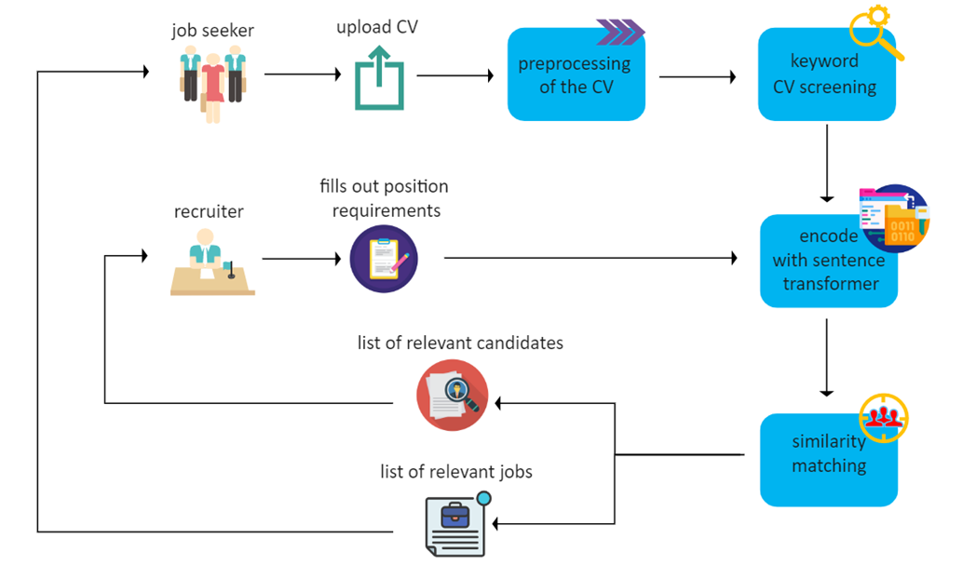

Figure - 5.1 Hiral system architecture

Here is a high-level overview of the architecture:

The job seeker would interact with the system through a user interface, which would allow them to enter their resume by category and submit it for processing then the text would be screened for keywords that are relevant to the category next text would be encoded using sentence transformers, which are deep learning models that can encode sentences and words into high-dimensional vectors to measure cosine similarity between the encoded resume and the encoded job offers. After that the cosine similarity between the encoded resume and the encoded job offers would be calculated. The resulting value would be a measure of the cosine of the angle between the two vectors and would indicate the degree of similarity between the resume and the job offer. The resumes would be matched with the job offers based on their cosine similarity scores, highest scores would be considered the best matches for the job offers.

Overall, this architecture would involve several components working together to preprocess, screen, encode, and match resumes with job offers. By using advanced natural language processing techniques, such as sentence transformers and cosine similarity, the system would be able to identify the best matches between job seekers and job offers, making the recruitment process more efficient and effective.

## Class Diagram /DFD

Link for higher quality: [hiral class diagram.pdf](https://drive.google.com/file/d/1j6qL9afoDnFOHARRzb6eR0cGl1aLN6Pa/view?usp=sharing)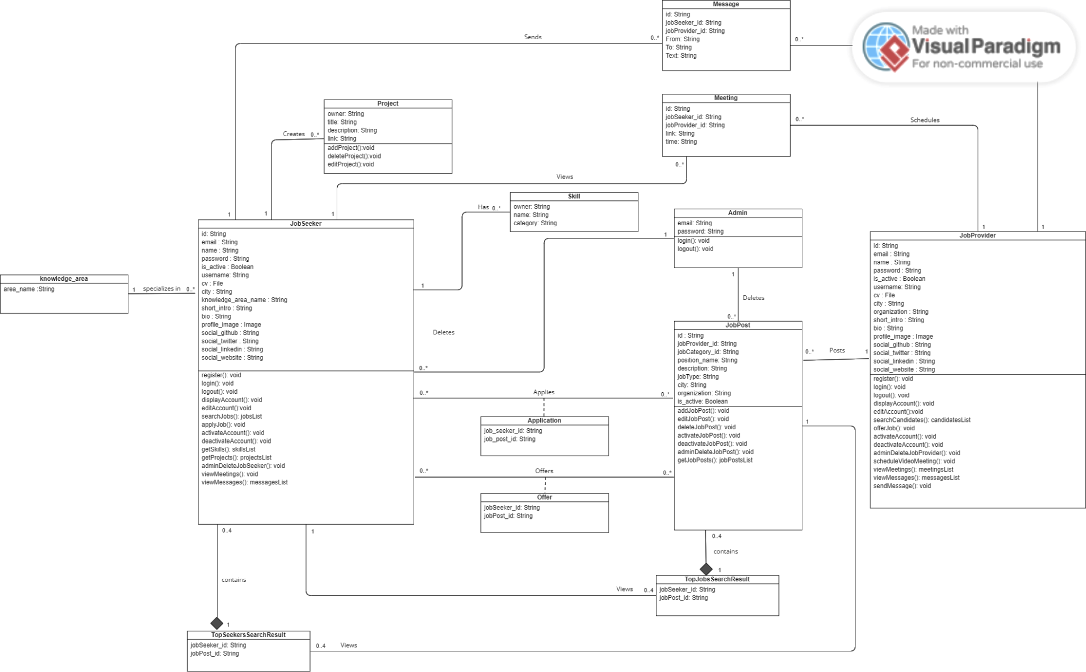

Figure - 5.2 Class Diagram

## Component Level Design

Register:

Classification: function

Definition: the user will be able to register to the website

Constrains:

Pre-condition: The user is not already registered to the website

Post-condition: The system registers the user to the website

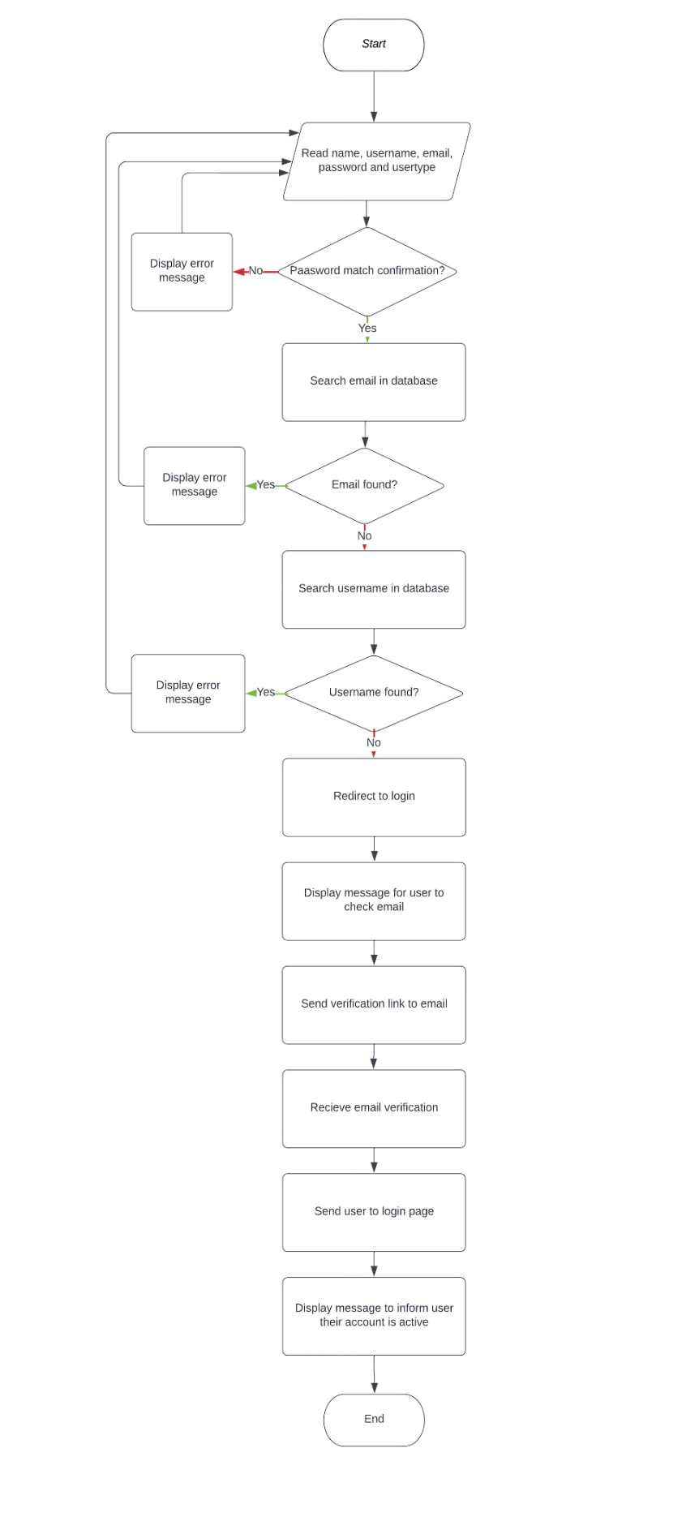Flowchart:

Figure - 5.3 Register Flowchart

Edit account:

Classification: function

Definition: the user will be able Edit account information

Constrains:

Pre-condition: The user is logged in

Post-condition: The system updates user’s account information with the changes they made

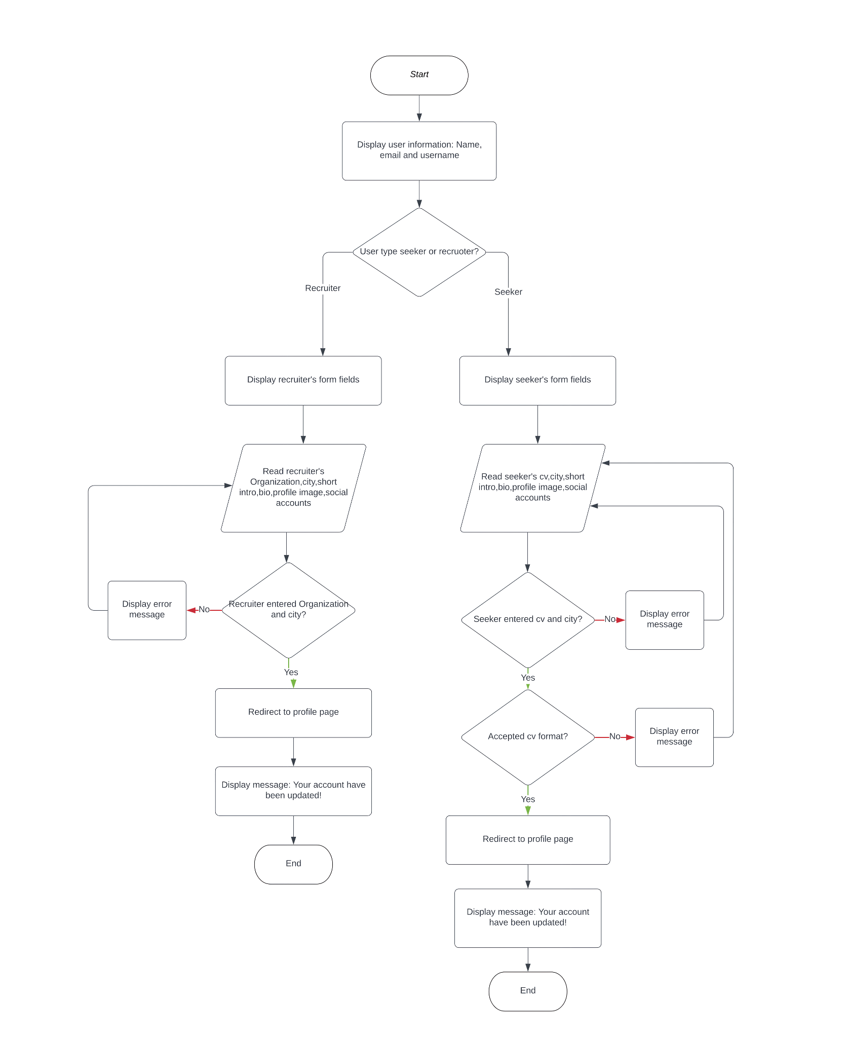Flowchart:

Figure - 5.3 Edit account Flowchart

Seeker set account to active:

Classification: function

Definition: the seeker will be able to set their account to active so that their profile will appear to the job recruiters when they search for candidate

Constrains:

Pre-condition: The seeker is logged in.

Post-condition: The system set the is_active field to true

Pseudocode:

1.BEGIN

2.When the seeker is on profile page:

3.Display a check button labeled "Activate"

4.IF the seeker clicks the "Activate" button:

5.Set the "is_active" field in the database to "True"

6.IF the seeker unclicks the "Activate" button:

7.Set the "is_active" field in the database to "False"

8. END

Seeker add, edit and delete project:

Classification: function

Definition: the seeker will be able to Add, edit and delete their projects so that the recruiter can view them when they visit their page

Constrains:

Pre-condition: The seeker is logged in.

Post-condition: The system Adds, modifies and deletes projects from the seeker’s profile

Pseudocode:

1-BEGIN

2-When the seeker is on profile page:

3-Display section “past projects”

4-FOR each project in the seeker’s past projects:

5-Display the project’s title and description and link

6-IF the seeker clicks the “Add project” button:

7-Display a form to add a new project with fields for the project's inforamtion

8-IF the seeker submits the form with valid data:

9-Add the new project to the seeker’s past projects

10-IF the seeker clicks the “Edit” button next to the project:

11-Display a form to edit the project with field for the project’s information

12-IF the seeker submits the form with valid data:

13-Update the project with the new data

14-IF the seeker clicks the “Delete” button next to the project:

15-Display a confirmation message to the seeker

16-IF the seeker confirms the deletion:

17-Remove the project from the seeker’s past projects

18-END

Recruiter add, edit and delete job post:

Classification: function

Definition: the recruiter will be able to Add, edit and delete their job posts

Constrains:

Pre-condition: The recruiter is logged in.

Post-condition: The system Adds, modifies and deletes job posts from the recruiter’s “My jobs” page

Pseudocode:

1-BEGIN

2-When the recruiter is on “My jobs” page:

3-Display “Add job post” button

3-Display recruiter’s job posts

4-FOR each job post:

5-Display the job post’s title and description and search button and view button

6-IF the recruiter clicks the “Add job post” button:

7-Display a form to add a new job post with fields for the job post's information

8-IF the recruiter submits the form with valid data:

9-Add the new job post to the recruiter’s job posts

10-IF the recruiter clicks the “Edit” button next to the job post:

11-Display a form to edit the job post with field for the job post’s information

12-IF the recruiter submits the form with valid data:

13-Update the job post with the new data

14-IF the recruiter clicks the “Delete” button next to the job post:

15-Display a confirmation message to the recruiter

16-IF the recruiter confirms the deletion:

17-Remove the job post from the recruiter’s job posts

18-END

Recruiter search for employees:

Classification: function

Definition: the recruiter will be able to search for qualified employees for a specific job post based on job description

Constrains:

Pre-condition: The recruiter is logged in and the job post status is active

Post-condition: The system suggests qualified candidates for the job post based on job description

Pseudocode:

1-BEGIN

2-When the recruiter is on “My jobs” page:

3-Display recruiter’s job posts

4-FOR each job post:

5-Display the job post’s title and description and search button and view button

6-IF the recruiter clicks the search button:

7-Display message “Searching for candidates”

8-Redirect recruiter to the home page

9-Display the qualified candidates’ profiles to recruiter

10-Display message “Qualified candidates for “Job title””

11-END

Seeker Receive Job offers:

Classification: function

Definition: the seeker will receive job offers based on their set of skills

Constrains:

Pre-condition: The seeker is logged in and the seeker status is active

Post-condition: The system suggests appropriate job offers based on the seeker’s skills

Pseudocode:

1-BEGIN

2-IF the system found new job post that correspond to seeker’s skills:

3-SEND notification message to seeker in website

4-SEND notification message to seeker in email

5-When the seeker is on “activities” page:

6-Display section “Received offers”

7-Display all job offers with the new job offer

8-END

View analytical dashboard:

Classification: function

Definition: the seeker and recruiter will be able to view their analytical dashboard to monitor their progress in finding candidates/ getting job offers

Constrains:

Pre-condition: The user is logged in

Post-condition: The system Displays the analytical dashboard to user

Pseudocode:

1-BEGIN

2-IF user type is recruiter:

3-WHEN recruiter is on profile page:

4-Display recruiter’s Dashboard

5-IF user type is seeker:

6-WHEN seeker is on “Dashboard” page:

7-Display seeker’s Dashboard

8-END

## Data Design

### Data Models

Describe the data structure and contents.

#### ER Diagram

Figure - 5.4.1.1 ER Diagram

#### Relational Schema

Project {id, owner, title, description, link}

Primary Key: id

Skill {id, owner, name, category}

Primary Key: id

JobSeeker {id, email, name, password, is_active, username, cv, city, knowledge_area_name, short_intro, bio, profile_image, social_github, social_twitter, social_linkedin, social_website}

Primary Key: id

Knowledge_area {id, area_name}

Primary Key: id

Meeting {id, jobSeeker_id, jobProvider_id, link, time}

Primary Key: id

Foreign Key: jobSeeker_id, jobProvider_id

Message {id, jobSeeker_id, jobProvider_id, From, To, Text}

Primary Key: id

Foreign Key: jobSeeker_id, jobProvider_id

Admin {email, password}

Application {job_seeker_id, job_post_id}

Foreign Key: job_seeker_id, job_post_id

Offer {job_seeker_id, job_post_id}

Foreign Key: job_seeker_id, job_post_id

JobPost {id, jobProvider_id, jobCategory_id, position_name, description, jobType, city, organization, is_active}

Primary Key: id

Foreign Key: jobProvider_id, jobCategory_id

JobProvider {id, email, name, password, is_active, username, cv, city, organization, short_intro, bio, profile_image, social_github, social_twitter, social_linkedin, social_website}

Primary Key: id

TopSeekersSearchResult {id, jobSeeker_id, jobPost_id}

Primary Key: id

Foreign Key: jobSeeker_id, jobPost_id

TopJobsSearchResult {jobSeeker_id, jobPost_id, category}

Foreign Key: jobSeeker_id, jobPost_id

#### Data Dictionary

Table - 5.4.1.3 Data dictionary

|  |  |  |  |  |  |  |  |  |
| --- | --- | --- | --- | --- | --- | --- | --- | --- |
| Entity | Attribute | Description | Data  Type | Length | Req. | Multi-  valued | Default  value | PK |
| Project | id | Project's id | int | 100 | Y |  |  | Y |
| owner | Project's owner | var | 100 | Y |  |  |  |
| title | Project's title | var | 150 | Y |  |  |  |
| description | Project's description | text | 50,000 |  |  |  |  |
| link | Project's link | var | 200 | Y |  |  |  |
| Skill | id | Skill's id | int | 1,000 | Y |  |  | Y |
| owner | Skill's owner | var | 100 | Y |  |  |  |
| name | Skill's name | var | 100 | Y |  |  |  |
| category | Skill's category | var | 100 | Y |  |  |  |
| JobSeeker | id | Seeker's id | var | 1,000 | Y |  |  | Y |
| email | Seeker's email | var | 150 | Y |  |  |  |
| name | Seeker's name | var | 100 | Y |  |  |  |
| password | Seeker's account password | var | 50 | Y |  |  |  |
| is_active | Seeker availability | bool | 1 | Y |  | Y |  |
| username | Seeker's username | var | 100 | Y |  |  |  |
| cv | Seeker's CV | file | 10MB | Y |  |  |  |
| city | Seeker's city | var | 200 | Y |  |  |  |
| knowledge_area_name | Seeker's knowledge area | var | 150 | Y |  |  |  |
| short_intro | Short intro about seeker | var | 200 |  |  |  |  |
| bio | Seeker's bio | text | 100,000 |  |  |  |  |
| profile_image | Seeker's profile image | img | 1MB |  |  |  |  |
| social_github | Seeker's GitHub link | var | 200 |  |  |  |  |
| social_twitter | Seeker's Twitter link | var | 200 |  |  |  |  |
| social_linkedin | Seeker's LinkedIn link | var | 200 |  |  |  |  |
| social_website | Seeker's website link | var | 200 |  |  |  |  |
| Knowledge_area | id | Knowledge_area's id | int | 1,000 | Y |  |  | Y |
| area_name | Knowledge_area's name | var | 150 | Y |  |  |  |
| Meeting | id | Meeting's id | var | 10,000 | Y |  |  | Y |
| jobSeeker_id | Seeker's id | var | 1,000 | Y |  |  |  |
| jobProvider_id | Provider's id | var | 1,000 | Y |  |  |  |
| link | Meeting's link | var | 200 | Y |  |  |  |
| time | Meeting's time | var | 5 | Y |  |  |  |
| Message | id | Meeting's id | var | 10,000 | Y |  |  |  |
| jobSeeker_id | Seeker's id | var | 1,000 | Y |  |  |  |
| jobProvider_id | Provider's id | var | 1,000 | Y |  |  |  |
| From | The sender | var | 100 | Y |  |  |  |
| To | The receiver | var | 100 | Y |  |  |  |
| Text | Message's text | text | 50,000 | Y | Y |  |  |
| Admin | email | Admin's email | var | 150 | Y |  |  |  |
| password | Admin's account password | var | 50 | Y |  |  |  |
| Application | job_seeker_id | Seeker's id | var | 1,000 | Y |  |  |  |
| job_post_id | Provider's id | var | 1,000 | Y |  |  |  |
| Offer | job_seeker_id | Seeker's id | var | 1,000 | Y |  |  |  |
| job_post_id | Provider's id | var | 1,000 | Y |  |  |  |
| JobPost | id | Post's id | var | 1,000 | Y |  |  | Y |
| jobProvider_id | Provider's id | var | 1,000 | Y |  |  |  |
| jobCategory_id | Category's id | var | 1,000 | Y |  |  |  |
| position_name | Job's position name | var | 500 | Y |  |  |  |
| description | Job's description | text | 50,000 | Y |  |  |  |
| jobType | Type of job | var | 100 | Y |  |  |  |
| city | Job location | var | 100 | Y |  |  |  |
| organization | Job organization | var | 500 | Y |  |  |  |
| is_active | Job availability | bool | 1 | Y |  | Y |  |
| JobProvider | id | Provider's id | var | 1,000 | Y |  |  | Y |
| email | Provider's email | var | 150 | Y |  |  |  |
| name | Provider's name | var | 100 | Y |  |  |  |
| password | Provider's account password | var | 50 | Y |  |  |  |
| is_active | Provider availability | bool | 1 | Y |  | Y |  |
| username | Provider's username | var | 100 | Y |  |  |  |
| cv | Provider's CV | file | 10MB |  |  |  |  |
| city | Provider's city | var | 200 | Y |  |  |  |
| organization | Provider's organization | var | 150 | Y |  |  |  |
| short_intro | Short intro about provider | var | 200 | Y |  |  |  |
| bio | Provider's bio | text | 100,000 |  |  |  |  |
| profile_image | Seeker's profile image | img | 1MB |  |  |  |  |
| social_github | Provider's GitHub link | var | 200 |  |  |  |  |
| social_twitter | Provider's Twitter link | var | 200 |  |  |  |  |
| social_linkedin | Provider's LinkedIn link | var | 200 |  |  |  |  |
| social_website | Provider's website link | var | 200 |  |  |  |  |
| Top Seekers Search Result | id | TopSeekersSearchResult's id |  |  | Y |  |  | Y |
| jobSeeker_id | Seeker's id | var | 1,000 | Y |  |  |  |
| jobPost_id | Provider's id | var | 1,000 | Y |  |  |  |
| TopJobs  Search  Result | jobSeeker_id | Seeker's id | var | 1,000 | Y |  |  |  |
| jobPost_id | Provider's id | var | 1,000 | Y |  |  |  |
| category | Job category | var | 150 | Y |  |  |  |

### Data Collection and Preparation

In order to test the Hiral system, we are planning to collect public CVs online and from our friends. This will help us to evaluate the effectiveness of the keyword-scanning algorithm and ensure that the app is accurately matching job seekers with relevant job postings.

To collect public CVs for testing, we'll search for CVs that are publicly available on job boards and social media platforms that allow us to use them. We'll make sure we follow any rules and obtain permission where necessary.

For CVs from our friends, we will reach out to them and ask for permission to use their CVs in our testing process. We will ensure that their personal information is kept confidential and that their CVs are only used for testing purposes.

Once we have collected a sufficient number of CVs, we will run them through the keyword-scanning algorithm and evaluate the results.

To improve the accuracy of the keyword-scanning algorithm, we preprocessed job seekers' CVs using a tokenizer. This involved breaking down the text into individual tokens, which were then matched against relevant keywords and phrases in our dictionary.

We use a dictionary in our keyword-scanning that contains relevant skills and qualifications to match them with job seekers' CVs. The algorithm scans through the CVs, identifies the matching skills and qualifications. By using a dictionary to guide the keyword-scanning process, we ensure that the algorithm is accurate and efficient in identifying the most relevant skills and qualifications for each job posting.

When a recruiter posts a job, we use an NLP model to automatically extract keywords, and update our dictionary with any new terms that are not already included. The administrators must approve any newly added keywords. Additionally, if a job seeker uses keyword-scanning but some relevant skills are not detected, they are permitted to manually add those skills to the dictionary. This approach enables us to continuously improve the accuracy and efficiency of the job matching process by ensuring that our system is always up to date with the latest skills and qualifications in demand.

By preprocessing the CVs in this way, we were able to more accurately identify and highlight the most relevant skills and qualifications mentioned in the CVs.

We will also manually review the matches to ensure that they are accurate and relevant. Overall, collecting public CVs online and from our friends will help us to thoroughly test the job search app system and ensure that it is functioning as intended.

## Interface Design

* Job seeker navigation hierarchy

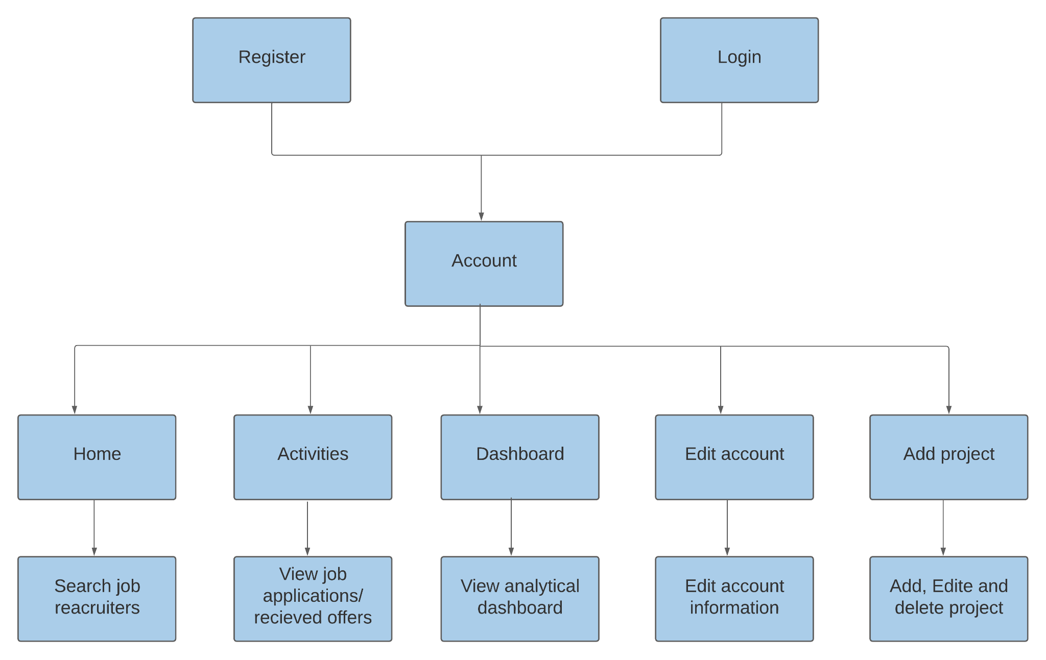

Figure - 5.5 Seeker navigation hierarchy

* Job recruiter navigation hierarchy

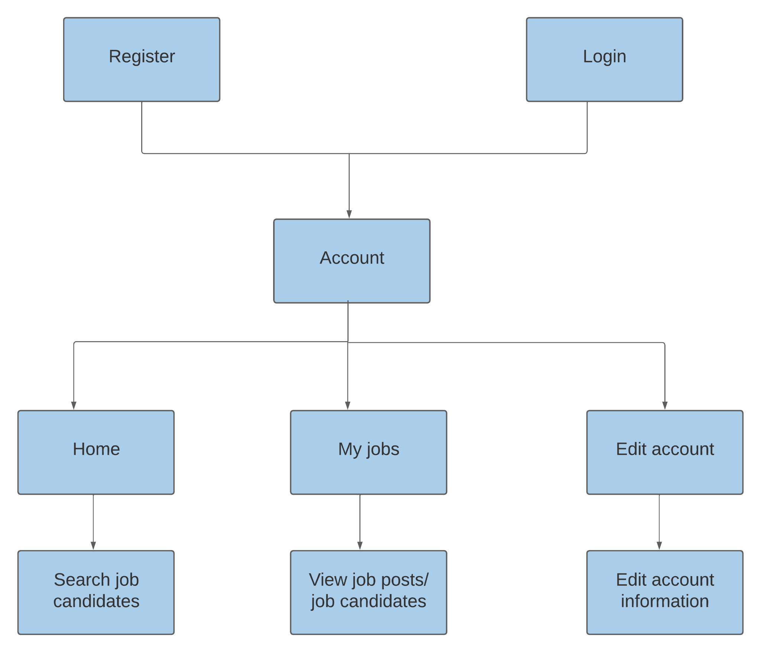

Figure - 5.5 Recruiter navigation hierarchy

* UX guidelines incorporated while designing our interface:

1. Visibility in system status.
2. Error prevention.
3. Simplify navigation.
4. Make relevant information easy to find.
5. Use familiar fonts.

* User Interfaces

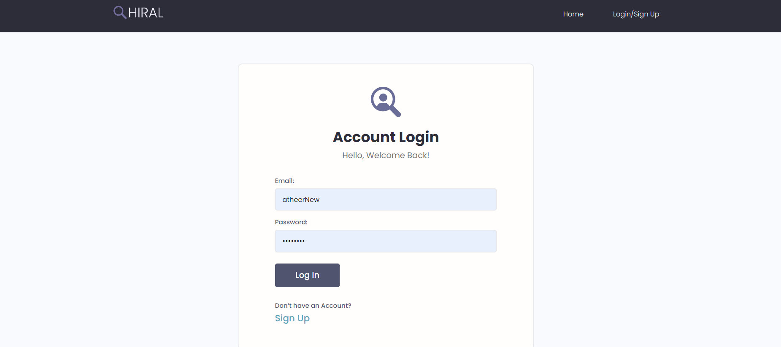

Figure - 5.5 Login interface

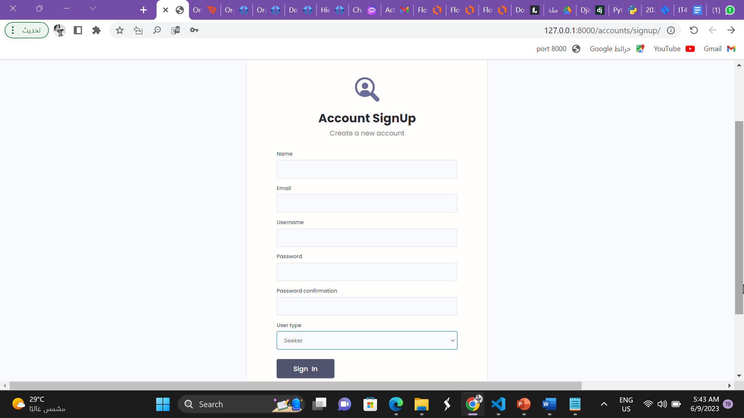

Figure - 5.5 Signup interface

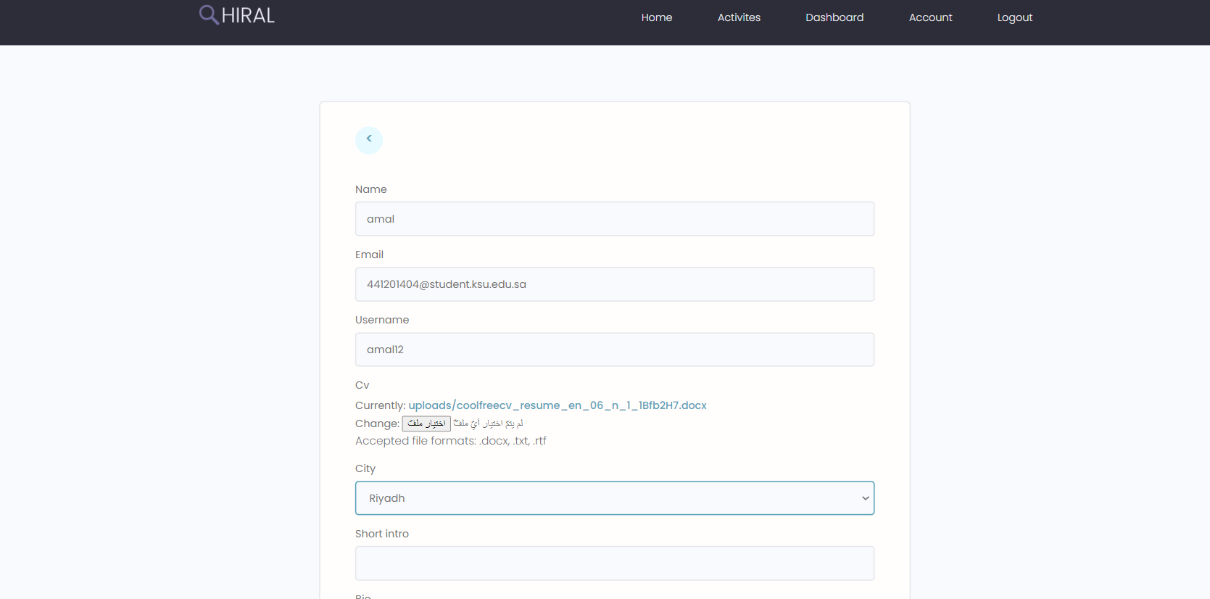

Figure - 5.5 Seeker Edit account interface (a)

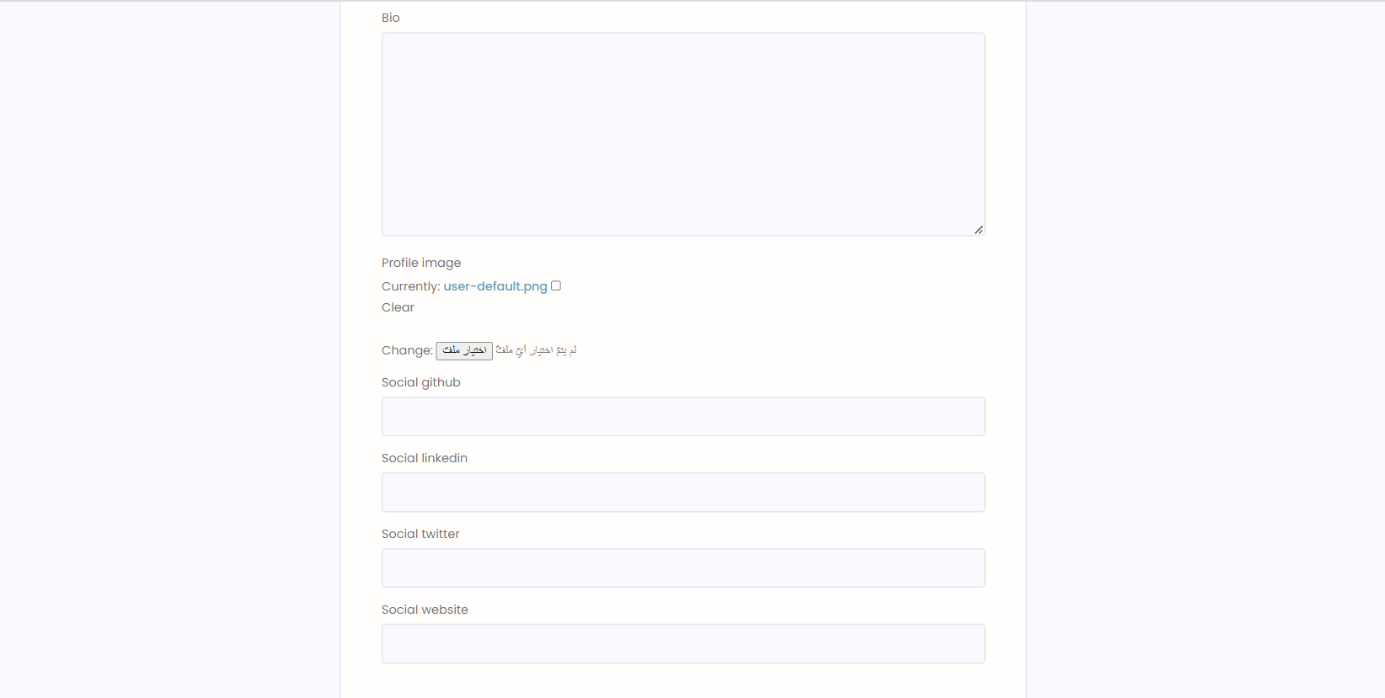

Figure - 5.5 Seeker Edit account interface (b)

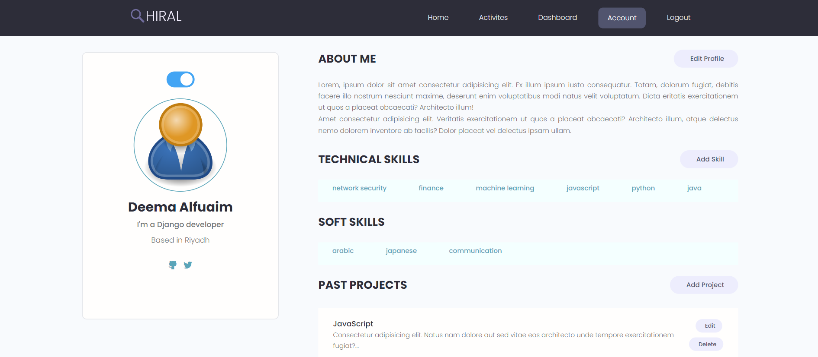

Figure - 5.5 Seeker profile interface

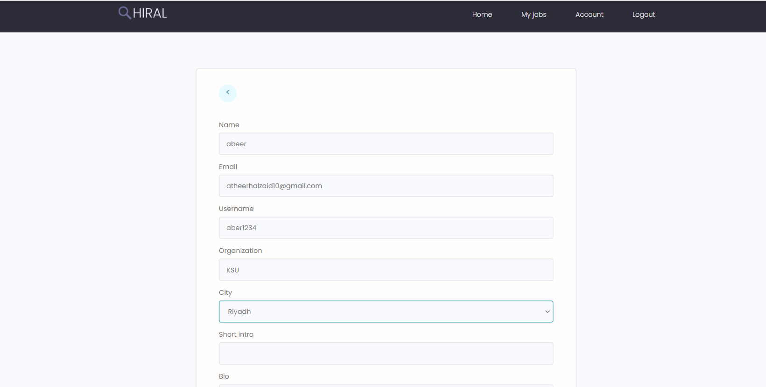

Figure - 5.5 Recruiter Edit account interface (a)

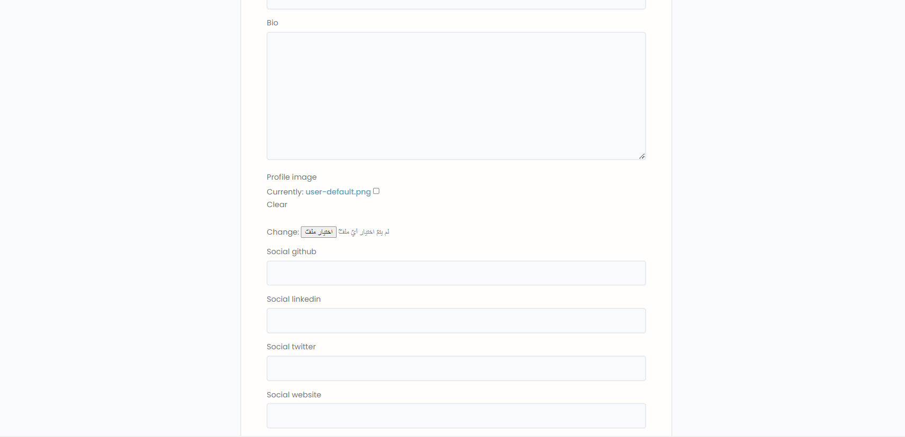

Figure – 5.5 Recruiter Edit account interface (b)

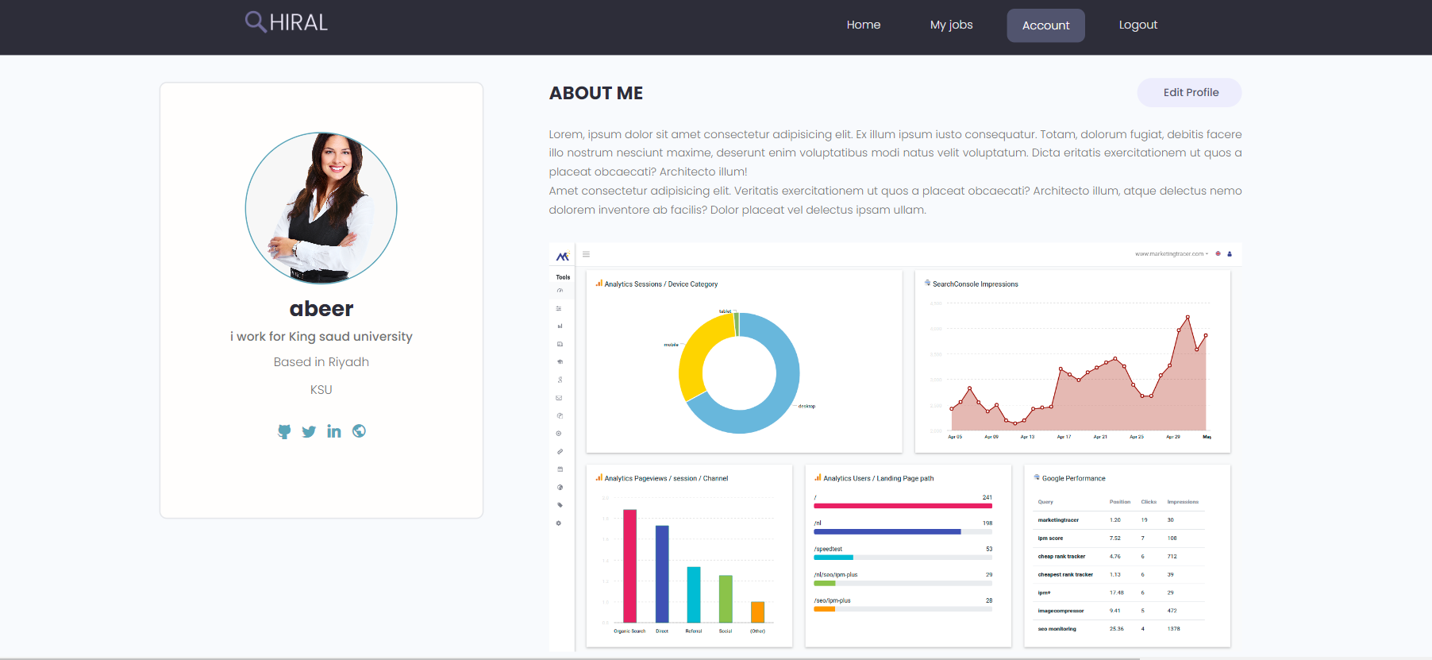

Figure - Recruiter profile interface

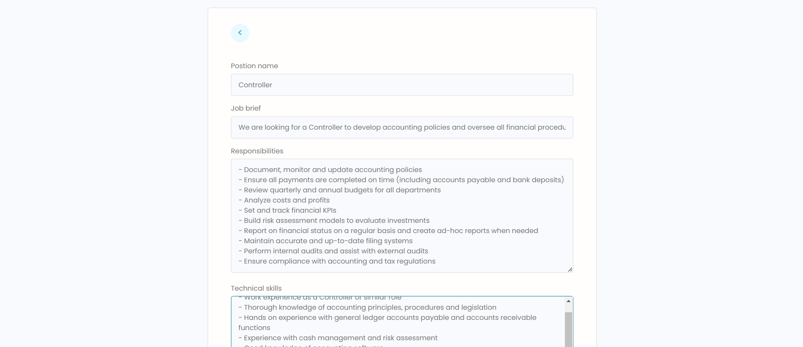

Figure - 5.5 Add job post interface (a)

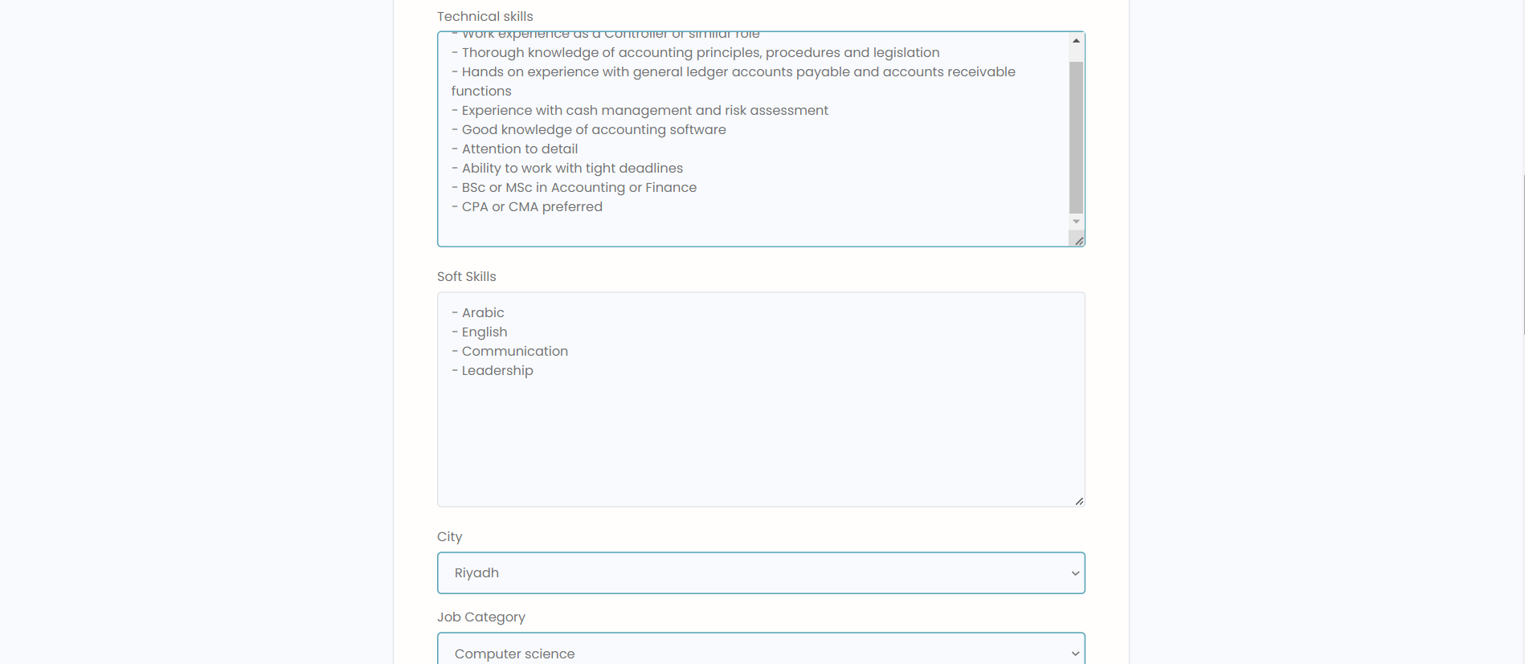

Figure - 5.5 Add job post interface (b)

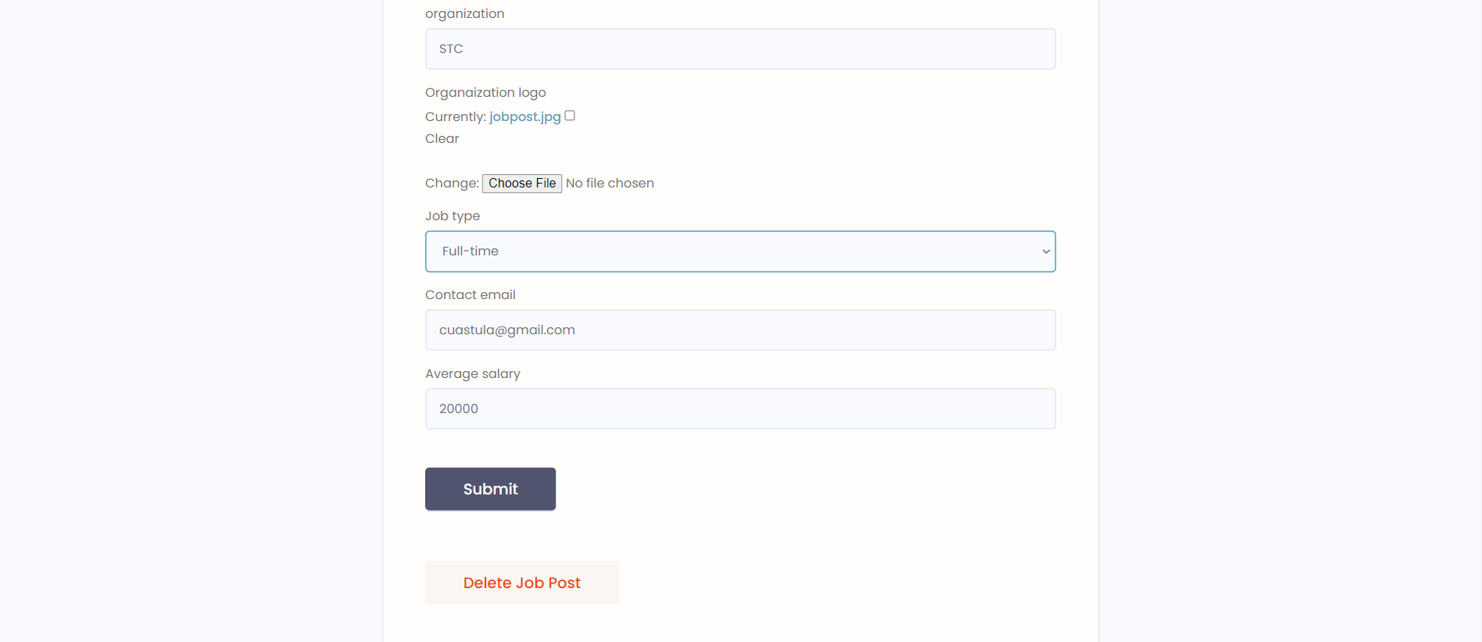

Figure - 5.5 Add job post interface (c)

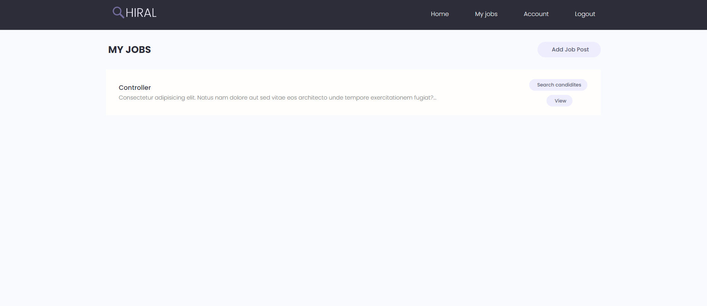

Figure - job posts interface

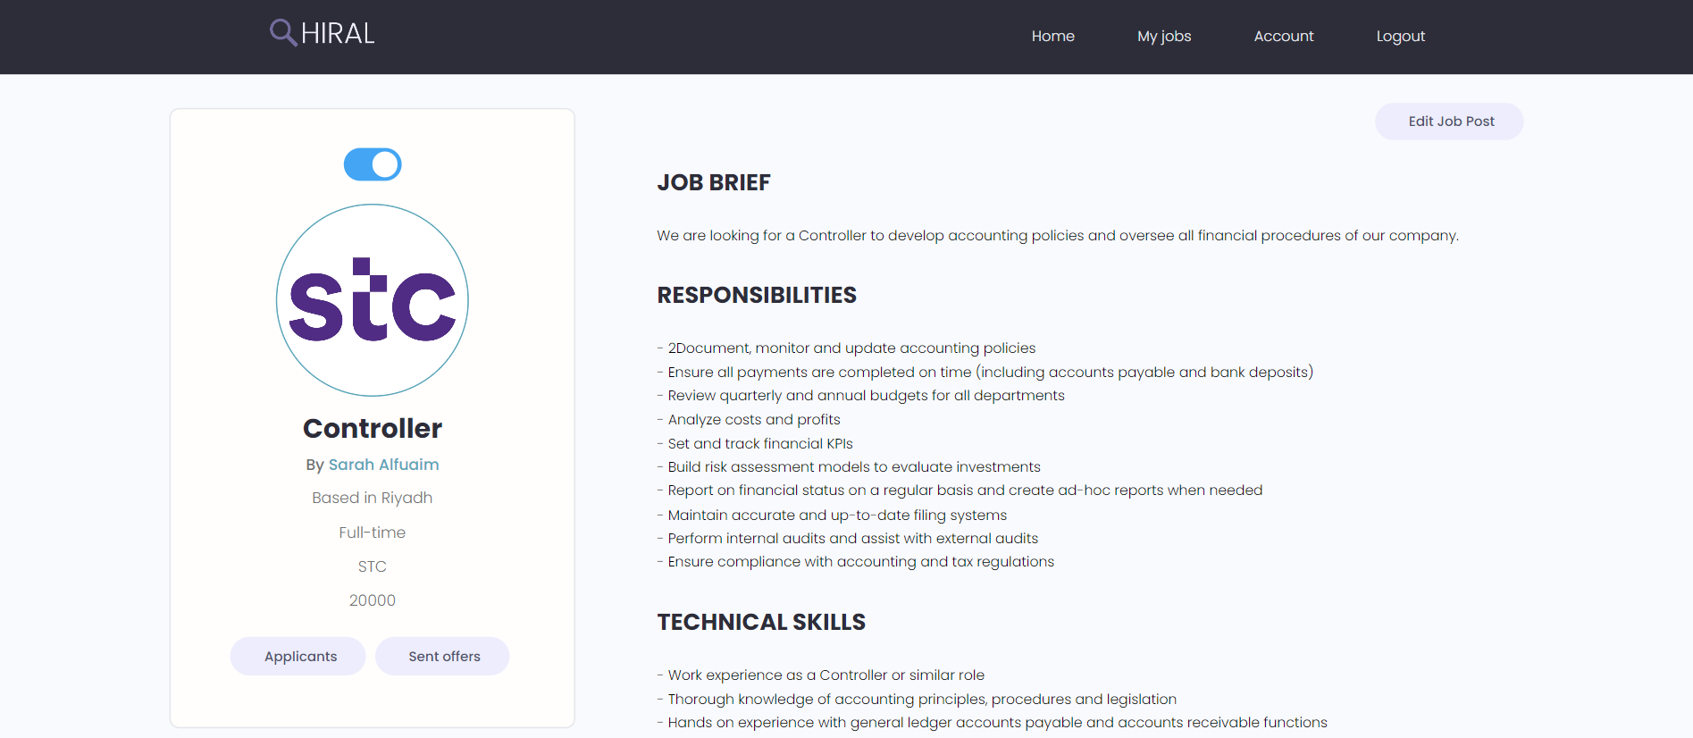

Figure - 5.5 job post interface (a)

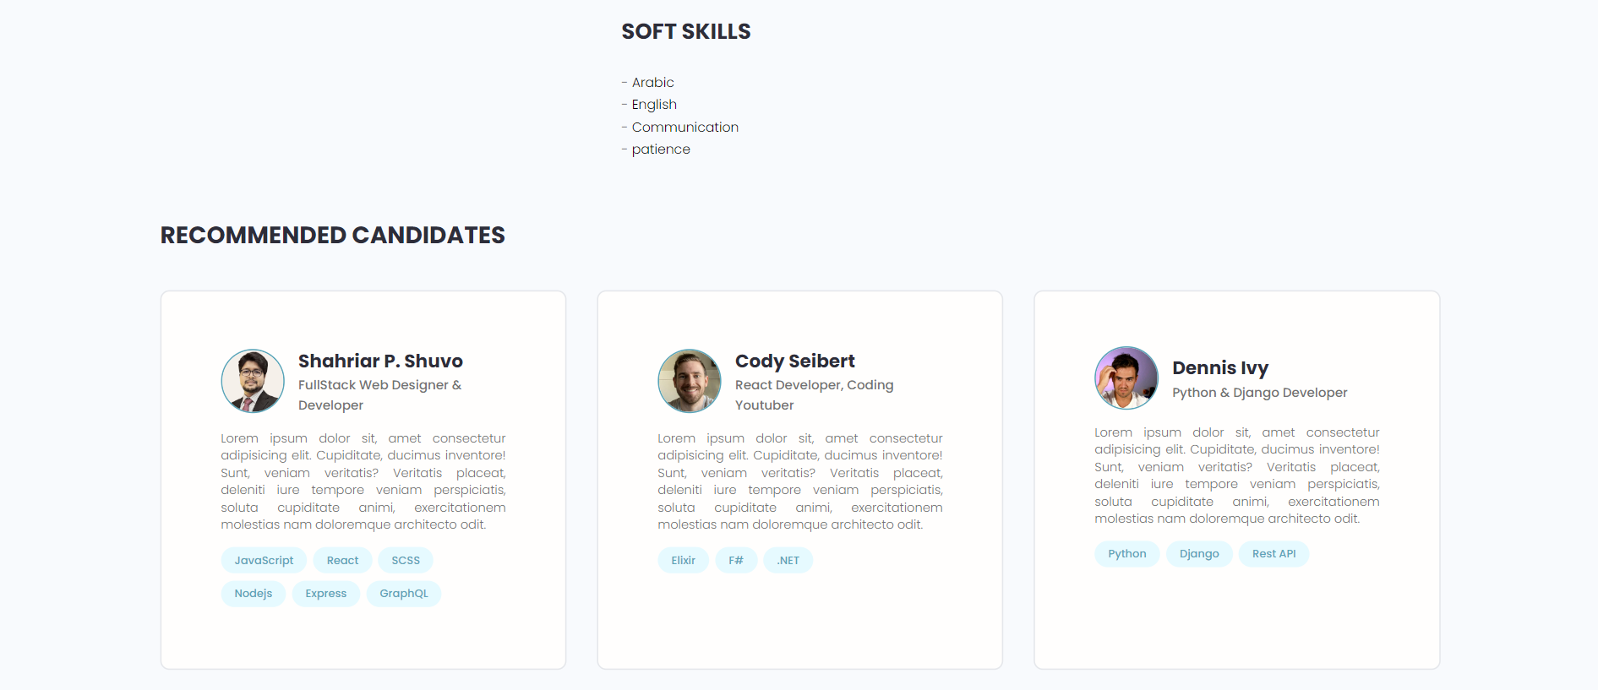

Figure - 5.5 job post interface (b)



CHAPTER 6

System

Implementation

# System Implementation

This chapter covers the system implementation in detail. It discusses the software tools used to develop the application, the system implementation, and the challenges.

Hiral was developed using an iterative process shown in figure 28 that involved several key stages. In the analysis phase, we identified project goals, selected user stories, and conducted market research. In the design phase, we created the user interface, determined app functionalities. The implementation phase involved writing back-end code, developing the front-end user interface, and creating an SQLite database. In the testing phase, we tested each task, evaluated the system's performance, and gathered user feedback. Finally, in the documentation phase, we documented changes made and conducted code reviews. This iterative process helped ensure that the final product met project requirements and allowed for continuous improvement throughout the development process.

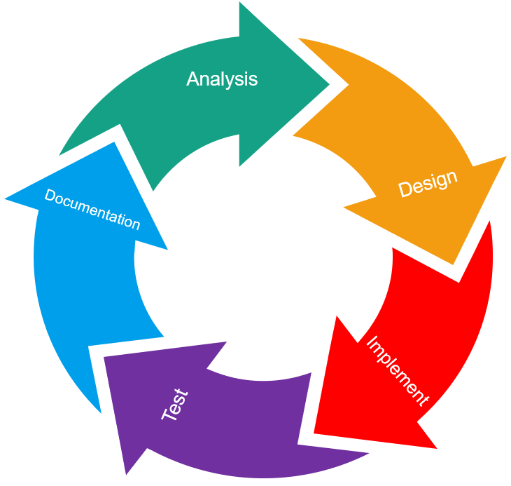

Figure - 6 Hiral iterative development

Developing and implementing a software application such as Hiral requires a structured approach. To ensure the successful implementation of the app, we followed a series of steps, as illustrated in the accompanying figure.

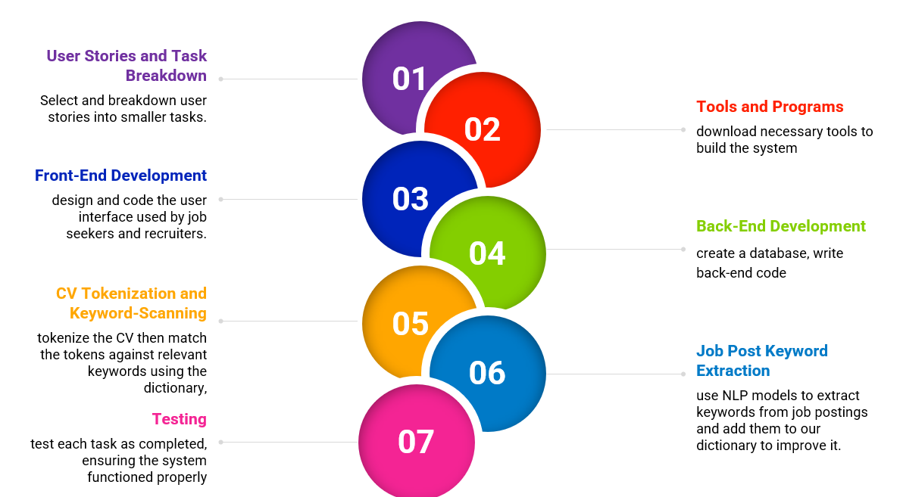

Figure - 6 System implementation steps

Step 1: User Stories and Task Breakdown

The first step in developing the job search app was to select the user stories that we would work on during the sprint. We then broke these user stories down into smaller tasks to make the development process more manageable.

Step 2: Tools and Programs

Once we had our task list, we downloaded the necessary tools and programs to build the system. This included Visual Studio Code as our text editor, Python as our programming language, and the Django web framework to build our app.

Step 3: Front-End Development

With our tools in place, we started building the front-end of the app using HTML, CSS, and UI kits. This involved designing and coding the user interface that job seekers and recruiters would use.

Step 4: Back-End Development

Next, we created an SQLite database using Django models and migrated it to the system. This allowed us to complete the development of the back-end functionalities. We then wrote the back-end code using the Django framework.

Step 5: CV Tokenization and Keyword-Scanning

To prepare CVs for keyword-scanning using our automated dictionary, we first tokenized the text. This involved breaking down the CV into individual tokens. We then used our dictionary to match these tokens against relevant keywords and phrases. This process allowed our system to accurately identify and highlight the most relevant skills mentioned in the CV.

Step 6: Job Post Keyword Extraction

Our approach involves using NLP models to extract keywords from job postings, which will then be added to our dictionary to increase automation. This will help us to more accurately and efficiently match job seekers with relevant job postings.

Step 7: Testing

As we completed each user story and task, we tested the system to ensure that everything worked correctly. We also tested the keyword-scanning algorithm to make sure that it accurately identified and highlighted the most relevant skills, qualifications, and experiences mentioned in the CV and tested the NLP model to ensure it captures the skills and adds them to our dictionary.

* Software Tools

Table - 6 Software tools

|  |  |  |
| --- | --- | --- |
| Software Type | Version | Description |
| Django | 4.2.1 | Django is a web development framework that allows developers to build web applications quickly and easily. It provides a wide range of built-in features and tools, making it ideal for building complex, data-driven websites. |
| Python | 3.9.11 | Python is an easy-to-learn programming language used for web development, data analysis, artificial intelligence, and scientific computing. |
| VS Code | 1.78.2 | Visual Studio Code is a free text editor used to write and debug code. It offers a range of features, such as syntax highlighting, debugging, and Git integration. |
| HTML | HTML5 | HTML is a standard language used for creating and designing web pages. |
| CSS | 3.37.2 | CSS is a style sheet language used to describe the presentation and layout of web pages written in HTML. |
| SQLite | 3.37.2 | SQLite is a serverless database engine that can be embedded in applications and accessed through SQL commands. |
| GitHub | 3.7.10 | GitHub is a code hosting platform used to manage and integrate source code. |

In conclusion, Hiral was developed using an iterative process that involved selecting user stories, breaking them down into smaller tasks, and testing each component as it was completed. We conducted thorough analysis and documentation throughout the process to identify areas for improvement and ensure that the final product met project requirements. Hiral uses a keyword-scanning algorithm to match job seekers' CVs with relevant job postings, which is made possible by tokenizing the text and using a dictionary to identify relevant keywords and phrases. Furthermore, we use NLP models to extract keywords from job postings, which are included in our dictionary to automate the process. This improves the accuracy of job matching, enabling us to match job seekers with relevant job postings more precisely and efficiently.



CHAPTER 7

System

Testing

# System Testing

To confirm that Hiral functions as intended, we conducted system testing in this chapter, including user acceptance testing and user surveys. We then analyzed and discussed the results to ensure that the system meets the requirements and expectations of our users.

## User Acceptance Testing

During the user acceptability testing stage of software development, the target audience tests the software to ensure it meets their needs. We selected seven members for the testing, including recent graduates, recruitment professionals, and employees seeking new opportunities. This type of testing is crucial to confirm that the application satisfies the end users' requirements and to identify any areas that may require improvement.

### Demographics of Participants

Table - 7.1.1 Demographics of participants

|  | Variable 1 | Variable 2 | Variable 3 | Variable 4 | Variable 5 | Variable 6 | Variable 7 |
| --- | --- | --- | --- | --- | --- | --- | --- |
| Age | 18-25 | 26-35 | 18-25 | 26-35 | 18-25 | 18-25 | 18-25 |
| Gender | Female | Male | Female | Male | Female | Female | Female |
| education | University undergraduates | University graduate | University undergraduates | University graduate | University graduate | University graduate | University graduate |

### Questionnaire/Interview Results

As we did before in system requirements, we created the survey using Google Forms to survey Arabic Some of them have experience, broad outlook in the field of information technology and some do not have any background in this field; the survey consists of 8 questions three of them were regarding demographics and five were related to the user experience (attached in Appendix C), 7 responses were received. To gather their feedback and make sure that the acceptance criteria were met. We asked them how long they took for you to complete the registration task, how easy was to navigate through the application, what are their thoughts on the design and layout, how likely they are to recommend this application to a friend, how would they rate their overall experience with the application, their age, gender, and educational level. Overall, the questionnaire produced a good result, The time required to complete registration did not take long, navigation within the app was smooth, the layout and design were great, recommending the application to a friend and the experience of it were relatively high, the age range of people who responded to the survey most of them were female and ranged from the 18 to 35 age range, and for the educational four of them were university graduated , two were in university undergraduates and one had an upper degree. According to our findings, we can better comprehend the many viewpoints’ people have expressed through this questionnaire. Moreover, the application satisfies its criteria and it's simple to use and navigating, resulting in a better user experience

Table - 7.1.2 Questionnaire results

| Question Number | Question | Value | Responses |
| --- | --- | --- | --- |
| 1 | On a scale from 1 to 5 (1=very slow, 5=very fast), How long did it take for you to complete the registration task? | very fast | 42.9% |
| fast | 28.6% |
| natural | 28.6% |
| slow | 0 |
| very slow | 0 |
| 2 | On a scale from 1 to 5 (1=very hard, 5=very easy), how easy was it to navigate through the application? | very easy | 57.1% |
| easy | 14.3% |
| natural | 28.6% |
| hard | 0 |
| very hard | 0 |
| 3 | On a scale from 1 to 5 (1=very bad, 5=very good), What are your thoughts on the design and layout? | very good | 85.7% |
| good | 14.3% |
| natural | 0 |
| bad | 0 |
| very bad | 0 |
| 4 | On a scale from 1 to 5 (1=not at all likely, 5=very likely), how likely are you to recommend this application to a friend? | very likely | 42.9% |
| likely | 28.6% |
| natural | 28.6% |
| not likely | 0 |
| not at all likely | 0 |
| 5 | How would you rate your overall experience with the application? | very good | 71.4% |
| good | 28.6% |
| natural | 0 |
| bad | 0 |
| very bad | 0 |

## Discussion

Based on user feedback, our website is an effective solution for job seekers and recruiters alike. The registration process is said to not take long, navigating the app was easy, and the interface was clear and consistent. Additionally, most of the users are willing to recommend our website to others. Overall, we received great feedback from our users.



CHAPTER 8

Conclusions

and

Future Work

# Conclusions and Future Work

* Global impact.

Hiral has the power to make a serious global impact. By matching job seekers with job postings that align with their skills and experience, the website can reduce unemployment rates and promote productivity. Plus, by reducing bias in the job search process, Hiral can help to ensure that all job seekers have an equal opportunity to advance in their careers. And let's not forget about the time-saving benefits of automating the matching process. With all these benefits, Hiral website is poised to drive economic growth and prosperity worldwide.

* Local impact

Hiral will help to ensure that all job seekers in Saudi Arabia have a fair shot at landing their dream job. And with the time-saving benefits of automating the matching process, the website can help job seekers and employers in Saudi Arabia to focus on other important tasks, like building businesses and driving innovation.

* Problems and challenges encountered during the software development

When we first embarked on the project, the team members were faced with the daunting challenge of mastering the Django framework and Python programming language, which were unfamiliar to us. Along the way, we encountered a slew of exceptions that left us searching for answers. Despite our best efforts, the available resources for understanding the Django framework weren't clear. Adding to the complexity of the project was the juggling act of studying for other university courses, which made time management a critical factor in our success. But like true professionals, we rose to the occasion, developing our skills and organizing our time with military precision. With a fierce determination to overcome any obstacle, we honed our abilities to tackle even the murkiest of exceptions, emerging victorious with a comprehensive understanding of the Django framework.

* The main contribution of the project

The main contribution of Hiral is that it enables a more efficient and accurate matching process. By leveraging natural language processing and semantic matching algorithms, the website can analyze job seekers' skills and match them with job posts that are the most relevant and promising. This not only saves time for both job seekers and employers but also helps to reduce the likelihood of mismatches between job seekers and job posts.

* Limitation of system and future work.

Hiral is a website that uses a semantic similarity matching algorithm to match job seekers with their dream jobs. But as with any innovative technology, there are some limitations to consider.

First up limited data. Without a robust dataset, the algorithm may struggle to make accurate matches. Additionally, algorithm accuracy can be a challenge, as even the best algorithms can have flaws. Another limitation is that Hiral's NLP models may not always capture all relevant keywords from job postings, which can affect the accuracy of the job matching process.

Future work could focus on developing new data sources to increase accuracy, refining the algorithm to eliminate flaws, and enhancing the dictionary employed in our keyword-scanning process. By honing in on these limitations, we can make sure that job search websites are serving job seekers and employers to the max and making a serious impact on the labor market.

* Conclusion

This document is a detailed account of how we created Hiral, from the very start to the end. beginning with the introduction chapter, which clarifies the idea and gives a general overview of Hiral. The introduction chapter is followed by the background chapter, which is important in preparing the reader to understand Hiral details by providing a brief explanation of knowledge aspects in which Hiral falls. To deliver an application that fills a gap in existing applications, and to specify Hiral features, we examined and discussed academic papers and applications within the same field as Hiral, which were represented in the literature review chapter. After achieving a clear understanding of Hiral features, we began the system analysis and design chapter, which converts Hiral features into a form used to facilitate the implementation of Hiral application and support the understanding of Hiral components. After analyzing our system, we began developing Hiral by using the Django framework and testing it to ensure it was bug free.

In the end, we not only mastered a new technology but also gained invaluable experience in time management and problem-solving. We emerged from the project as battle-hardened professionals, ready to take on any challenge that comes our way.



CHAPTER 9

References

# References

[1] Rubin, K. S. (2017). Essential Scrum: A practical guide to the most popular agile process. Upper Saddle River, NJ: Addison-Wesley.

[2] “Artificial Intelligence Resume Screening: AI-friendly Resume Guide” (2023).[Online]. Available: <https://playhunt.io/for-candidates/artificial-intelligence-resume-screening>

[Accessed: 4-April-2023].

[3] “AI In Resume Screening: Expectations vs. Reality” (2023).[Online]. Available: <https://vervoe.com/ai-in-resume-screening/>

[Accessed: 4-April-2023].

[4] Harispe S.; Ranwez S. Janaqi S.; Montmain J. (2015). *Semantic Similarity from Natural Language and Ontology Analysis*. Synthesis Lectures on Human Language Technologies.

[5] Yinfei Yang et al.(2018). *Learning Semantic Textual Similarity from Conversations*. Google ResearchMountain View, CA, USA.

[6] “Sentence Transformers: Meanings in Disguise” (2023).[Online]. Available: <https://towardsdatascience.com/sentence-transformers-meanings-in-disguise-323cf6ac1e52>

[Accessed: 2-April-2023].

[7] “Mastering Sentence Transformers For Sentence Similarity” (2022).[Online]. Available: <https://predictivehacks.com/mastering-sentence-transformers-for-sentence-similarity/>

[Accessed: 2-April-2023].

[8] “Jaccard Similarity – Text Similarity Metric in NLP” (2023).[Online]. Available: <https://studymachinelearning.com/jaccard-similarity-text-similarity-metric-in-nlp/>

[Accessed: 2-June-2023].

[9] “Measurement of Text Similarity: A Survey” (2020).[Online]. Available: <https://www.mdpi.com/2078-2489/11/9/421>

[Accessed: 2-June-2023].

[10] Lai, Y., & Liu, Y. (2020). *An empirical study on the impact of job hiring apps on recruitment process*. IEEE International Conference on Industrial Engineering and Engineering Management (IEEM)

[11] “Defeating Robots: 75 Percent of Resumes Are Never Read by a Human” (2023).[Online]. Available: <https://blog.careerminds.com/75-percent-of-resumes-are-never-read>

[Accessed: 4-April-2023].

[12] “Automating Job Search with AI” (2022).[Online]. Available: <https://intellectdata.com/automating-job-search-with-ai/>

[Accessed: 2-April-2023].

[13] Nils Reimers and Iryna Gurevych. (2019). *Sentence-BERT: Sentence Embeddings using Siamese BERT-Networks*. Department of Computer Science, Darmstadt University.

[14] “How Recruitment Metrics & Dashboards Can Help Improve Hiring New Candidates?” (2023).[Online].Available:<https://www.datapine.com/blog/recruitment-metrics-and-dashboards/>

[Accessed: 5-April-2023].

[15] <https://www.crunchbase.com/organization/ziprecruiter>

[16] <https://play.google.com/store/apps/details?id=com.indeed.android.jobsearch&hl=ar>

[17] <https://en.wikipedia.org/wiki/Glassdoor>

[18] <https://play.google.com/store/apps/details?id=com.jobrapp.jobr&hl=ar>



CHAPTER 10

Appendix A

Requirements

Elicitation’s Questionnaire

# Appendix A: Requirement elicitation’s questionnaire

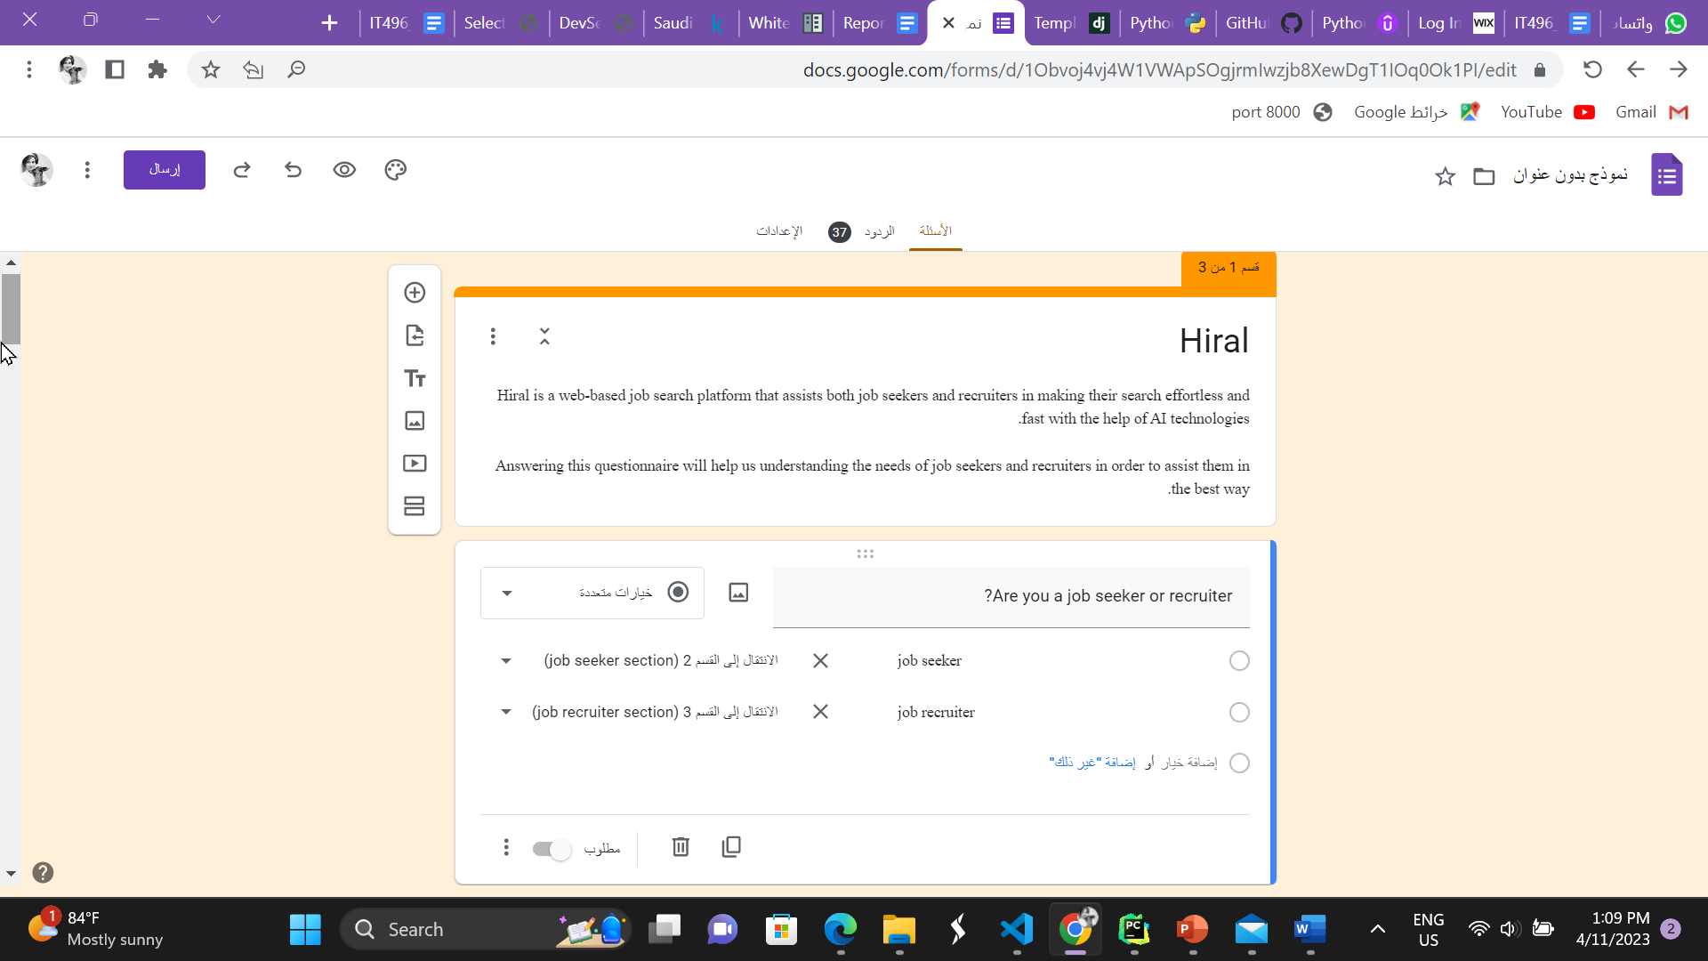

Figure - Survey questions

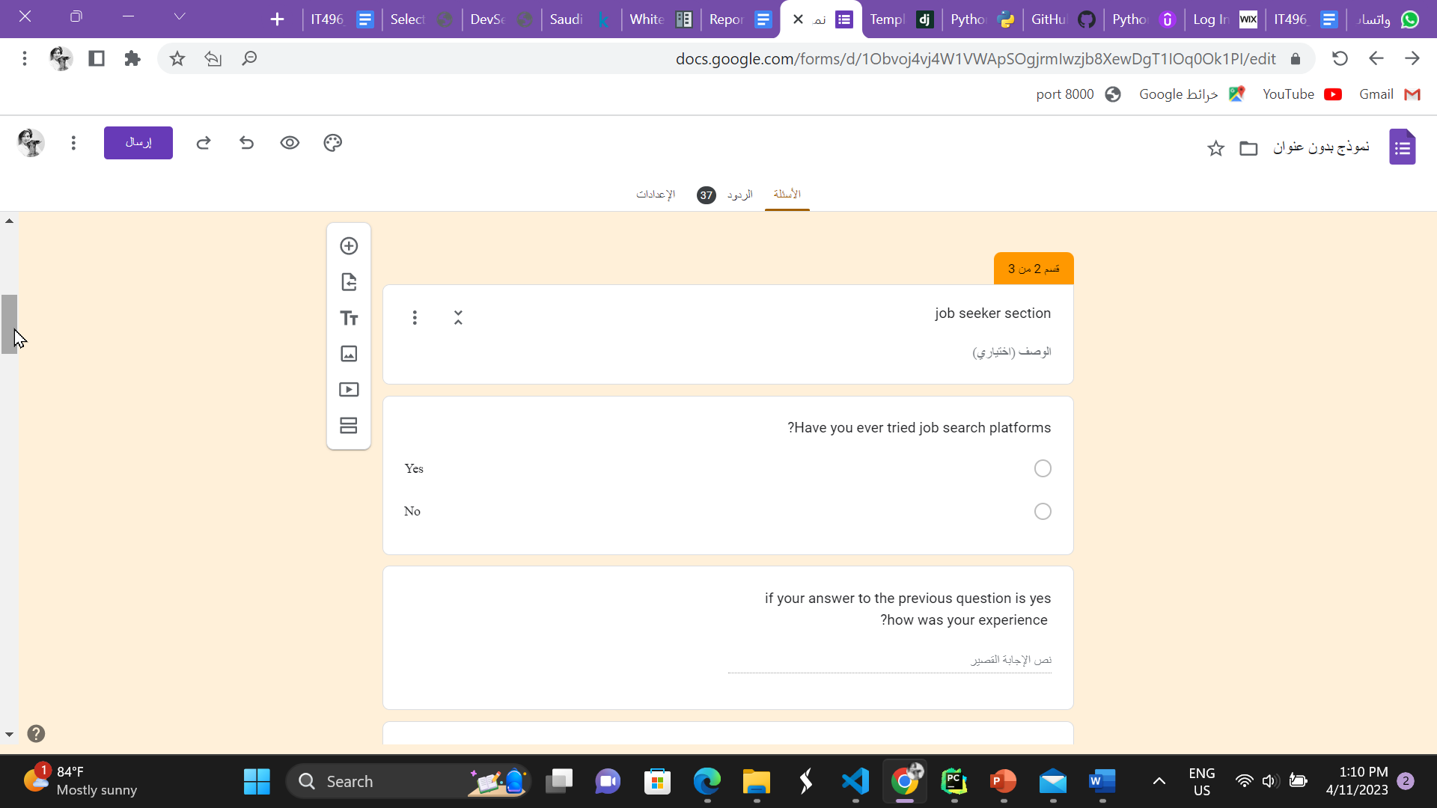

Figure - Survey questions

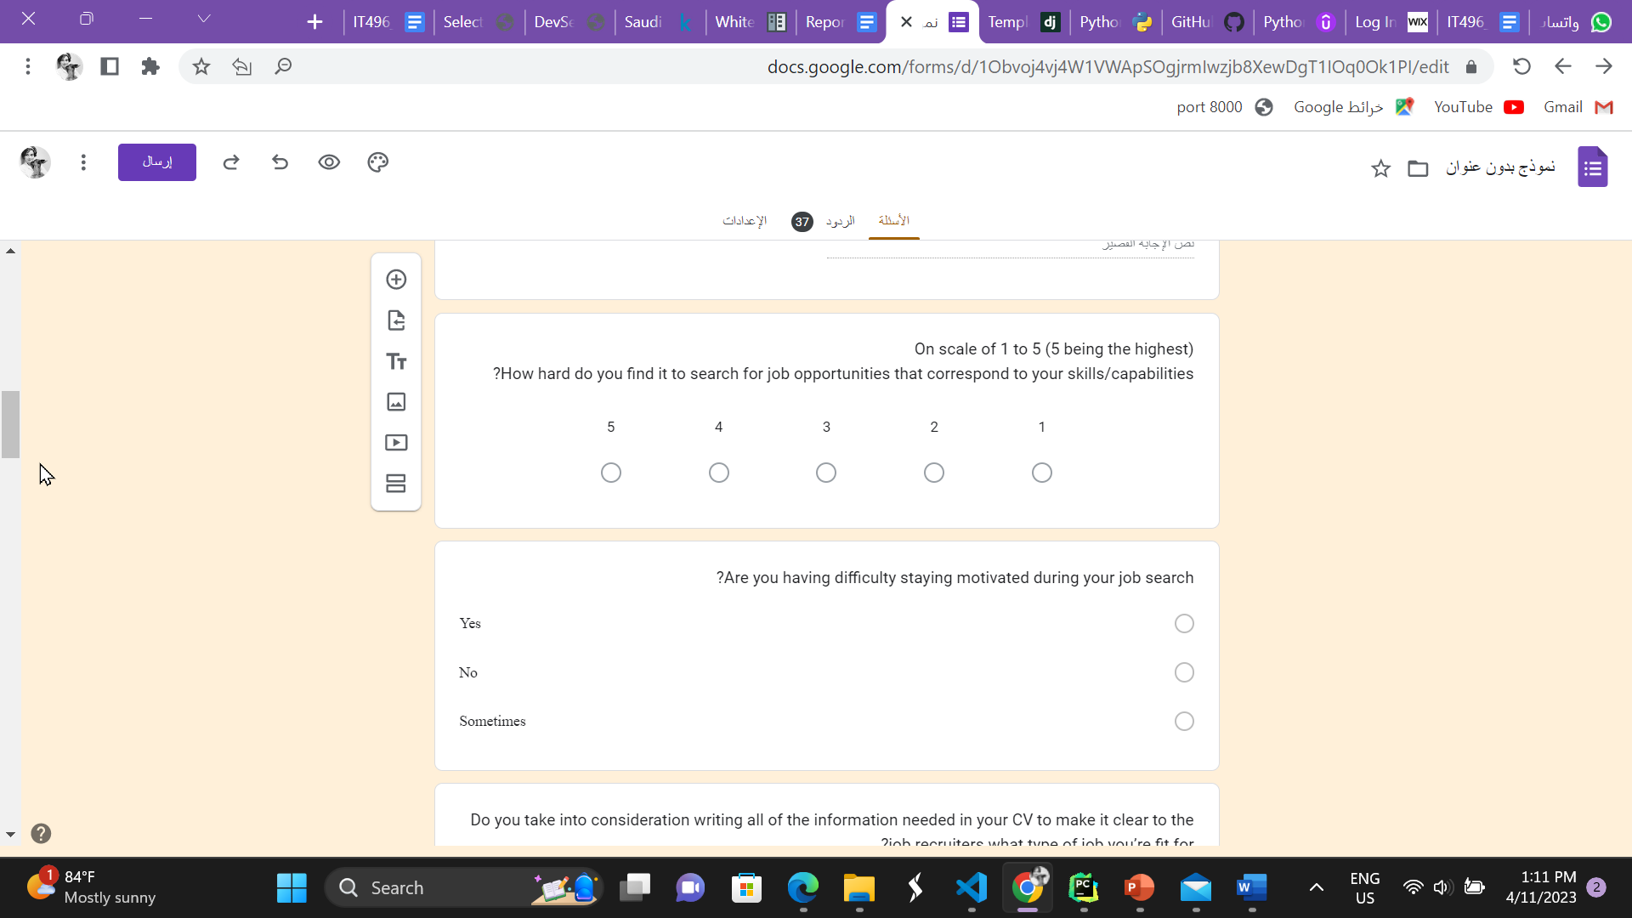

Figure - Survey questions

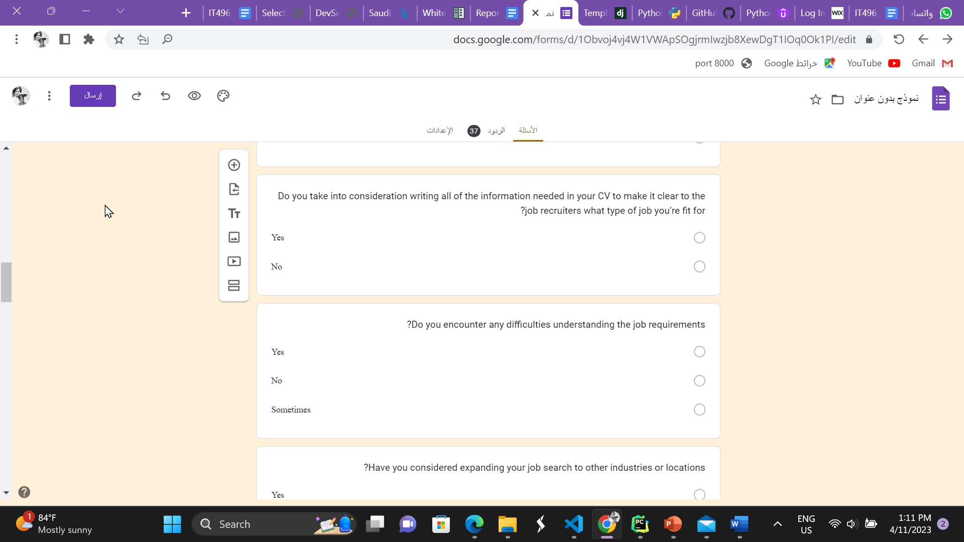

Figure - Survey questions

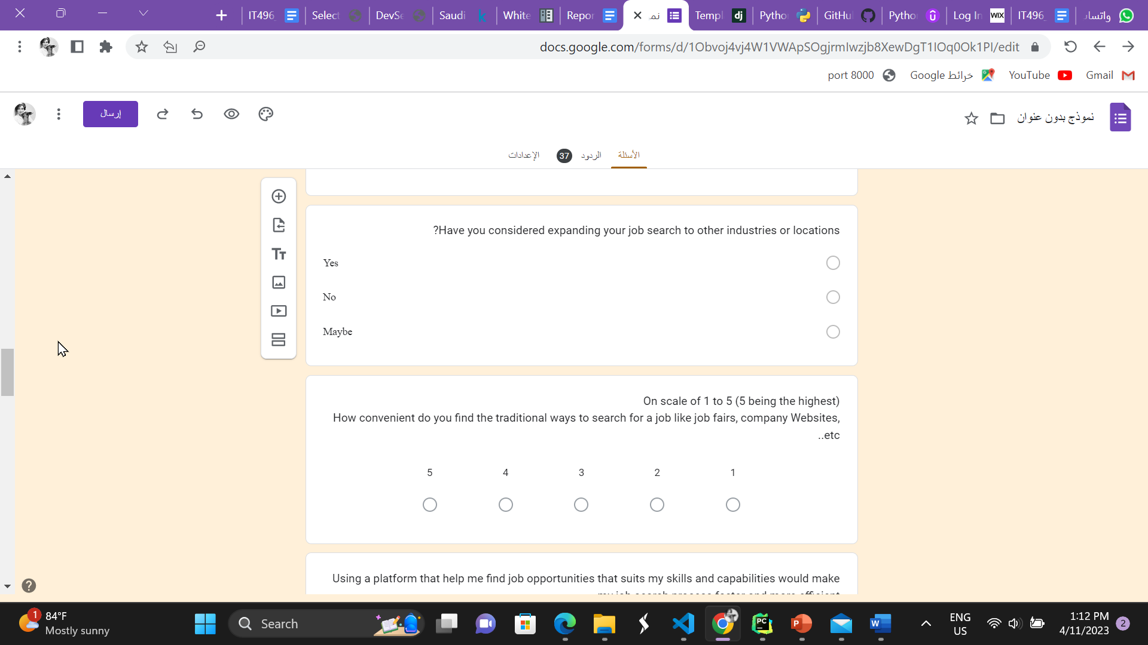

Figure - Survey questions

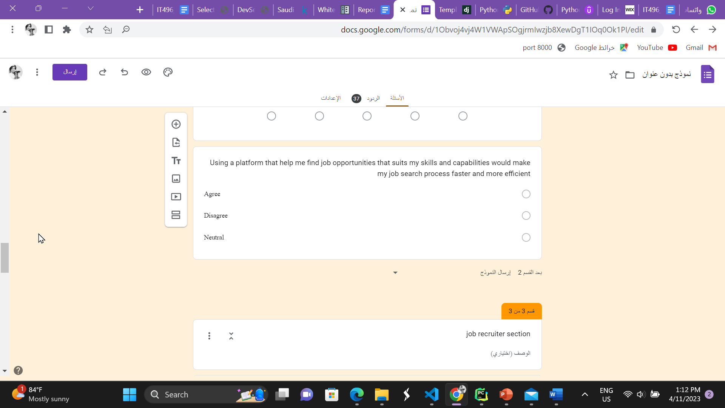

Figure - Survey questions

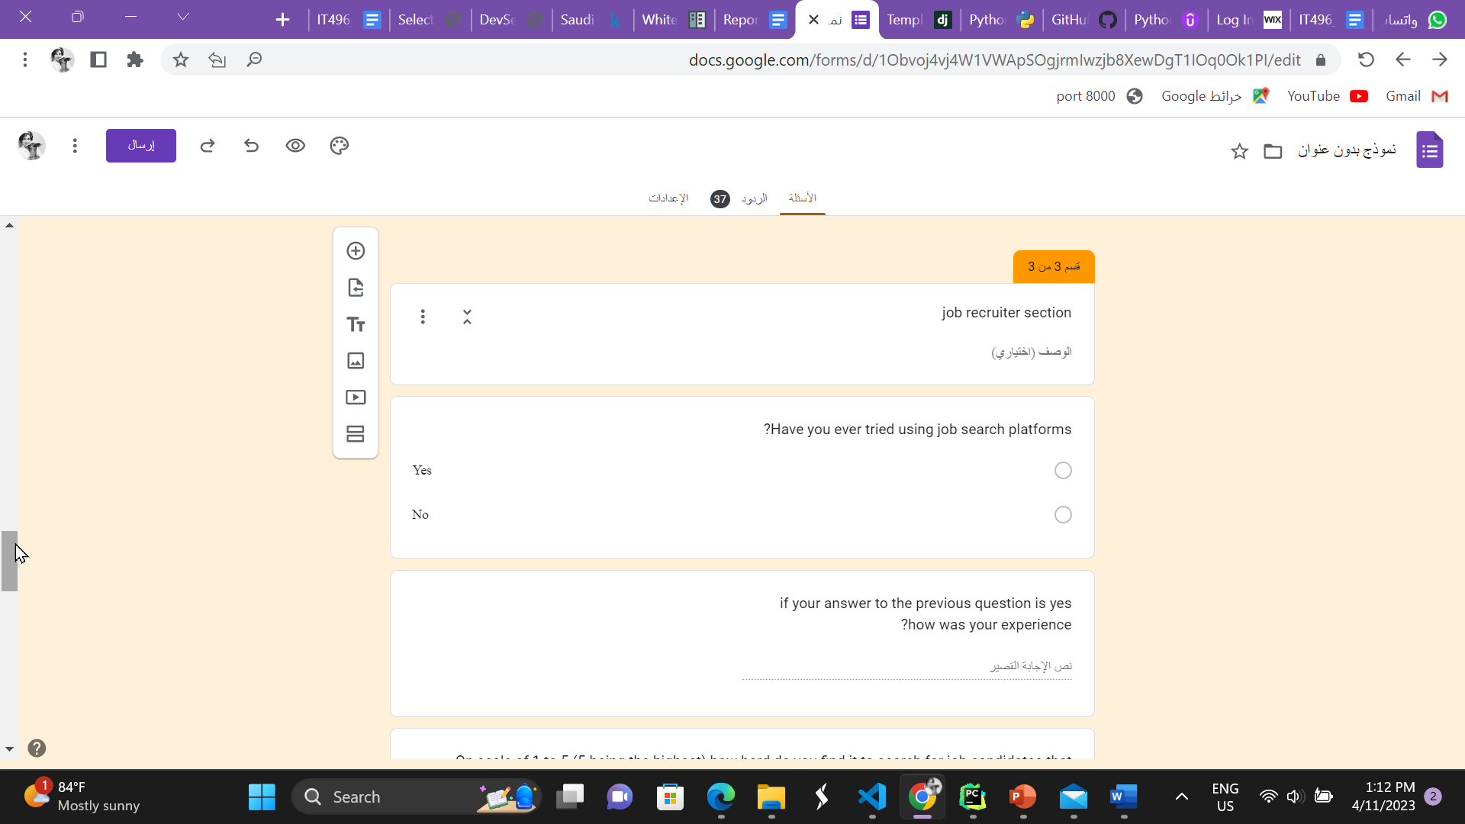

Figure - Survey questions

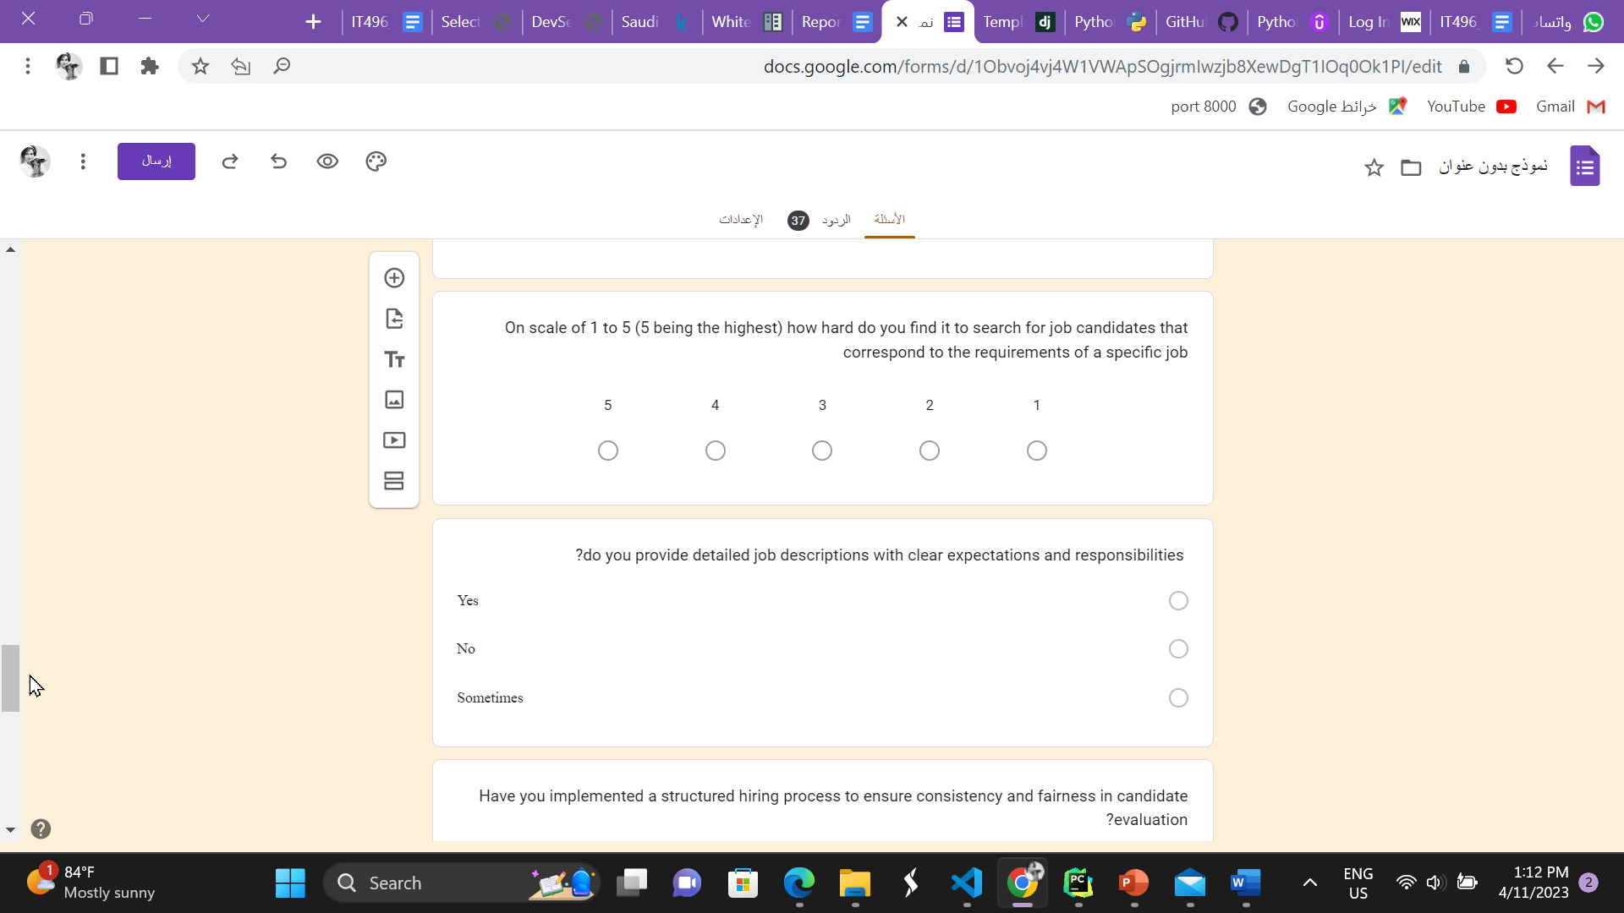

Figure - Survey questions

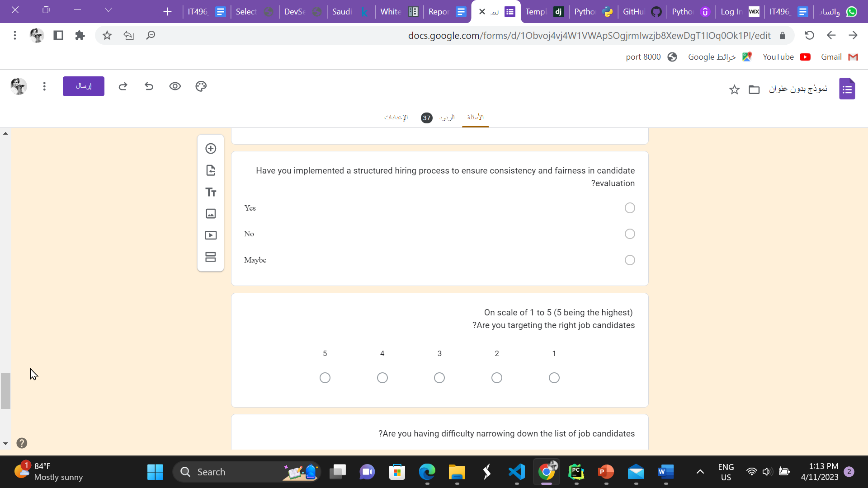

Figure - Survey questions

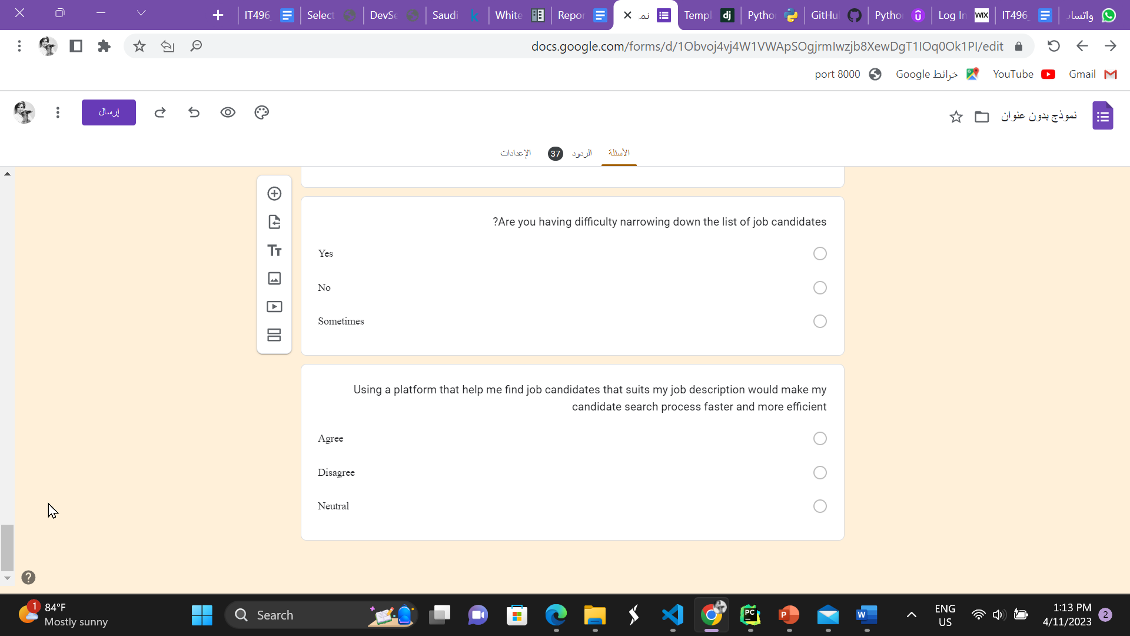

Figure - Survey questions

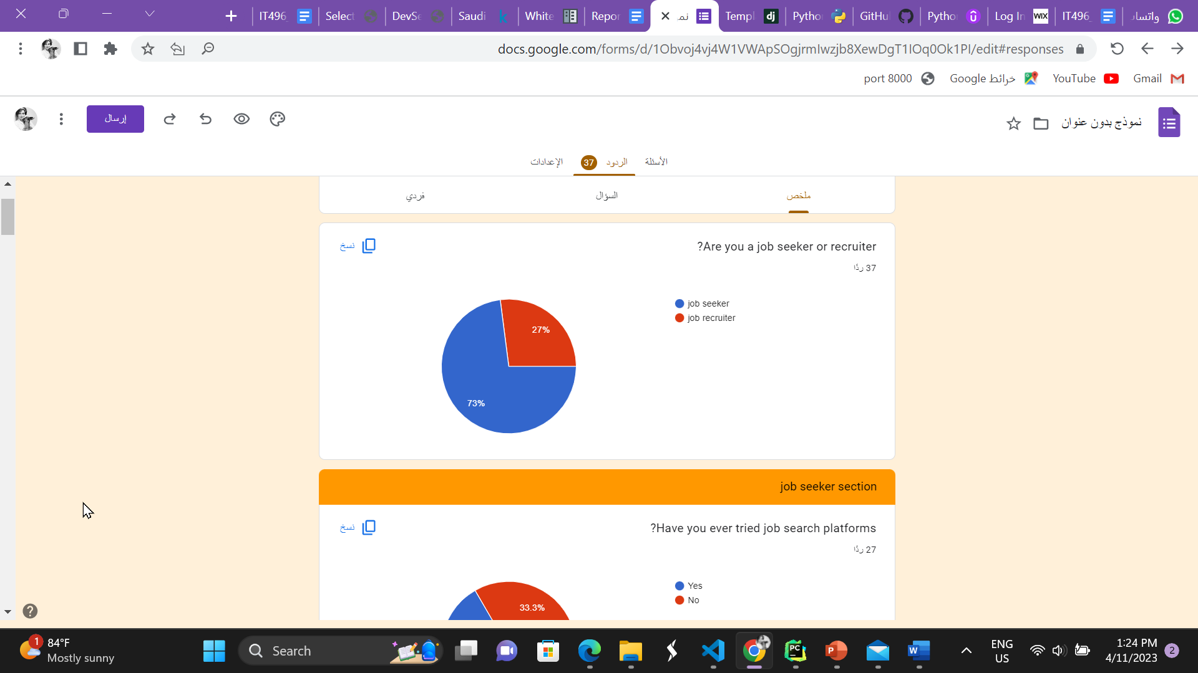

Figure - Survey answers

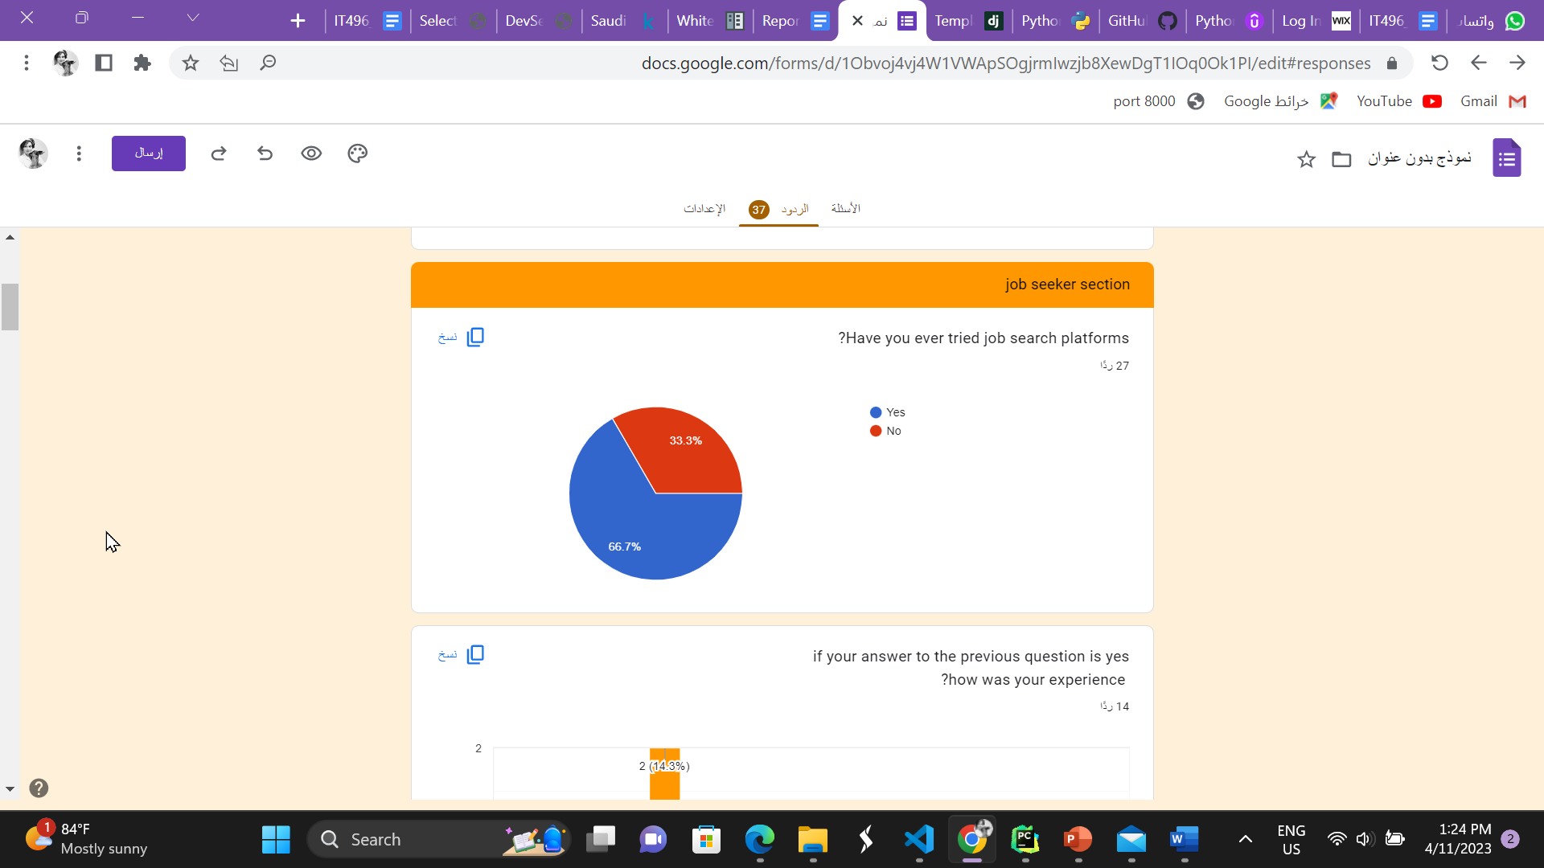

Figure - Survey answers

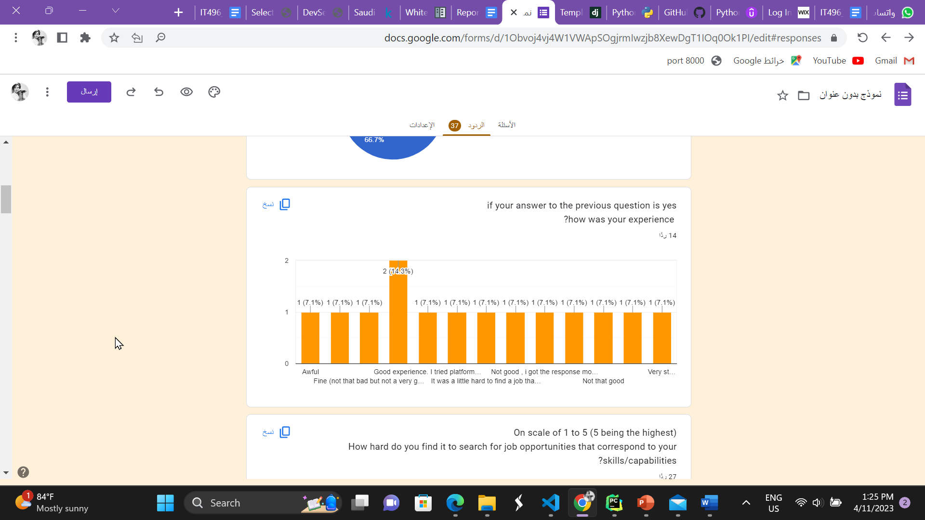

Figure - Survey answers

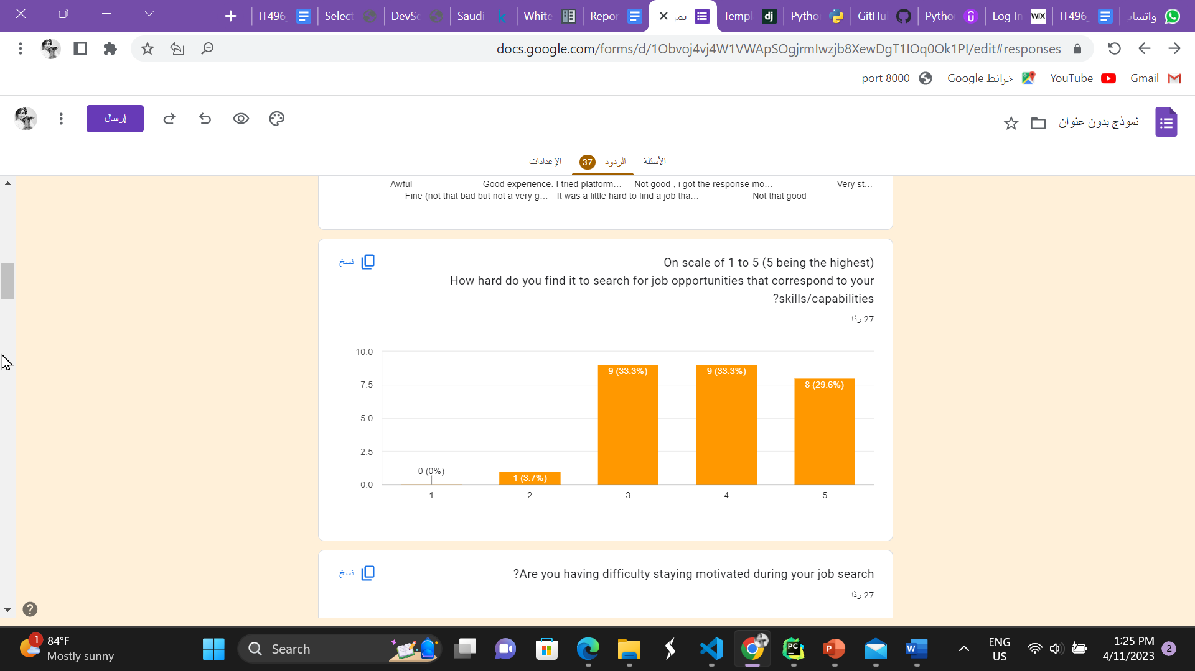

Figure - Survey answers

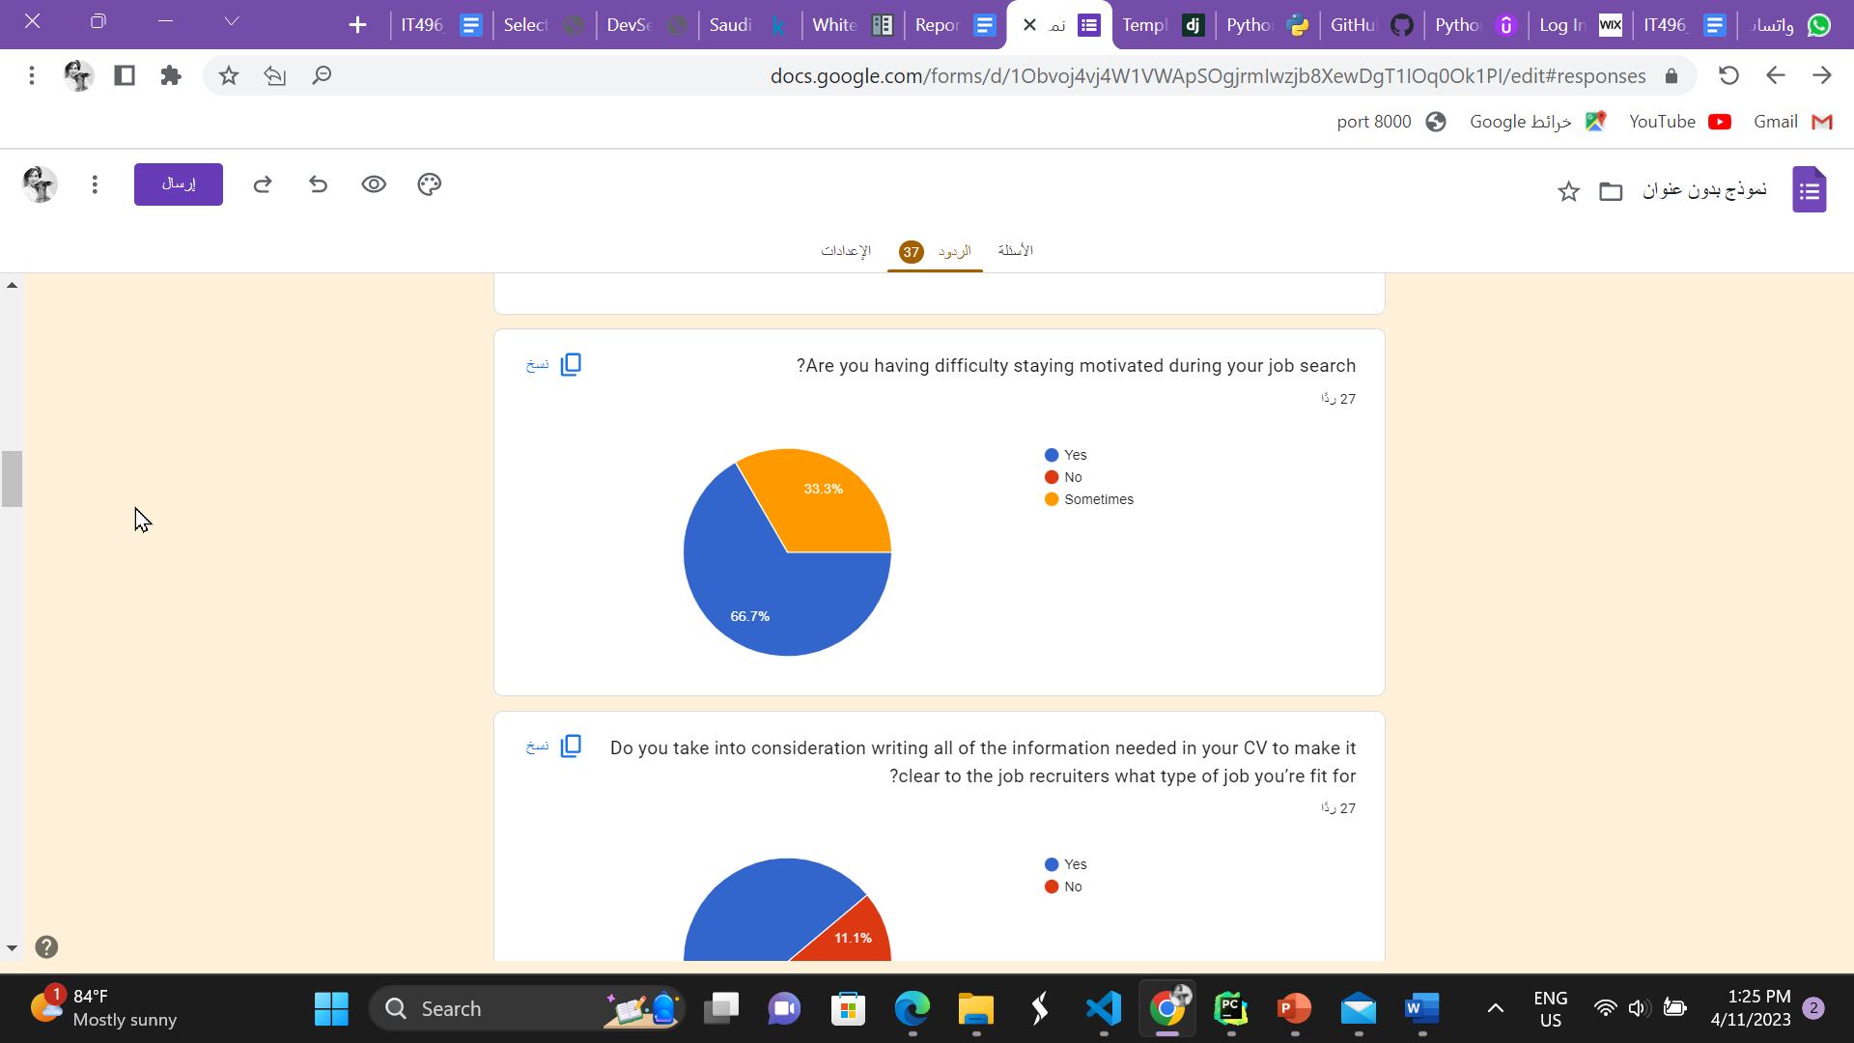

Figure - Survey answers

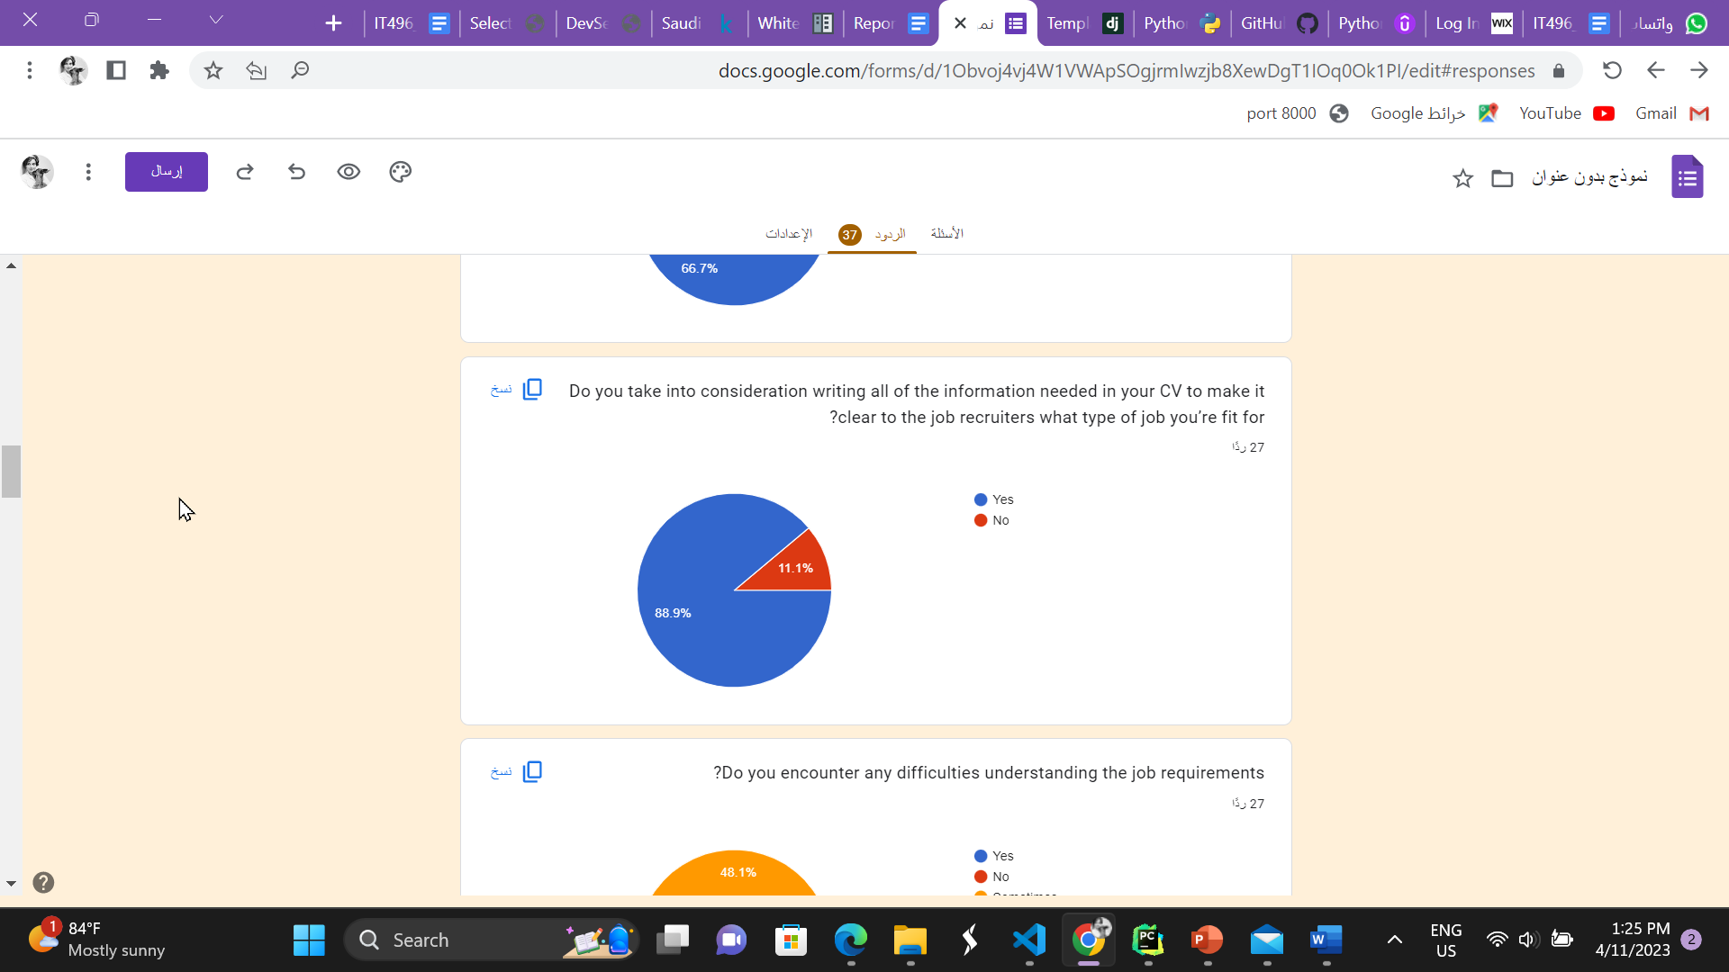

Figure - Survey answers

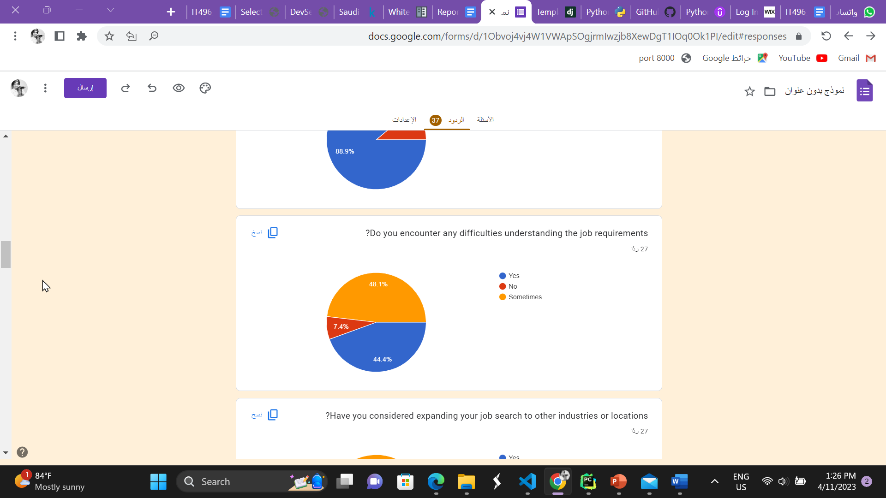

Figure - Survey answers

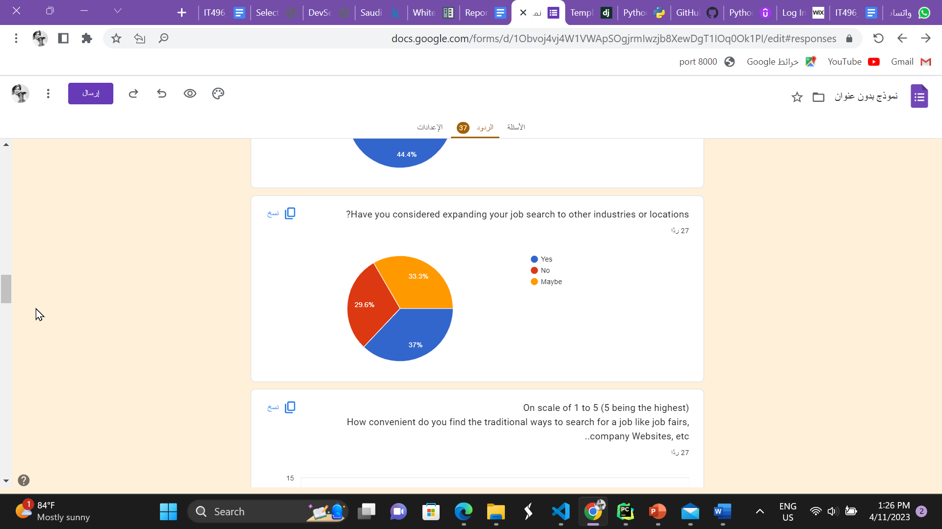

Figure - Survey answers

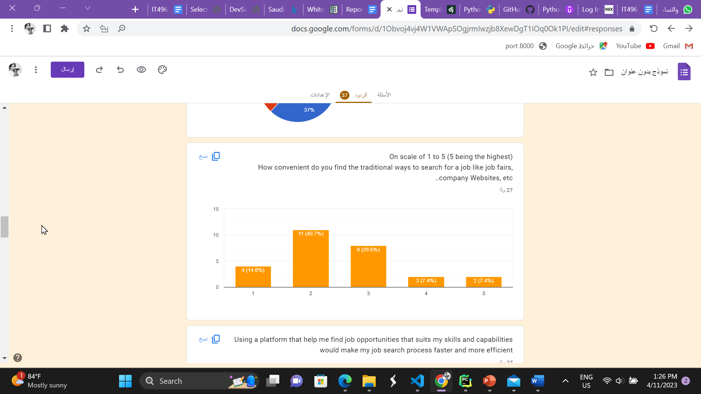

Figure - Survey answers

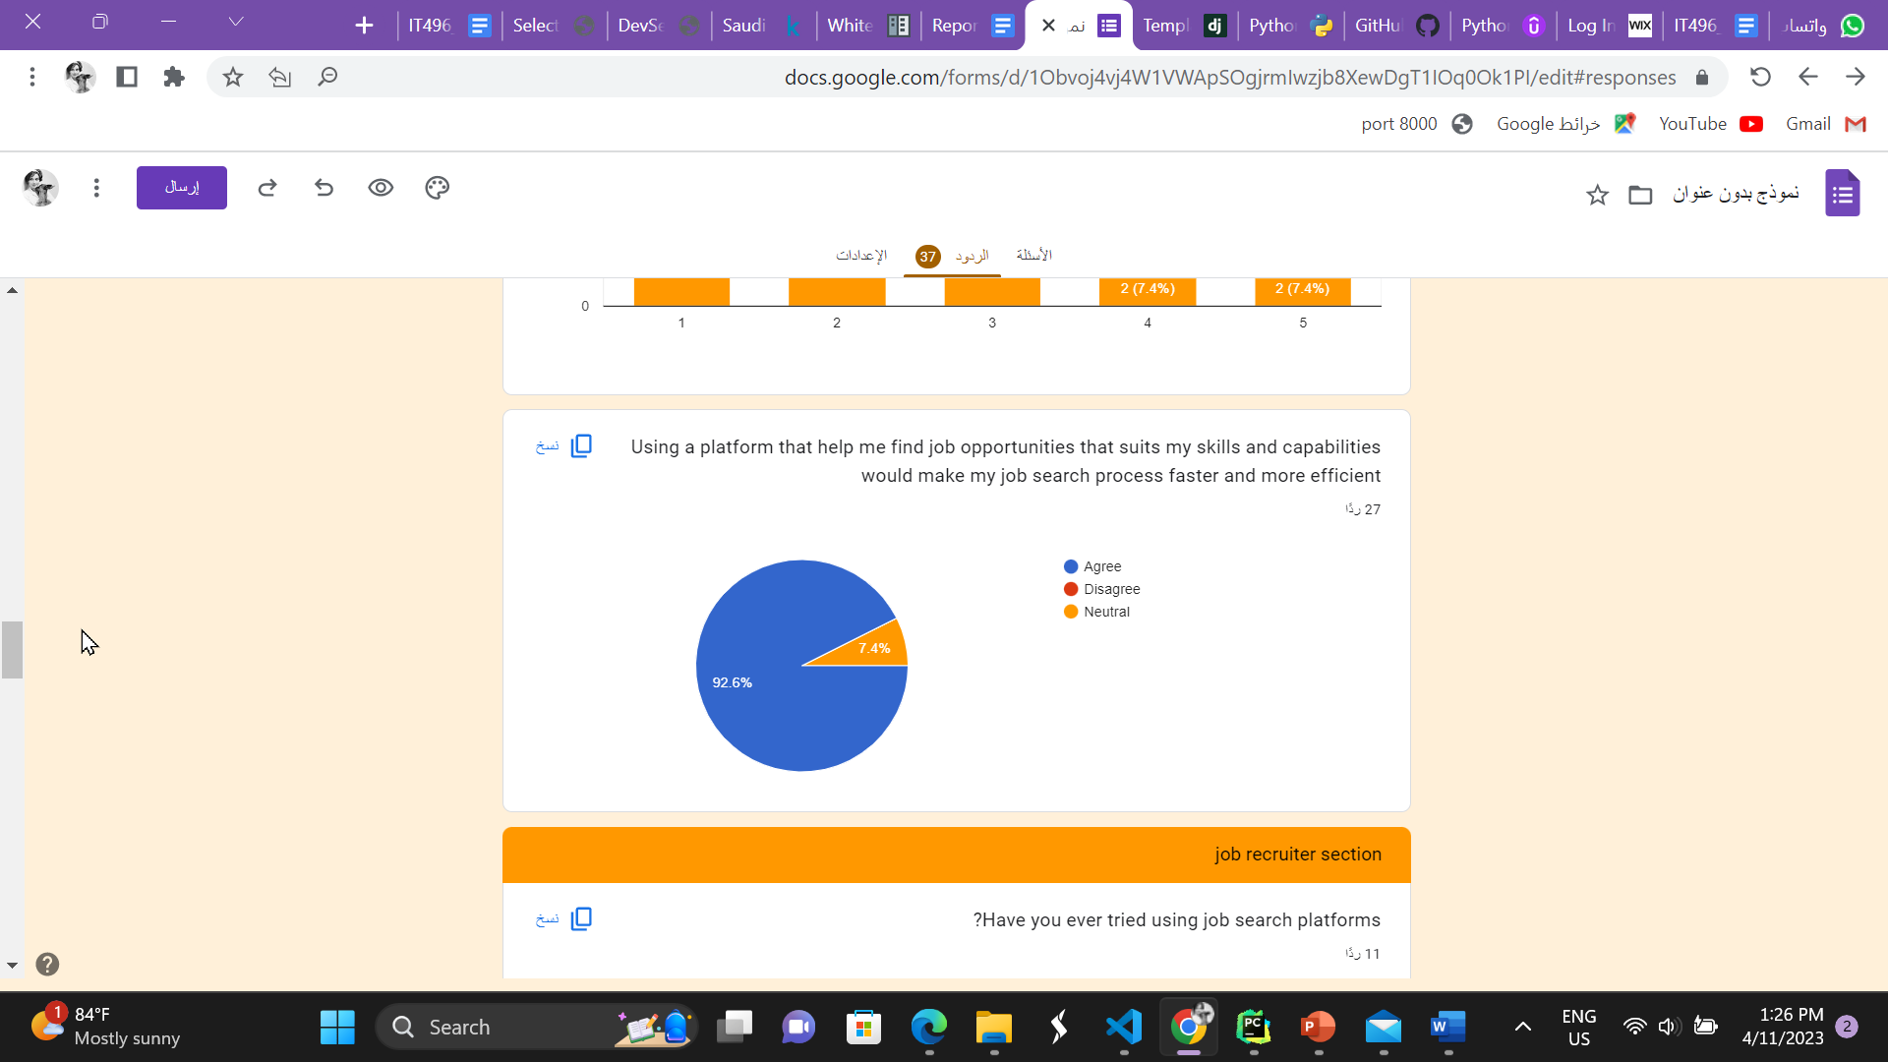

Figure - Survey answers

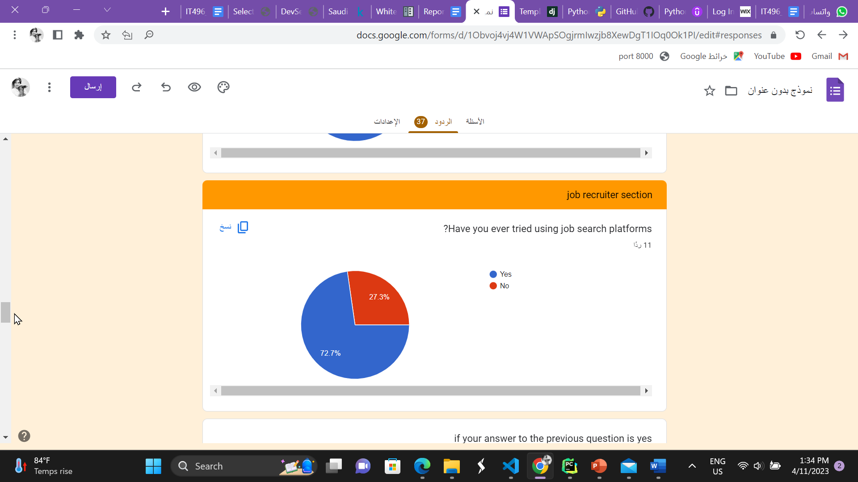

Figure - Survey answers

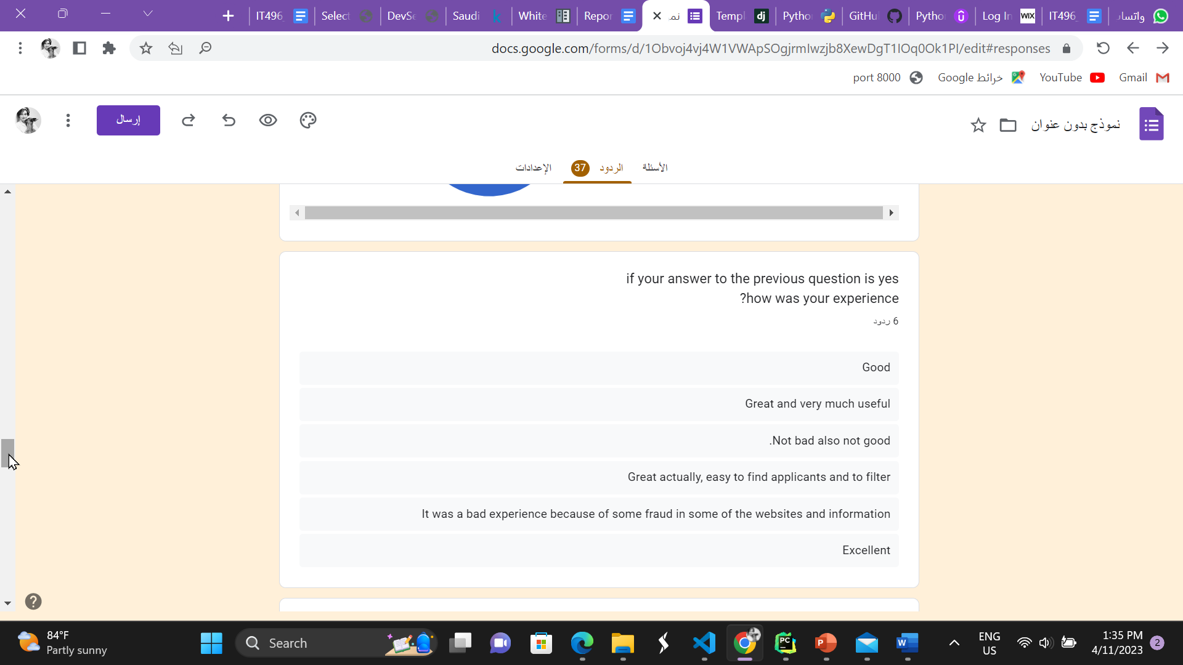

Figure - Survey answers

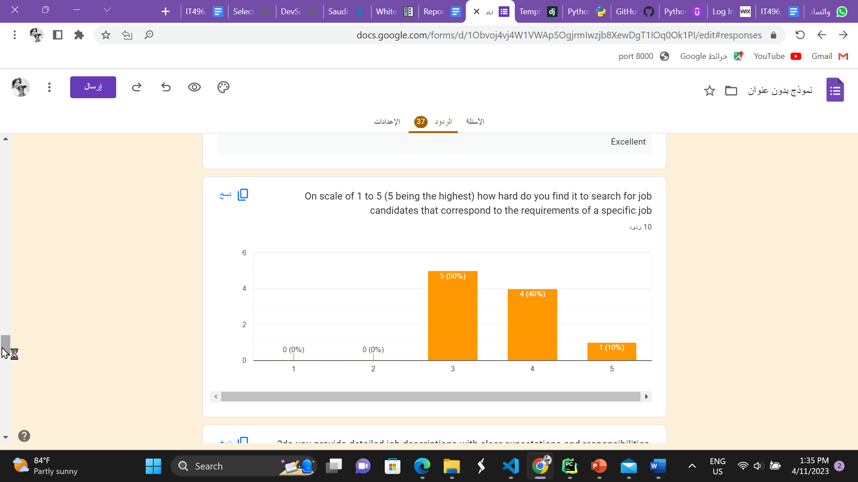

Figure - Survey answers

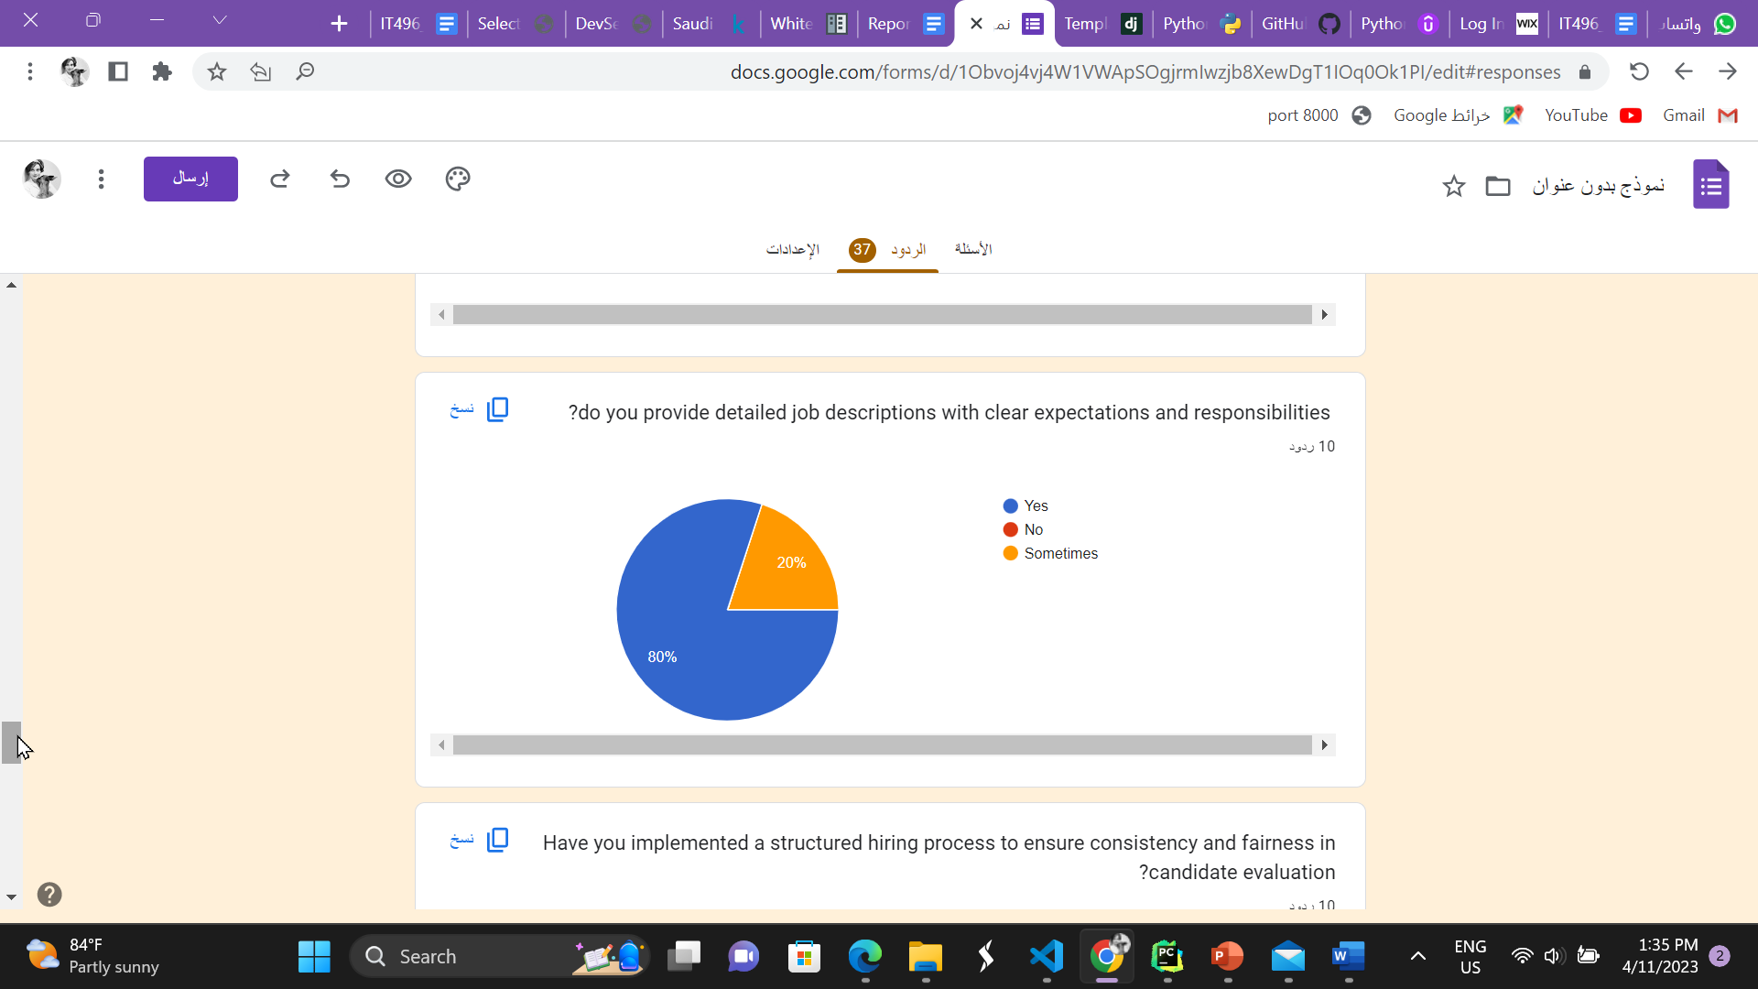

Figure - Survey answers

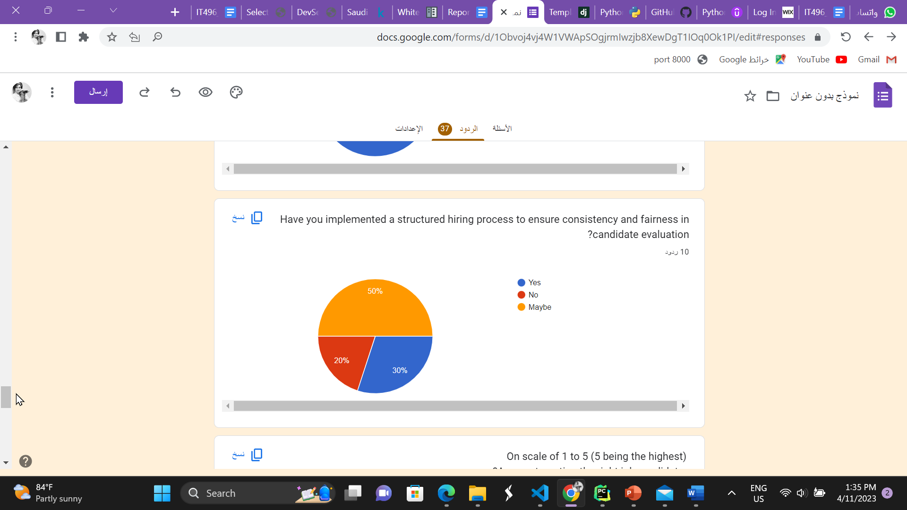

Figure - Survey answers

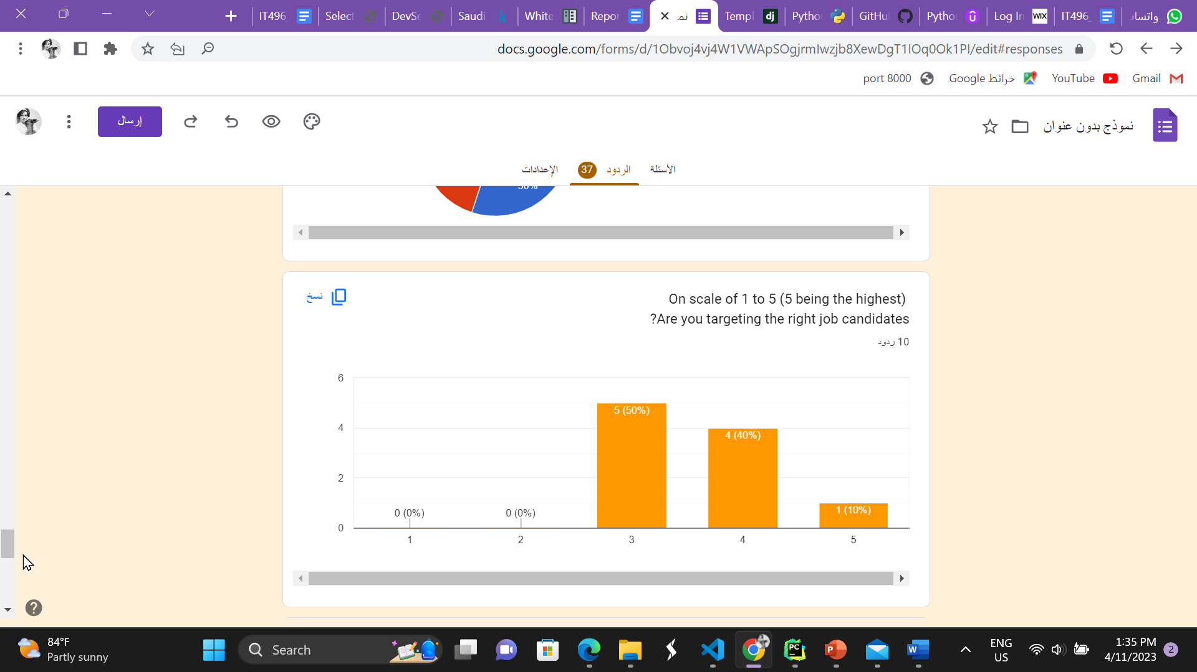

Figure - Survey answers

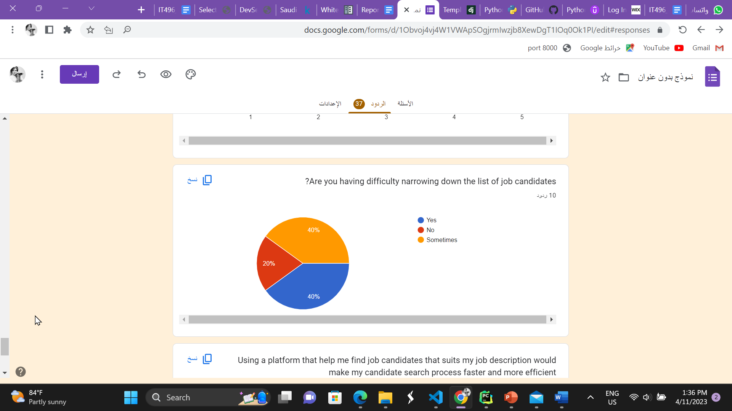

Figure - Survey answers

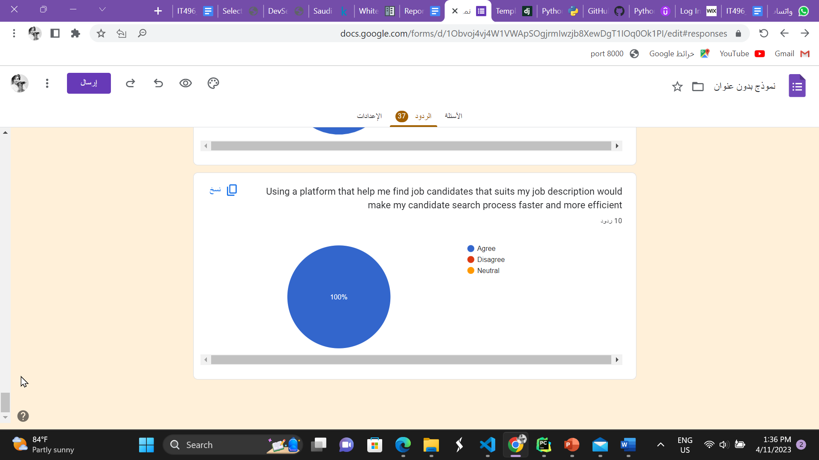

Figure - Survey answers



CHAPTER 10

Appendix B

Requirements

Elicitation’s Interview

# Appendix B: Requirement elicitation’s interview

* Job recruiter:

1. How do you normally assess whether or not a job candidate is a good suit for a specific job you’re offering?
2. Have you ever used an online job search or recruitment platform to find candidates? If so, what features were most helpful to you?
3. What are some common mistakes you've noticed in the process of picking candidates that could potentially be addressed through a new job search platform?
4. How important is it to you to have access to a large pool of potential candidates with capabilities that correspond to the job you’re offering?

* Job seeker:

1. What challenges have you faced while job searching?
2. What have you done to stay up to date on the latest job search trends?
3. How have you used technology to enhance your job search?
4. Have you used social media to find job opportunities?



CHAPTER 10

Appendix C

Jira

# Appendix C: Jira

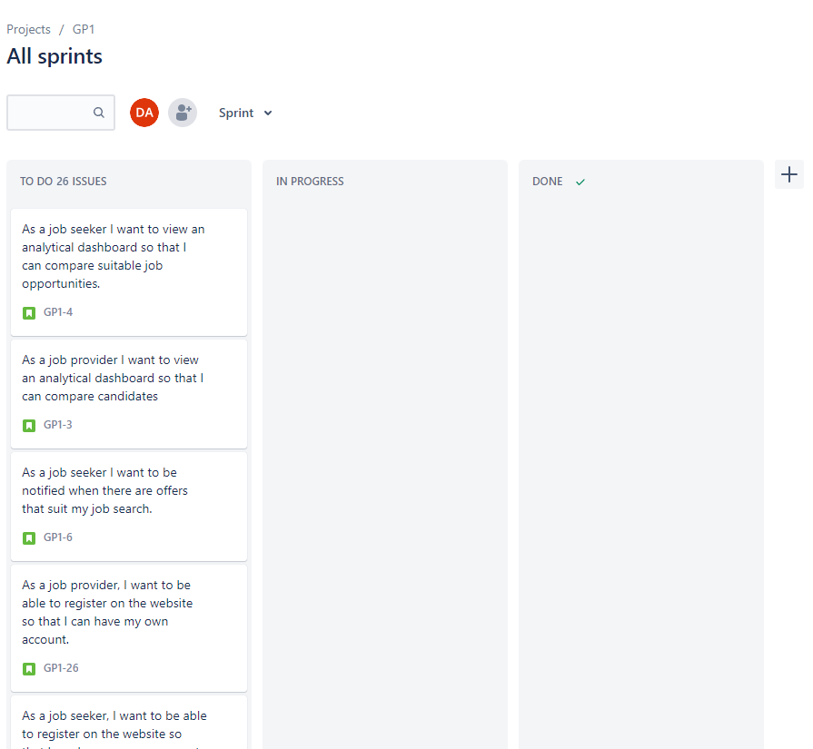

Figure - Jira sprints



Figure - Jira roadmap

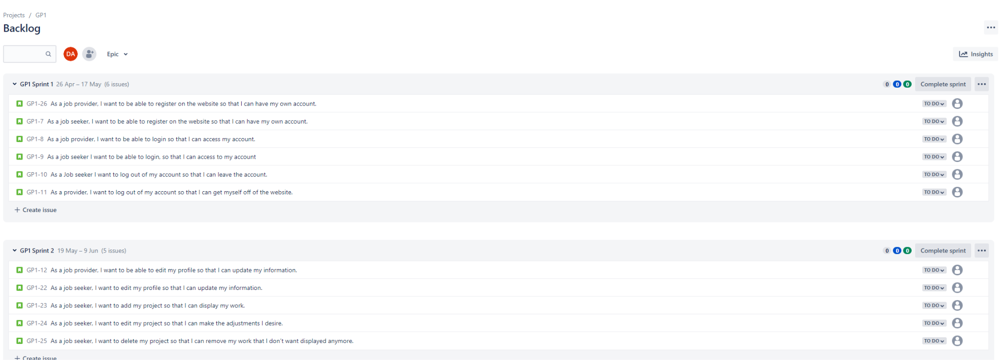

Figure - Jira backlog

Link: <https://2022-it320-g6.atlassian.net/jira/software/projects/GP1/boards/3/roadmap?shared=&atlOrigin=eyJpIjoiYjBjNDI4YWZkMDdkNGUxZmEyYzI2ZDIxZjgyOWE3ODMiLCJwIjoiaiJ9>



CHAPTER 10

Appendix D

Testing

# Appendix D: Testing

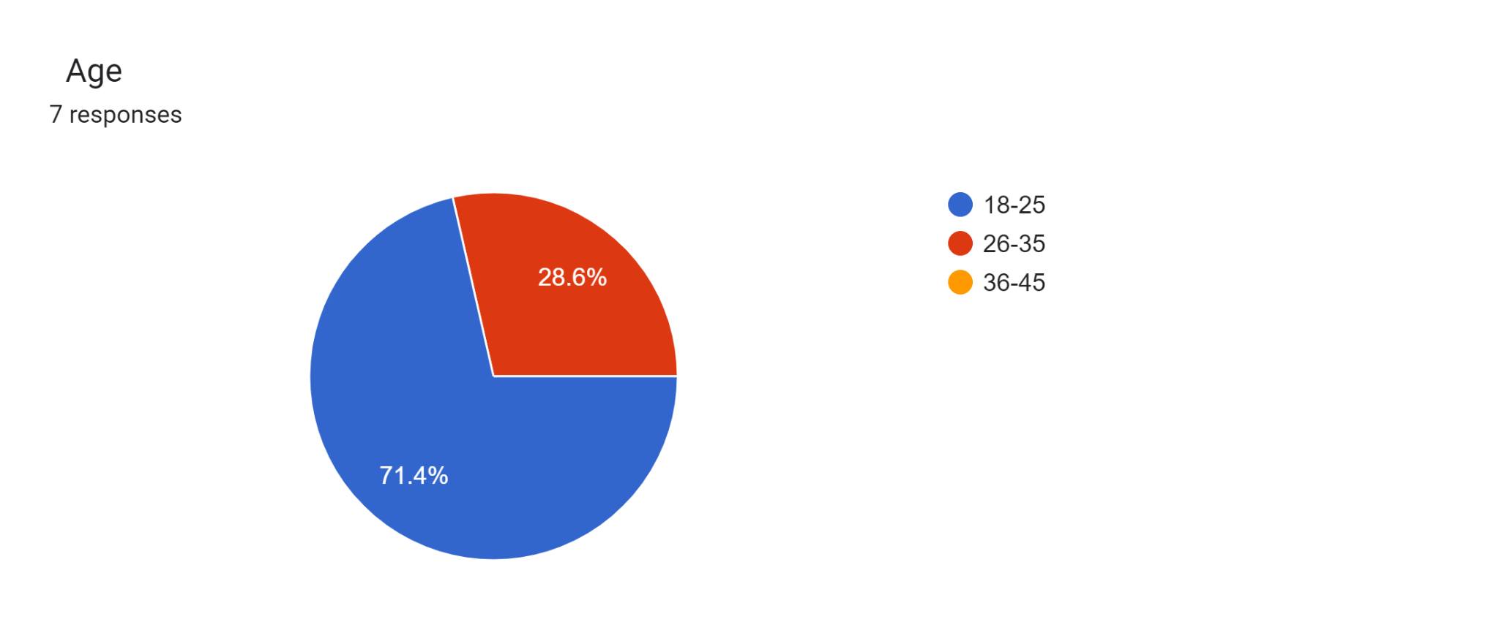

Figure - Testing survey

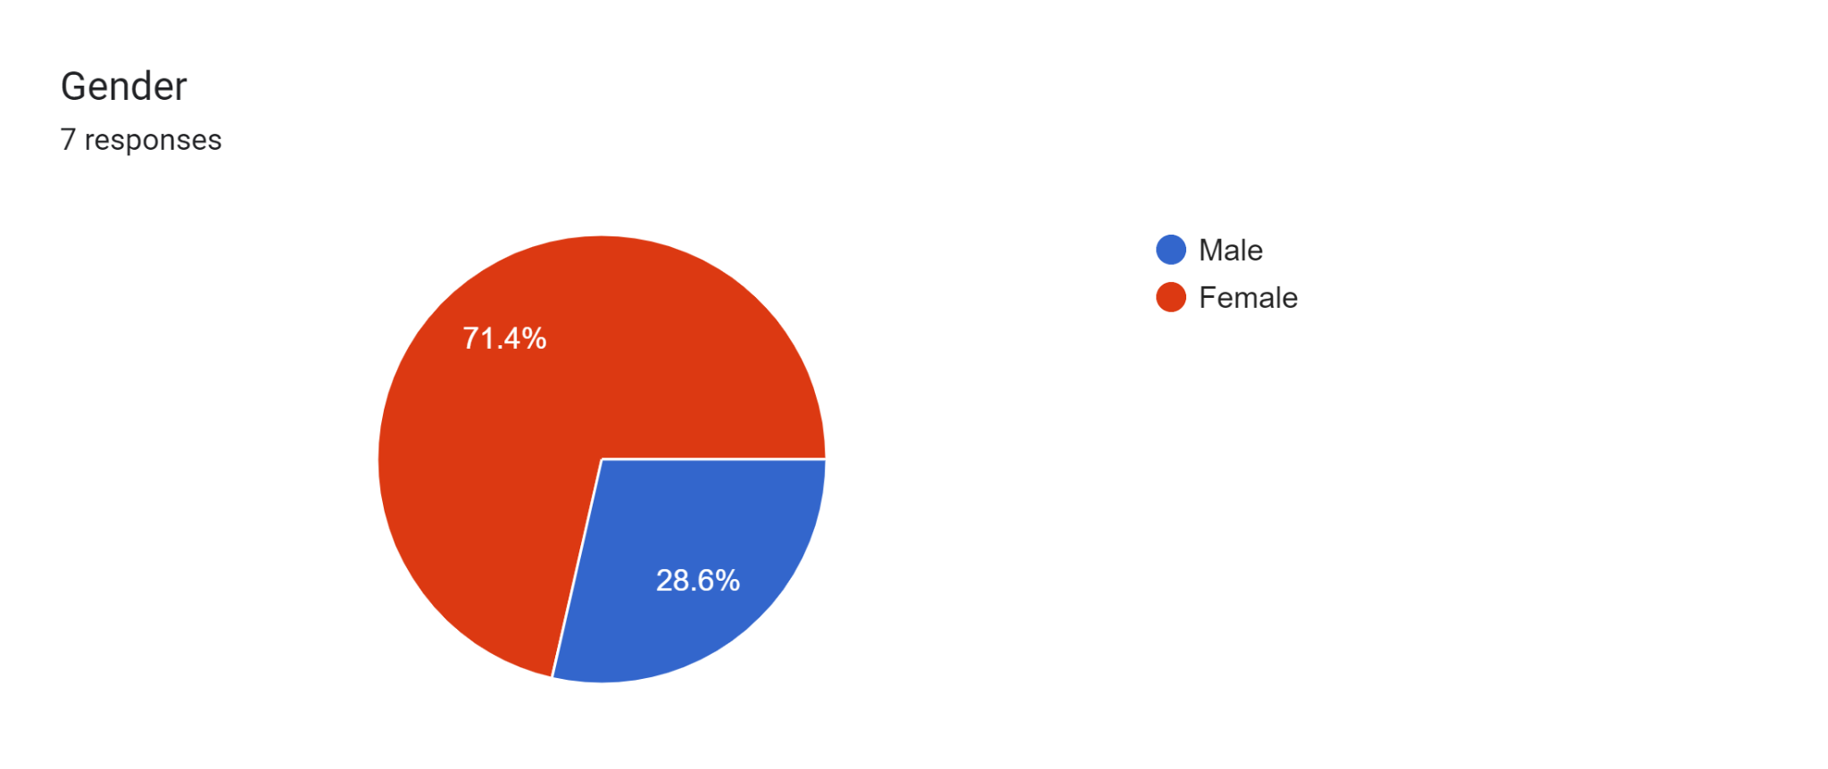

Figure - Testing survey

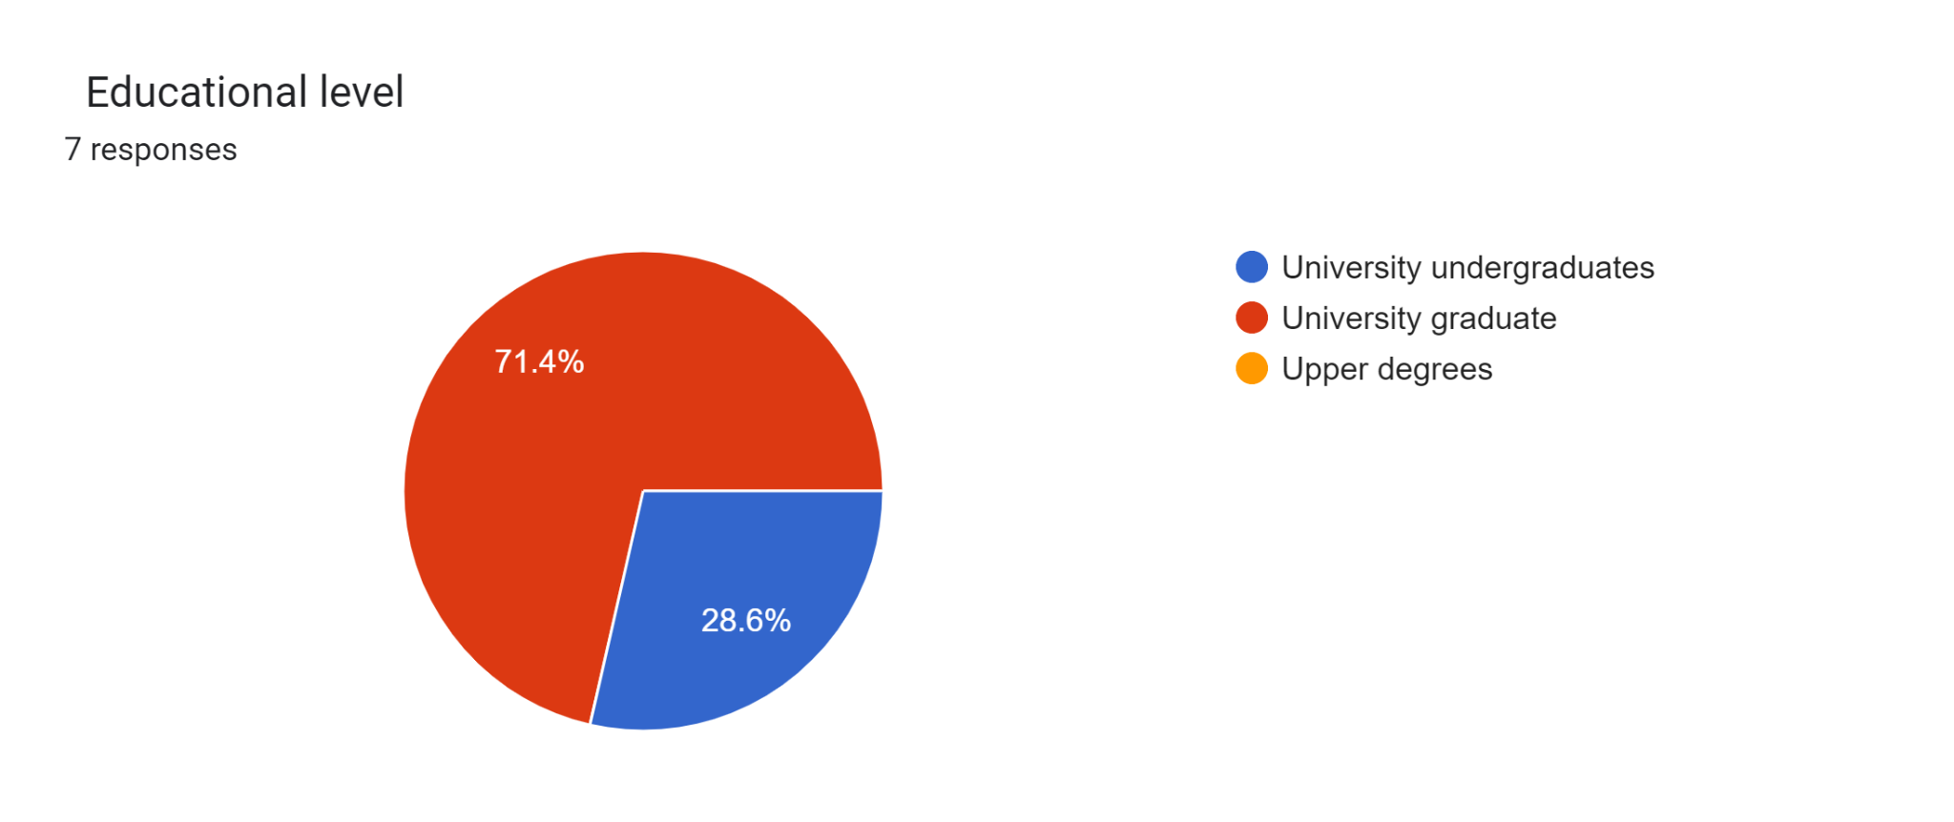

Figure - Testing survey

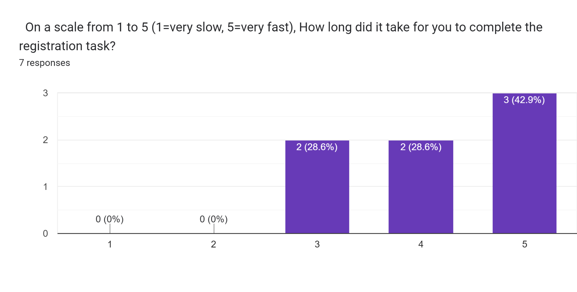

Figure - Testing survey

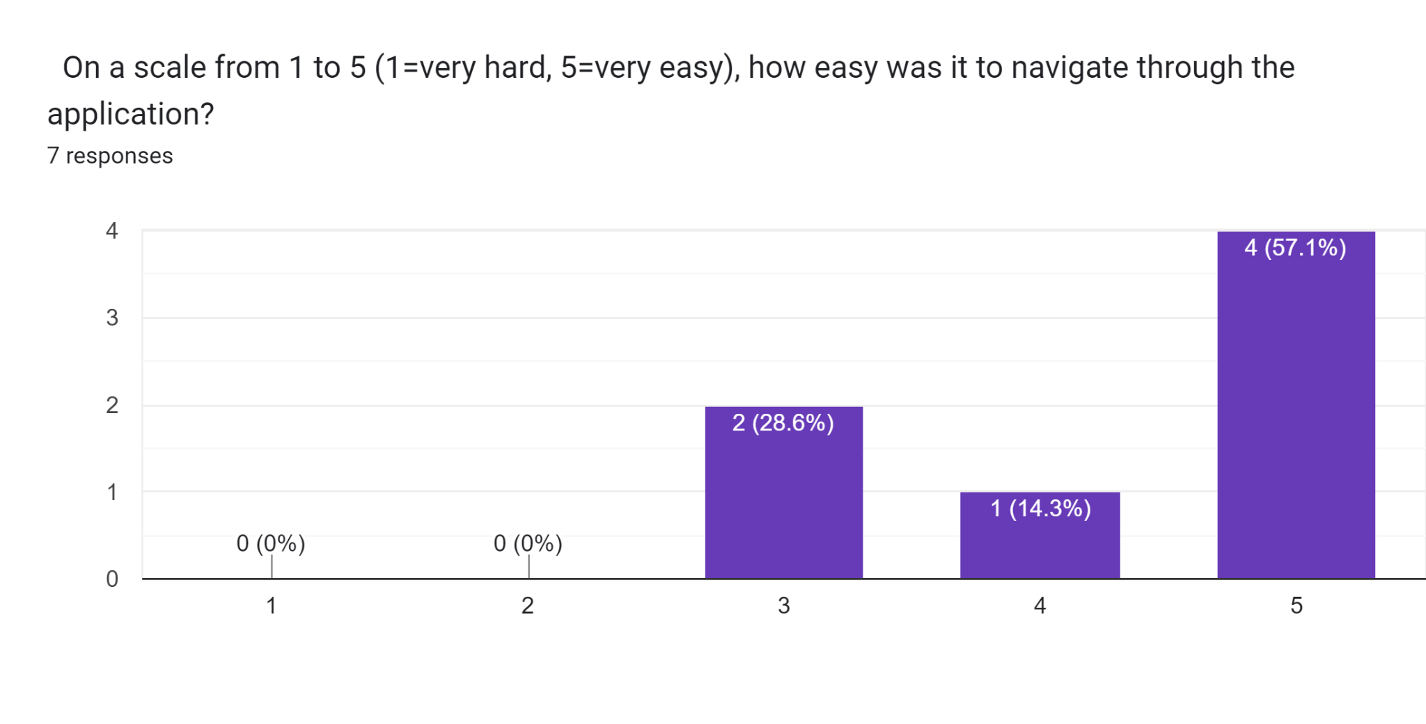

Figure - Testing survey

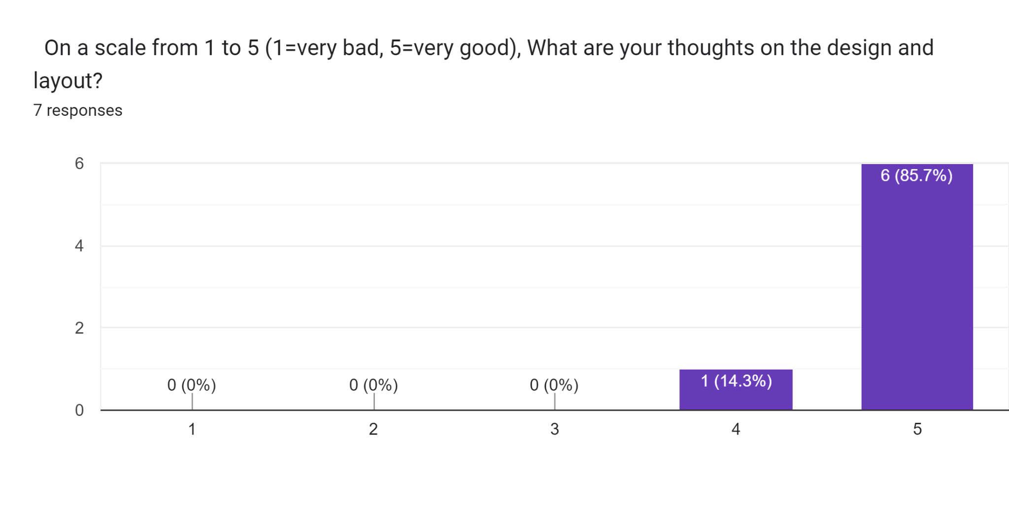

Figure - Testing survey

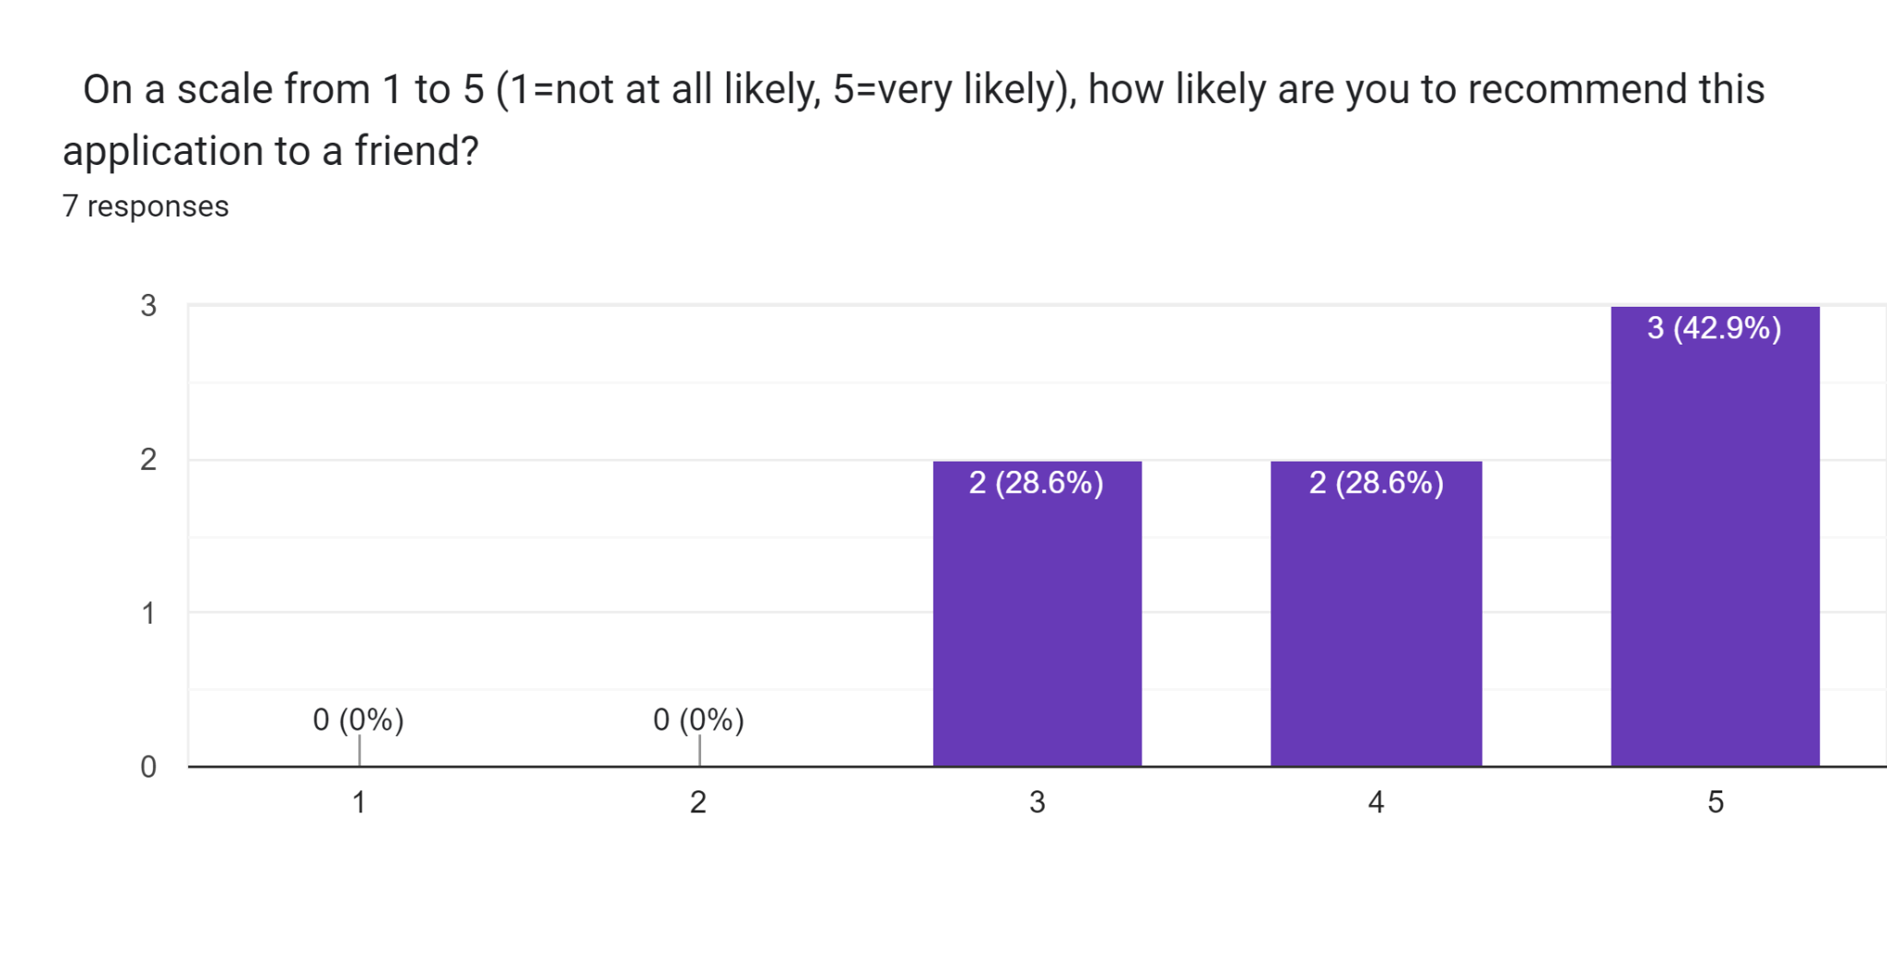

Figure - Testing survey

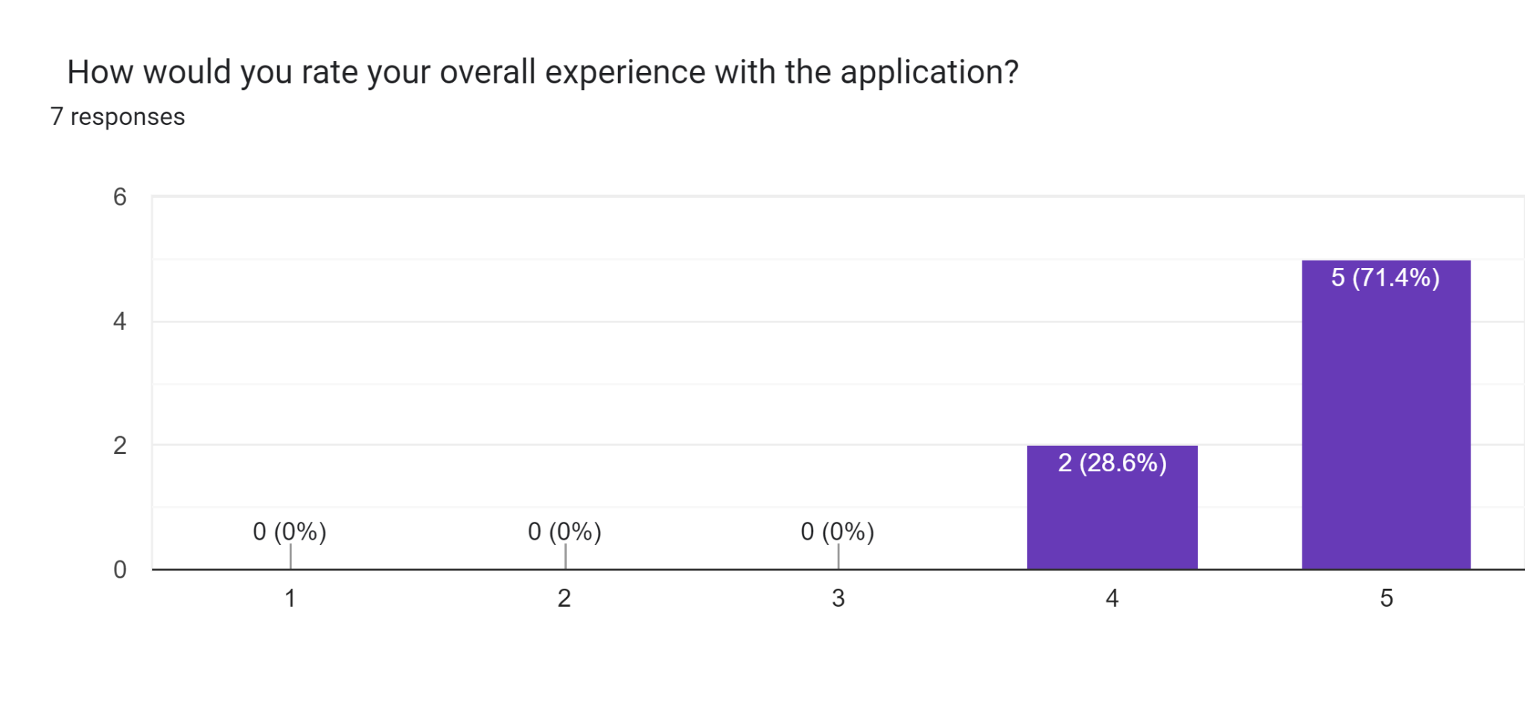

Figure - Testing survey